UNITED STATES
SECURITIES AND EXCHANGE COMMISSION
Washington, D.C. 20549
FORM 10-Q
☒ QUARTERLY REPORT PURSUANT TO SECTION 13 OR 15(d) OF THE SECURITIES EXCHANGE ACT OF 1934
For the quarterly period ended June 30, 2026
OR
☐ TRANSITION REPORT PURSUANT TO SECTION 13 OR 15(d) OF THE SECURITIES EXCHANGE ACT OF 1934
For the Transition Period from to
Commission File Number: 001-34949
ARBUTUS BIOPHARMA CORPORATION
(Exact Name of Registrant as Specified in Its Charter)
British Columbia, Canada |  |  |  |  |  | 98-0597776
(State or Other Jurisdiction of |  |  |  |  |  | (I.R.S. Employer
Incorporation or Organization) |  |  |  |  |  | Identification No.)
701 Veterans Circle, Warminster, PA 18974
(Address of Principal Executive Offices and Zip Code)
267-469-0914
(Registrant’s Telephone Number, Including Area Code)
Securities registered pursuant to Section 12(b) of the Act:
Title of each class |  |  | Trading Symbol(s) |  |  | Name of each exchange on which registered
Common Shares, without par value |  |  | ABUS |  |  | The Nasdaq Stock Market LLC

Indicate by check mark whether the registrant (1) has filed all reports required to be filed by Section 13 or 15(d) of the Securities Exchange Act of 1934 during the preceding 12 months (or for such shorter period that the registrant was required to file such reports), and (2) has been subject to such filing requirements for the past 90 days. Yes ☒ No ☐

Indicate by check mark whether the registrant has submitted electronically every Interactive Data File required to be submitted pursuant to Rule 405 of Regulation S-T (§232.405 of this chapter) during the preceding 12 months (or for such shorter period that the registrant was required to submit such files). Yes ☒ No ☐

Indicate by check mark whether the registrant is a large accelerated filer, an accelerated filer, a non-accelerated filer, a smaller reporting company, or an emerging growth company. See the definitions of “large accelerated filer,” “accelerated filer,” “smaller reporting company,” and “emerging growth company” in Rule 12b-2 of the Exchange Act.
Large accelerated filer |  |  | Accelerated filer |  |  | Non-accelerated filer |  |  | Smaller reporting company |  |  | Emerging growth company
☐ |  |  | ☐ |  |  | ☒ |  |  | ☒ |  |  | ☐
If an emerging growth company, indicate by check mark if the registrant has elected not to use the extended transition period for complying with any new or revised financial accounting standards provided pursuant to Section 13(a) of the Exchange Act. ☐
Indicate by check mark whether the registrant is a shell company (as defined in Rule 12b-2 of the Exchange Act).
Yes ☐ No ☒
As of August 10, 2026, the registrant had 197,847,835 common shares, without par value, outstanding.

ARBUTUS BIOPHARMA CORPORATION
 |  |  |  |  |  | Page
PART I. FINANCIAL INFORMATION |  |  |  |  |  | 1
ITEM 1. |  |  | FINANCIAL STATEMENTS (UNAUDITED) |  |  | 1
ITEM 2. |  |  | MANAGEMENT’S DISCUSSION AND ANALYSIS OF FINANCIAL CONDITION AND RESULTS OF OPERATIONS |  |  | 18
ITEM 3. |  |  | QUANTITATIVE AND QUALITATIVE DISCLOSURES ABOUT MARKET RISK |  |  | 37
ITEM 4. |  |  | CONTROLS AND PROCEDURES |  |  | 37
PART II. OTHER INFORMATION |  |  |  |  |  | 38
ITEM 1. |  |  | LEGAL PROCEEDINGS |  |  | 38
ITEM 1A. |  |  | RISK FACTORS |  |  | 40
ITEM 2. |  |  | UNREGISTERED SALES OF EQUITY SECURITIES AND USE OF PROCEEDS |  |  | 40
ITEM 3. |  |  | DEFAULTS UPON SENIOR SECURITIES |  |  | 40
ITEM 4. |  |  | MINE SAFETY DISCLOSURES |  |  | 40
ITEM 5. |  |  | OTHER INFORMATION |  |  | 40
ITEM 6. |  |  | EXHIBITS |  |  | 41

PART I. FINANCIAL INFORMATION

ITEM 1. FINANCIAL STATEMENTS (UNAUDITED)

ARBUTUS BIOPHARMA CORPORATION
Condensed Consolidated Balance Sheets
(Unaudited)
(In thousands of U.S. Dollars, except share amounts)
 |  |  | June 30, 2026 |  |  |  |  |  | December 31, 2025
Assets
Current assets:
Cash and cash equivalents |  |  | $ | 19,171 |  |  |  |  | $ | 18,008
Investments in marketable securities, current |  |  | 73,454 |  |  |  |  |  | 73,463
Accounts receivable |  |  | 369 |  |  |  |  |  | 1,447
Receivable from Genevant license |  |  | 179,373 |  |  |  |  |  | —
Prepaid expenses and other current assets |  |  | 1,516 |  |  |  |  |  | 1,538
Total current assets |  |  | 273,883 |  |  |  |  |  | 94,456
Property and equipment, net of accumulated depreciation and impairment of $235 (December 31, 2025: $213) |  |  | 10 |  |  |  |  |  | 32
Other non-current assets |  |  | 132 |  |  |  |  |  | 130
Total assets |  |  | $ | 274,025 |  |  |  |  | $ | 94,618
Liabilities and stockholders’ equity
Current liabilities:
Accounts payable and accrued liabilities |  |  | $ | 2,850 |  |  |  |  | $ | 5,459
Lease liability, current |  |  | 514 |  |  |  |  |  | 547
Total current liabilities |  |  | 3,364 |  |  |  |  |  | 6,006
Liability related to sale of future royalties |  |  | 3,111 |  |  |  |  |  | 3,442
Contingent consideration |  |  | 8,817 |  |  |  |  |  | 8,395
Lease liability, non-current |  |  | — |  |  |  |  |  | 199
Total liabilities |  |  | 15,292 |  |  |  |  |  | 18,042
Stockholders’ equity
Common shares
Authorized: Unlimited number without par value
Issued and outstanding: 197,634,118  (December 31, 2025: 192,531,225) |  |  | 1,448,177 |  |  |  |  |  | 1,421,429
Additional paid-in capital |  |  | 74,321 |  |  |  |  |  | 83,318
Deficit |  |  | (1,215,521) |  |  |  |  |  | (1,380,073)
Accumulated other comprehensive loss |  |  | (48,244) |  |  |  |  |  | (48,098)
Total stockholders’ equity |  |  | 258,733 |  |  |  |  |  | 76,576
Total liabilities and stockholders’ equity |  |  | $ | 274,025 |  |  |  |  | $ | 94,618

See accompanying notes to the condensed consolidated financial statements.

1

ARBUTUS BIOPHARMA CORPORATION
Condensed Consolidated Statements of Operations and Comprehensive Income (Loss)
(Unaudited)
(In thousands of U.S. Dollars, except share and per share amounts)

 |  |  | Three Months Ended June 30, |  |  |  |  |  |  |  |  |  |  |  | Six Months Ended June 30,
 |  |  | 2026 |  |  |  |  |  | 2025 |  |  |  |  |  | 2026 |  |  |  |  |  | 2025
Revenue
Collaborations and licenses |  |  | $ | 202 |  |  |  |  | $ | 10,213 |  |  |  |  | $ | 406 |  |  |  |  | $ | 11,529
License revenue from Genevant |  |  | 632 |  |  |  |  |  | — |  |  |  |  |  | 179,373 |  |  |  |  |  | —
Non-cash royalty revenue |  |  | 180 |  |  |  |  |  | 526 |  |  |  |  |  | 361 |  |  |  |  |  | 974
Total revenue |  |  | 1,014 |  |  |  |  |  | 10,739 |  |  |  |  |  | 180,140 |  |  |  |  |  | 12,503
Operating expenses
Research and development |  |  | 2,898 |  |  |  |  |  | 5,498 |  |  |  |  |  | 7,018 |  |  |  |  |  | 14,457
General and administrative |  |  | 3,867 |  |  |  |  |  | 3,328 |  |  |  |  |  | 9,756 |  |  |  |  |  | 9,160
Change in fair value of contingent consideration |  |  | 213 |  |  |  |  |  | 260 |  |  |  |  |  | 422 |  |  |  |  |  | 559
Restructuring costs |  |  | — |  |  |  |  |  | 165 |  |  |  |  |  | — |  |  |  |  |  | 12,538
Total operating expenses |  |  | 6,978 |  |  |  |  |  | 9,251 |  |  |  |  |  | 17,196 |  |  |  |  |  | 36,714
(Loss) income from operations |  |  | (5,964) |  |  |  |  |  | 1,488 |  |  |  |  |  | 162,944 |  |  |  |  |  | (24,211)
Other income
Interest income |  |  | 842 |  |  |  |  |  | 1,042 |  |  |  |  |  | 1,657 |  |  |  |  |  | 2,239
Interest expense |  |  | (18) |  |  |  |  |  | (28) |  |  |  |  |  | (35) |  |  |  |  |  | (56)
Foreign exchange (loss) gain |  |  | (3) |  |  |  |  |  | 21 |  |  |  |  |  | (14) |  |  |  |  |  | 25
Total other income |  |  | 821 |  |  |  |  |  | 1,035 |  |  |  |  |  | 1,608 |  |  |  |  |  | 2,208
Net (loss) income |  |  | $ | (5,143) |  |  |  |  | $ | 2,523 |  |  |  |  | $ | 164,552 |  |  |  |  | $ | (22,003)
Net (loss) income per common share
Basic |  |  | $ | (0.03) |  |  |  |  | $ | 0.01 |  |  |  |  | $ | 0.84 |  |  |  |  | $ | (0.12)
Diluted |  |  | $ | (0.03) |  |  |  |  | $ | 0.01 |  |  |  |  | $ | 0.84 |  |  |  |  | $ | (0.12)
Weighted average number of common shares
Basic |  |  | 197,470,724 |  |  |  |  |  | 191,551,282 |  |  |  |  |  | 195,626,117 |  |  |  |  |  | 191,130,631
Diluted |  |  | 197,470,724 |  |  |  |  |  | 192,399,733 |  |  |  |  |  | 196,847,687 |  |  |  |  |  | 191,130,631
Comprehensive (loss) income
Unrealized loss on available-for-sale securities |  |  | $ | (49) |  |  |  |  | $ | (21) |  |  |  |  | $ | (146) |  |  |  |  | $ | (52)
Comprehensive (loss) income |  |  | $ | (5,192) |  |  |  |  | $ | 2,502 |  |  |  |  | $ | 164,406 |  |  |  |  | $ | (22,055)

See accompanying notes to the condensed consolidated financial statements.

2

ARBUTUS BIOPHARMA CORPORATION
Condensed Consolidated Statements of Stockholders’ Equity
(Unaudited)
(In thousands of U.S. Dollars, except share amounts)

 |  |  | Common Shares
 |  |  | Number of Shares |  |  |  |  |  | Share Capital |  |  |  |  |  | Additional Paid-In Capital |  |  |  |  |  | Deficit |  |  |  |  |  | Accumulated Other Comprehensive Loss |  |  |  |  |  | Total Stockholders' Equity
Balance December 31, 2025 |  |  | 192,531,225 |  |  |  |  |  | $ | 1,421,429 |  |  |  |  | $ | 83,318 |  |  |  |  | $ | (1,380,073) |  |  |  |  | $ | (48,098) |  |  |  |  | $ | 76,576
Stock-based compensation expense |  |  | — |  |  |  |  |  | — |  |  |  |  |  | 1,359 |  |  |  |  |  | — |  |  |  |  |  | — |  |  |  |  |  | 1,359
Issuance of common shares pursuant to exercise of options |  |  | 4,149,396 |  |  |  |  |  | 22,262 |  |  |  |  |  | (9,706) |  |  |  |  |  | — |  |  |  |  |  | — |  |  |  |  |  | 12,556
Issuance of common shares pursuant to ESPP |  |  | 27,203 |  |  |  |  |  | 115 |  |  |  |  |  | (27) |  |  |  |  |  | — |  |  |  |  |  | — |  |  |  |  |  | 88
Issuance of common shares upon vesting of RSUs |  |  | 239,933 |  |  |  |  |  | 688 |  |  |  |  |  | (688) |  |  |  |  |  | — |  |  |  |  |  | — |  |  |  |  |  | —
Unrealized loss on available-for-sale securities |  |  | — |  |  |  |  |  | — |  |  |  |  |  | — |  |  |  |  |  | — |  |  |  |  |  | (97) |  |  |  |  |  | (97)
Net income |  |  | — |  |  |  |  |  | — |  |  |  |  |  | — |  |  |  |  |  | 169,695 |  |  |  |  |  | — |  |  |  |  |  | 169,695
Balance March 31, 2026 |  |  | 196,947,757 |  |  |  |  |  | $ | 1,444,494 |  |  |  |  | $ | 74,256 |  |  |  |  | $ | (1,210,378) |  |  |  |  | $ | (48,195) |  |  |  |  | $ | 260,177
Stock-based compensation expense |  |  | — |  |  |  |  |  | — |  |  |  |  |  | 1,625 |  |  |  |  |  | — |  |  |  |  |  | — |  |  |  |  |  | 1,625
Issuance of common shares pursuant to exercise of options |  |  | 686,361 |  |  |  |  |  | 3,683 |  |  |  |  |  | (1,560) |  |  |  |  |  | — |  |  |  |  |  | — |  |  |  |  |  | 2,123
Unrealized loss on available-for-sale securities |  |  | — |  |  |  |  |  | — |  |  |  |  |  | — |  |  |  |  |  | — |  |  |  |  |  | (49) |  |  |  |  |  | (49)
Net loss |  |  | — |  |  |  |  |  | — |  |  |  |  |  | — |  |  |  |  |  | (5,143) |  |  |  |  |  | — |  |  |  |  |  | (5,143)
Balance June 30, 2026 |  |  | 197,634,118 |  |  |  |  |  | $ | 1,448,177 |  |  |  |  | $ | 74,321 |  |  |  |  | $ | (1,215,521) |  |  |  |  | $ | (48,244) |  |  |  |  | $ | 258,733

See accompanying notes to the condensed consolidated financial statements.

3

ARBUTUS BIOPHARMA CORPORATION
Condensed Consolidated Statements of Stockholders’ Equity
(Unaudited)
(In thousands of U.S. Dollars, except share amounts)

 |  |  | Common Shares
 |  |  | Number of Shares |  |  |  |  |  | Share Capital |  |  |  |  |  | Additional Paid-In Capital |  |  |  |  |  | Deficit |  |  |  |  |  | Accumulated Other Comprehensive Loss |  |  |  |  |  | Total Stockholders' Equity
Balance December 31, 2024 |  |  | 189,963,492 |  |  |  |  |  | $ | 1,410,025 |  |  |  |  | $ | 82,048 |  |  |  |  | $ | (1,346,572) |  |  |  |  | $ | (48,135) |  |  |  |  | $ | 97,366
Stock-based compensation expense |  |  | — |  |  |  |  |  | — |  |  |  |  |  | 3,564 |  |  |  |  |  | — |  |  |  |  |  | — |  |  |  |  |  | 3,564
Issuance of common shares pursuant to exercise of options |  |  | 892,857 |  |  |  |  |  | 4,616 |  |  |  |  |  | (1,963) |  |  |  |  |  | — |  |  |  |  |  | — |  |  |  |  |  | 2,653
Issuance of common shares pursuant to ESPP |  |  | 44,541 |  |  |  |  |  | 173 |  |  |  |  |  | (42) |  |  |  |  |  | — |  |  |  |  |  | — |  |  |  |  |  | 131
Issuance of common shares upon vesting of RSUs |  |  | 580,584 |  |  |  |  |  | 1,518 |  |  |  |  |  | (1,518) |  |  |  |  |  | — |  |  |  |  |  | — |  |  |  |  |  | —
Unrealized loss on available-for-sale securities |  |  | — |  |  |  |  |  | — |  |  |  |  |  | — |  |  |  |  |  | — |  |  |  |  |  | (31) |  |  |  |  |  | (31)
Net loss |  |  | — |  |  |  |  |  | — |  |  |  |  |  | — |  |  |  |  |  | (24,526) |  |  |  |  |  | — |  |  |  |  |  | (24,526)
Balance March 31, 2025 |  |  | 191,481,474 |  |  |  |  |  | $ | 1,416,332 |  |  |  |  | $ | 82,089 |  |  |  |  | $ | (1,371,098) |  |  |  |  | $ | (48,166) |  |  |  |  | $ | 79,157
Stock-based compensation expense |  |  | — |  |  |  |  |  | — |  |  |  |  |  | 864 |  |  |  |  |  | — |  |  |  |  |  | — |  |  |  |  |  | 864
Issuance of common shares pursuant to exercise of options |  |  | 160,037 |  |  |  |  |  | 778 |  |  |  |  |  | (325) |  |  |  |  |  | — |  |  |  |  |  | — |  |  |  |  |  | 453
Unrealized loss on available-for-sale securities |  |  | — |  |  |  |  |  | — |  |  |  |  |  | — |  |  |  |  |  | — |  |  |  |  |  | (21) |  |  |  |  |  | (21)
Net income |  |  | — |  |  |  |  |  | — |  |  |  |  |  | — |  |  |  |  |  | 2,523 |  |  |  |  |  | — |  |  |  |  |  | 2,523
Balance June 30, 2025 |  |  | 191,641,511 |  |  |  |  |  | $ | 1,417,110 |  |  |  |  | $ | 82,628 |  |  |  |  | $ | (1,368,575) |  |  |  |  | $ | (48,187) |  |  |  |  | $ | 82,976

See accompanying notes to the condensed consolidated financial statements.

4

ARBUTUS BIOPHARMA CORPORATION
Condensed Consolidated Statements of Cash Flows
(Unaudited)
(In thousands of U.S. Dollars)
 |  |  | Six Months Ended June 30,
 |  |  | 2026 |  |  |  |  |  | 2025
OPERATING ACTIVITIES
Net income (loss) |  |  | $ | 164,552 |  |  |  |  | $ | (22,003)
Non-cash items:
Depreciation |  |  | 22 |  |  |  |  |  | 341
Loss on impairment of leasehold improvements and lab equipment |  |  | — |  |  |  |  |  | 2,811
Stock-based compensation expense |  |  | 2,984 |  |  |  |  |  | 4,428
Change in fair value of contingent consideration |  |  | 422 |  |  |  |  |  | 559
Non-cash royalty revenue |  |  | (361) |  |  |  |  |  | (974)
Non-cash interest expense |  |  | 30 |  |  |  |  |  | 55
Net accretion and amortization of investments in marketable securities |  |  | (675) |  |  |  |  |  | (1,386)
Net change in operating items:
Accounts receivable |  |  | 1,078 |  |  |  |  |  | 1,384
Receivable from Genevant license |  |  | (179,373) |  |  |  |  |  | —
Prepaid expenses and other assets |  |  | 20 |  |  |  |  |  | (640)
Accounts payable and accrued liabilities |  |  | (2,609) |  |  |  |  |  | (3,056)
Change in deferred license revenue |  |  | — |  |  |  |  |  | (10,434)
Other liabilities |  |  | (218) |  |  |  |  |  | (225)
Net cash used in operating activities |  |  | (14,128) |  |  |  |  |  | (29,140)
INVESTING ACTIVITIES
Purchase of investments in marketable securities |  |  | (37,462) |  |  |  |  |  | (63,214)
Proceeds from sale of property and equipment |  |  | — |  |  |  |  |  | 9
Disposition of investments in marketable securities |  |  | 38,000 |  |  |  |  |  | 90,165
Net cash provided by investing activities |  |  | 538 |  |  |  |  |  | 26,960
FINANCING ACTIVITIES
Issuance of common shares pursuant to exercise of stock options |  |  | 14,679 |  |  |  |  |  | 3,106
Issuance of common shares pursuant to ESPP |  |  | 88 |  |  |  |  |  | 131
Net cash provided by financing activities |  |  | 14,767 |  |  |  |  |  | 3,237
Effect of foreign exchange rate changes on cash and cash equivalents |  |  | (14) |  |  |  |  |  | 25
Increase in cash and cash equivalents |  |  | 1,163 |  |  |  |  |  | 1,082
Cash and cash equivalents, beginning of period |  |  | 18,008 |  |  |  |  |  | 36,330
Cash and cash equivalents, end of period |  |  | $ | 19,171 |  |  |  |  | $ | 37,412

See accompanying notes to the condensed consolidated financial statements.

5

ARBUTUS BIOPHARMA CORPORATION

Notes to Condensed Consolidated Financial Statements
(Tabular amounts in thousands of U.S. Dollars, except share and per share amounts)

1. Nature of business and future operations

Description of the Business

Arbutus Biopharma Corporation (“Arbutus” or the “Company”) is a clinical-stage biopharmaceutical company focused on infectious disease. The Company is currently developing imdusiran (AB-729), its proprietary, GalNAc-conjugated, subcutaneously-delivered ribonucleic acid interference (RNAi) therapeutic, and AB-101, its proprietary oral PD-L1 inhibitor, for the treatment of chronic hepatitis B (“cHBV”).

The Company continues to protect and defend its intellectual property, which is the subject of its ongoing lawsuits against Pfizer Inc., BioNTech SE, and certain of their affiliates (collectively, “Pfizer/BioNTech”) for their use of the Company’s patented lipid nanoparticle (“LNP”) technology in their COVID-19 messenger ribonucleic acid interference (mRNA)-LNP vaccines and any other products that would infringe the asserted patents. The court issued a claim construction ruling in September 2025, which construed the disputed claim terms in a manner the Company generally considers to be favorable. The parties are awaiting further scheduling in the litigation. In July 2026, the Company, along with its exclusive licensee Genevant Sciences GmbH, filed three international lawsuits seeking to enforce patents protecting the Company’s LNP technology against Pfizer/BioNTech.

On March 3, 2026, the Company, along with Genevant Sciences GmbH and, solely for specified purposes, its parent company Genevant Sciences Ltd. (collectively, “Genevant,” a related party), entered into a settlement agreement (the “Moderna Settlement Agreement”) with Moderna, Inc. and ModernaTX, Inc. (together, “Moderna”) to resolve all patent infringement litigation and patent revocation proceedings involving Moderna and its affiliates pending in the United States and internationally (the “Moderna LNP Litigation”). Under the terms of the Moderna Settlement Agreement, Moderna made an aggregate $950.0 million noncontingent lump sum payment (the “Noncontingent Settlement Payment”) to the Company and Genevant on July 8, 2026. The Company received $178.4 million on July 8, 2026 as its share of the Noncontingent Settlement Payment, which included reimbursement of the Company’s litigation costs. In addition, Moderna is obligated to pay the Company and Genevant an additional aggregate contingent lump sum payment of $1.3 billion (the “Contingent Settlement Payment”) upon a ruling that is favorable to the Company and Genevant in a limited appeal related to 28 U.S.C. §1498 that Moderna filed, as allowed under the Moderna Settlement Agreement. The Company owned approximately 16% of the outstanding common equity of Genevant as of June 30, 2026, and the Company anticipates the payment of a material dividend from Genevant in the third quarter of calendar year 2026.

Liquidity

At June 30, 2026, the Company had an aggregate of $92.6 million in cash, cash equivalents and investments in marketable securities and no outstanding debt. The Company received $178.4 million as its share of the Noncontingent Settlement Payment on July 8, 2026. The Company believes it has sufficient cash resources to fund its operations for at least the next 12 months.

The success of the Company’s operations is dependent on obtaining the necessary regulatory approvals to bring one or more of its product candidates to market and achieve profitability from ongoing operations. The Company’s development activities and the commercialization of its products are dependent on its ability to successfully complete these activities and to obtain adequate financing through a combination of financing activities and operations. It is not possible to predict either the outcome of the Company’s existing or future development programs or the Company’s ability to continue to fund these programs in the future.

6

2. Significant accounting policies

Basis of presentation and principles of consolidation

These unaudited condensed consolidated financial statements have been prepared in accordance with United States generally accepted accounting principles for interim financial statements and accordingly, do not include all disclosures required for annual financial statements. These statements should be read in conjunction with the Company’s audited consolidated financial statements and notes thereto for the year ended December 31, 2025 included in the Company’s Annual Report on Form 10-K for the year ended December 31, 2025. These unaudited condensed consolidated financial statements include the accounts of Arbutus Biopharma Corporation and its one wholly-owned subsidiary, Arbutus Biopharma, Inc., and reflect, in the opinion of management, all adjustments and reclassifications necessary to fairly present the Company’s financial position as of June 30, 2026 and December 31, 2025, the Company’s results of operations for the three and six months ended June 30, 2026 and 2025, and the Company’s cash flows for the six months ended June 30, 2026 and 2025. Such adjustments are of a normal recurring nature. The results of operations for the three and six months ended June 30, 2026 are not necessarily indicative of the results for the full year. These unaudited condensed consolidated financial statements follow the same significant accounting policies as those described in the notes to the audited consolidated financial statements of the Company for the year ended December 31, 2025, except as described below under the section entitled “Recent Accounting Pronouncements.”

All intercompany balances and transactions have been eliminated.

Net income (loss) per share

Net income (loss) per share is calculated based on the weighted average number of common shares outstanding. Diluted net income (loss) per share is calculated using the treasury stock method and reflects the effect of all potentially dilutive securities (outstanding stock options and restricted stock units). The number of weighted average shares used in the calculation of net income per share for the three months ended June 30, 2025 and the six months ended June 30, 2026 were as follows:

 |  |  | Three Months Ended June 30, 2025 |  |  |  |  |  | Six Months Ended June 30, 2026
Weighted average shares:
Basic shares |  |  | 191,551,282 |  |  |  |  |  | 195,626,117
Potentially dilutive shares from equity-based compensation plans |  |  | 848,451 |  |  |  |  |  | 1,221,570
Diluted shares |  |  | 192,399,733 |  |  |  |  |  | 196,847,687

Diluted net loss per share does not differ from basic net loss per share for the three months ended June 30, 2026 or the six months ended June 30, 2025 since the effect of including potential common shares would be anti-dilutive as the Company was in a net loss position. Total antidilutive securities that were excluded from the computation of diluted weighted-average shares outstanding were as follows:
 |  |  | Three Months Ended June 30, |  |  |  |  |  |  |  |  |  |  |  | Six Months Ended June 30,
 |  |  | 2026 |  |  |  |  |  | 2025 |  |  |  |  |  | 2026 |  |  |  |  |  | 2025
Outstanding stock options and restricted stock units |  |  | 9,137,410 |  |  |  |  |  | 14,045,207 |  |  |  |  |  | 11,285,502 |  |  |  |  |  | 15,417,620

Revenue from collaborations and licenses

The Company generates revenue through certain collaboration agreements and license agreements. Such agreements may require the Company to deliver various rights and/or services, including intellectual property rights or licenses and research and development services. Under such agreements, the Company is generally eligible to receive non-refundable upfront payments, funding for research and development services, milestone payments and royalties.

The Company’s collaboration agreements fall under the scope of Accounting Standards Codification (ASC) Topic 808, Collaborative Arrangements (ASC 808), when both parties are active participants in the arrangement and are exposed to significant risks and rewards. For certain arrangements under the scope of ASC 808, the Company analogizes to ASC Topic 606, Revenue from Contracts with Customers (ASC 606), for some aspects, including for the delivery of a good or service (i.e., a unit of account).

7

ASC 606 requires an entity to recognize the amount of revenue to which it expects to be entitled for the transfer of promised goods or services to customers under a five-step model: (i) identify contract(s) with a customer; (ii) identify the performance obligations in the contract; (iii) determine the transaction price; (iv) allocate the transaction price to the performance obligations in the contract; and (v) recognize revenue when or as a performance obligation is satisfied.

In contracts where the Company has more than one performance obligation to provide its customer with goods or services, each performance obligation is evaluated to determine whether it is distinct based on whether (i) the customer can benefit from the good or service either on its own or together with other resources that are readily available and (ii) the good or service is separately identifiable from other promises in the contract. The consideration under the contract is then allocated between the distinct performance obligations based on their respective relative stand-alone selling prices. The estimated stand-alone selling price of each deliverable reflects the Company’s best estimate of what the selling price would be if the deliverable was regularly sold on a stand-alone basis and is determined by reference to market rates for the good or service when sold to others or by using an adjusted market assessment approach if the selling price on a stand-alone basis is not available.

The consideration allocated to each distinct performance obligation is recognized as revenue when control is transferred to the customer for the related goods or services. Consideration associated with at-risk substantive performance milestones, including sales-based milestones, is recognized as revenue when it is probable that a significant reversal of the cumulative revenue recognized will not occur. Sales-based royalties received in connection with licenses of intellectual property are subject to a specific exception in the revenue standards, whereby the consideration is not included in the transaction price and recognized in revenue until the customer’s subsequent sales or usages occur.

Deferred Revenue

When consideration is received or is unconditionally due from a customer, collaborator or licensee prior to the Company completing its performance obligation to the customer, collaborator or licensee under the terms of a contract, deferred revenue is recorded. Deferred revenue expected to be recognized as revenue within the 12 months following the balance sheet date is classified as a current liability. Deferred revenue not expected to be recognized as revenue within the 12 months following the balance sheet date is classified as a long-term liability. In accordance with ASC Topic 210-20, Balance Sheet - Offsetting (ASC 210-20) the Company’s deferred revenue was offset by a contract asset as further discussed in Note 9.

Recently adopted accounting standards

In December 2023, the Financial Accounting Standards Board (FASB) issued Accounting Standards Update (ASU) No. 2023-09, Income Taxes (Topic 740): Improvements to Income Tax Disclosures (ASU 2023-09), which improves income tax disclosures by requiring: (1) consistent categories and greater disaggregation of information in the rate reconciliation, and (2) income taxes paid disaggregated by jurisdiction. It also includes certain other amendments to improve the effectiveness of income tax disclosures. The Company adopted ASU 2023-09 for the year ended December 31, 2025 on a prospective basis and included the required enhanced disclosures in its Annual Report on Form 10-K for the year ended December 31, 2025. As the guidance relates to disclosure requirements only, adoption did not have an impact on the Company’s financial statements.

Recent accounting pronouncements

The Company has reviewed all recently issued standards and has determined that such standards will not have a material impact on the Company’s financial statements or do not otherwise apply to the Company’s operations.

3. Fair value measurements

The Company measures certain financial instruments and other items at fair value.

To determine the fair value, the Company uses the fair value hierarchy for inputs used in measuring fair value that maximize the use of observable inputs and minimize the use of unobservable inputs by requiring that the most observable inputs be used when available. Observable inputs are inputs market participants would use to value an asset or liability and are developed based on market data obtained from independent sources. Unobservable inputs are inputs based on assumptions about the factors market participants would use to value an asset or liability. The three levels of inputs that may be used to measure fair value are as follows:
•Level 1 inputs are quoted market prices for identical instruments available in active markets.
8

•Level 2 inputs are inputs other than quoted prices included within Level 1 that are observable for the asset or liability either directly or indirectly. If the asset or liability has a contractual term, the input must be observable for substantially the full term. An example includes quoted market prices for similar assets or liabilities in active markets.
•Level 3 inputs are unobservable inputs for the asset or liability and will reflect management’s assumptions about market assumptions that would be used to price the asset or liability.

Assets and liabilities are classified based on the lowest level of input that is significant to the fair value measurements. Changes in the observability of valuation inputs may result in a reclassification of levels for certain securities within the fair value hierarchy.

The carrying values of cash and cash equivalents, accounts receivable, accounts payable and accrued liabilities approximate their fair values due to the immediate or short-term maturity of these financial instruments.

To determine the fair value of the contingent consideration (Note 8), the Company uses a probability weighted assessment of the likelihood the milestones would be met and the estimated timing of such payments, and then the potential contingent payments are discounted to their present value using a probability adjusted discount rate that reflects the early stage nature of the development program, the time to complete the program development, and overall biotech indices. The Company determined the fair value of the contingent consideration was $8.8 million as of June 30, 2026, and the increase of $0.4 million from December 31, 2025 has been recorded as a component of total operating expenses in the condensed consolidated statements of operations and comprehensive income (loss) for the six months ended June 30, 2026. The assumptions used in the discounted cash flow model are level 3 inputs as defined above. There were no changes in the assumptions as of June 30, 2026 compared to December 31, 2025. The Company assessed the sensitivity of the fair value measurement to changes in these unobservable inputs, and determined that changes within a reasonable range would not result in a materially different assessment of fair value.

The following tables present information about the Company’s assets and liabilities that are measured at fair value on a recurring basis, and indicates the fair value hierarchy of the valuation techniques used to determine such fair value:

 |  |  | Level 1 |  |  |  |  |  | Level 2 |  |  |  |  |  | Level 3 |  |  |  |  |  | Total
As of June 30, 2026 |  |  | (in thousands)
Assets
Cash and cash equivalents |  |  | $ | 19,171 |  |  |  |  | $ | — |  |  |  |  | $ | — |  |  |  |  | $ | 19,171
Investments in marketable securities, current |  |  | — |  |  |  |  |  | 73,454 |  |  |  |  |  | — |  |  |  |  |  | 73,454
Total |  |  | $ | 19,171 |  |  |  |  | $ | 73,454 |  |  |  |  | $ | — |  |  |  |  | $ | 92,625
Liabilities
Contingent consideration |  |  | $ | — |  |  |  |  | $ | — |  |  |  |  | $ | 8,817 |  |  |  |  | $ | 8,817
Total |  |  | $ | — |  |  |  |  | $ | — |  |  |  |  | $ | 8,817 |  |  |  |  | $ | 8,817

 |  |  | Level 1 |  |  |  |  |  | Level 2 |  |  |  |  |  | Level 3 |  |  |  |  |  | Total
As of December 31, 2025 |  |  | (in thousands)
Assets
Cash and cash equivalents |  |  | $ | 18,008 |  |  |  |  | $ | — |  |  |  |  | $ | — |  |  |  |  | $ | 18,008
Investments in marketable securities, current |  |  | — |  |  |  |  |  | 73,463 |  |  |  |  |  | — |  |  |  |  |  | 73,463
Total |  |  | $ | 18,008 |  |  |  |  | $ | 73,463 |  |  |  |  | $ | — |  |  |  |  | $ | 91,471
Liabilities
Contingent consideration |  |  | $ | — |  |  |  |  | $ | — |  |  |  |  | $ | 8,395 |  |  |  |  | $ | 8,395
Total |  |  | $ | — |  |  |  |  | $ | — |  |  |  |  | $ | 8,395 |  |  |  |  | $ | 8,395

9

The following table presents the changes in fair value of the Company’s contingent consideration:
 |  |  | Liability at beginning of the period |  |  |  |  |  | Change in fair value of liability |  |  |  |  |  | Liability at end of the period
 |  |  | (in thousands)
Six Months Ended June 30, 2026 |  |  | $ | 8,395 |  |  |  |  | $ | 422 |  |  |  |  | $ | 8,817
Six Months Ended June 30, 2025 |  |  | $ | 10,225 |  |  |  |  | $ | 559 |  |  |  |  | $ | 10,784

See Note 4 for additional information regarding the fair value of the Company’s investments in marketable securities.

4. Investments in marketable securities

Investments in cash equivalents and marketable securities consisted of the following:
 |  |  | Amortized Cost |  |  |  |  |  | Gross Unrealized Gain(1) |  |  |  |  |  | Gross Unrealized Loss(1) |  |  |  |  |  | Fair Value
As of June 30, 2026 |  |  | (in thousands)
Cash equivalents
Money market funds |  |  | $ | 6,914 |  |  |  |  | $ | — |  |  |  |  | $ | — |  |  |  |  | $ | 6,914
US treasury bills |  |  | $ | 1,987 |  |  |  |  | $ | — |  |  |  |  | $ | — |  |  |  |  | $ | 1,987
Total |  |  | $ | 8,901 |  |  |  |  | $ | — |  |  |  |  | $ | — |  |  |  |  | $ | 8,901
Investments in marketable short-term securities
US treasury bills |  |  | 37,512 |  |  |  |  |  | 1 |  |  |  |  |  | (30) |  |  |  |  |  | 37,483
US government bonds |  |  | 36,001 |  |  |  |  |  | — |  |  |  |  |  | (30) |  |  |  |  |  | 35,971
Total |  |  | $ | 73,513 |  |  |  |  | $ | 1 |  |  |  |  | $ | (60) |  |  |  |  | $ | 73,454

(1) Gross unrealized gain (loss) is pre-tax and is reported in accumulated other comprehensive income (loss).

 |  |  | Amortized Cost |  |  |  |  |  | Gross Unrealized Gain(1) |  |  |  |  |  | Gross Unrealized Loss(1) |  |  |  |  |  | Fair Value
As of December 31, 2025 |  |  | (in thousands)
Cash equivalents
Money market funds |  |  | $ | 10,218 |  |  |  |  | $ | — |  |  |  |  | $ | — |  |  |  |  | $ | 10,218
Total |  |  | $ | 10,218 |  |  |  |  | $ | — |  |  |  |  | $ | — |  |  |  |  | $ | 10,218
Investments in marketable short-term securities
US treasury bills |  |  | 37,411 |  |  |  |  |  | 41 |  |  |  |  |  | — |  |  |  |  |  | 37,452
US government bonds |  |  | $ | 35,965 |  |  |  |  | $ | 46 |  |  |  |  | $ | — |  |  |  |  | $ | 36,011
Total |  |  | $ | 73,376 |  |  |  |  | $ | 87 |  |  |  |  | $ | — |  |  |  |  | $ | 73,463

(1) Gross unrealized gain (loss) is pre-tax and is reported in accumulated other comprehensive income (loss).

The contractual term to maturity of the $73.5 million of short-term marketable securities held by the Company as of June 30, 2026 is less than one year. As of June 30, 2026, the Company held no long-term marketable securities. As of December 31, 2025, the Company’s $73.5 million of short-term marketable securities had contractual maturities of less than one year, while the Company held no long-term marketable securities.

10

At June 30, 2026, the Company had 32 available-for-sale investment debt securities in an unrealized loss position without an allowance for credit losses. As of December 31, 2025, there were no available-for-sale investment debt securities in an unrealized loss position without an allowance for credit losses. Unrealized losses on the Company’s investments in debt securities have not been recognized into income as the issuers’ securities are of high credit quality and the decline in fair value is largely due to market conditions and/or changes in interest rates. The Company does not intend to sell and it is more likely than not that the Company will not be required to sell the securities prior to the anticipated recovery of their amortized cost basis. The issuers continue to make timely interest payments on the securities. The fair value is expected to recover as the securities approach maturity.

Accrued interest receivable on investments in marketable securities of $0.4 million and $0.3 million at June 30, 2026 and December 31, 2025, respectively, is included in prepaid expenses and other current assets.

The Company had no realized gains during either of the three and six months ended June 30, 2026 or 2025.

See Note 3 for additional information regarding the fair value of the Company’s investments in marketable securities.

5. Investment in Genevant

In April 2018, the Company entered into an agreement with Roivant Sciences Ltd. (Roivant), its largest shareholder, to launch Genevant Sciences Ltd., a company focused on nucleic acid- and gene editing-based therapeutics enabled by the Company’s LNP and ligand conjugate delivery technologies. The Company licensed rights to its LNP and ligand conjugate delivery platforms to Genevant outside of hepatitis B (HBV), except to the extent certain rights had already been licensed to other third parties (the Genevant License). The Company retained all rights to its LNP and conjugate delivery platforms for HBV.

Under the Genevant License, as amended, if a third-party sublicensee of intellectual property licensed by Genevant from the Company commercializes a sublicensed product, the Company becomes entitled to receive a specified percentage of certain revenue that may be received by Genevant for such sublicense, including royalties, commercial milestones and other sales-related revenue, or, if less, tiered low single-digit royalties on net sales of the sublicensed product. The specified percentage is 20% in the case of a mere sublicense (i.e., naked sublicense) by Genevant without additional contribution and 14% in the case of a bona fide collaboration with Genevant.

Additionally, if Genevant receives proceeds from an action for infringement by any third parties of the Company’s intellectual property licensed to Genevant, the Company would be entitled to receive, after deduction of litigation costs, 20% of the proceeds received by Genevant or, if less, tiered low single-digit royalties on net sales of the infringing product (inclusive of the proceeds from litigation or settlement, which would be treated as net sales).

The Company accounts for its interest in Genevant as equity securities without readily determinable fair values. Accordingly, an estimate of the fair value of the securities is based on the original cost less previously recognized equity method losses, less impairments, plus or minus changes resulting from observable price changes in orderly transactions for identical or a similar Genevant securities. As of June 30, 2026, the carrying value of the Company’s investment in Genevant was zero and the Company owned approximately 16% of the outstanding common equity of Genevant.

6. Accounts payable and accrued liabilities

Accounts payable and accrued liabilities were comprised of the following:
 |  |  | June 30, 2026 |  |  |  |  |  | December 31, 2025
 |  |  | (in thousands)
Trade accounts payable |  |  | $ | 373 |  |  |  |  | $ | 1,173
Research and development accruals |  |  | 448 |  |  |  |  |  | 412
Professional fee accruals |  |  | 735 |  |  |  |  |  | 1,075
Payroll accruals |  |  | 1,134 |  |  |  |  |  | 2,159
Restructuring liabilities |  |  | 160 |  |  |  |  |  | 640
Total accounts payable and accrued liabilities |  |  | $ | 2,850 |  |  |  |  | $ | 5,459

11

In March 2025, the Company implemented changes to focus its efforts on advancing the clinical development of imdusiran and AB-101. The decision was made to exit the Company’s corporate headquarters in Warminster, Pennsylvania, implement workforce reductions and discontinue in-house scientific research. The Company recognized $12.9 million of restructuring charges in 2025, of which there was an aggregate of $0.2 million in medical benefit costs and lease expenses accrued as of June 30, 2026.

7. Sale of future royalties
On July 2, 2019, the Company entered into a Purchase and Sale Agreement (the Agreement) with the Ontario Municipal Employees Retirement System (OMERS), pursuant to which the Company sold to OMERS part of its royalty interest on future global net sales of ONPATTRO® (Patisiran) (ONPATTRO), an RNA interference therapeutic currently being sold by Alnylam Pharmaceuticals, Inc. (Alnylam).

ONPATTRO utilizes Arbutus’s LNP technology, which was licensed to Alnylam pursuant to the Cross-License Agreement, dated November 12, 2012, by and between the Company and Alnylam (the LNP License Agreement). Under the terms of the LNP License Agreement, the Company is entitled to tiered royalty payments on global net sales of ONPATTRO ranging from 1.00% to 2.33% after offsets, with the highest tier applicable to annual net sales above $500 million. This royalty interest was sold to OMERS, effective as of January 1, 2019, for $20 million in gross proceeds before advisory fees. OMERS will retain this entitlement until it has received $30 million in royalties, at which point 100% of such royalty interest on future global net sales of ONPATTRO will revert to the Company. OMERS has assumed the risk of collecting up to $30 million of future royalty payments from Alnylam, and the Company is not obligated to reimburse OMERS if it fails to collect any such future royalties.

The $30 million in royalties to be paid to OMERS is accounted for as a liability, with the difference between the liability and the gross proceeds received accounted for as a discount. The discount, as well as $1.5 million of transaction costs, will be amortized as interest expense based on the projected balance of the liability as of the beginning of each period. As of June 30, 2026, the Company estimated an effective annual interest rate of approximately 1.5%. Over the course of the Agreement, the actual interest rate will be affected by the amount and timing of royalty revenue recognized and changes in the timing of forecasted royalty revenue. On a quarterly basis, the Company will reassess the expected timing of the royalty revenue, recalculate the amortization and effective interest rate and adjust the accounting prospectively as needed.

The Company recognizes non-cash royalty revenue related to the sales of ONPATTRO during the term of the Agreement. As royalties are remitted to OMERS from Alnylam, the balance of the recognized liability is effectively repaid over the life of the Agreement. From the inception of the royalty sale through June 30, 2026, an aggregate of $26.9 million of royalties have been earned by OMERS. There are a number of factors that could materially affect the amount and timing of royalty payments from Alnylam, none of which are within the Company’s control.

During the six months ended June 30, 2026, the Company recognized non-cash royalty revenue of $0.4 million and related non-cash interest expense of less than $0.1 million. During the six months ended June 30, 2025, the Company recognized non-cash royalty revenue of $1.0 million and related non-cash interest expense of less than $0.1 million.
The table below shows the activity related to the net liability for the six months ended June 30, 2026 and 2025:
 |  |  | Six Months Ended June 30,
 |  |  | 2026 |  |  |  |  |  | 2025
 |  |  | (in thousands)
Net liability related to sale of future royalties - beginning balance |  |  | $ | 3,442 |  |  |  |  | $ | 4,829
Non-cash royalty revenue |  |  | (361) |  |  |  |  |  | (974)
Non-cash interest expense |  |  | 30 |  |  |  |  |  | 55
Net liability related to sale of future royalties - ending balance |  |  | $ | 3,111 |  |  |  |  | $ | 3,910

In addition to the royalty from the LNP License Agreement, the Company is also receiving a second royalty interest ranging from 0.75% to 1.125% on global net sales of ONPATTRO, with 0.75% applying to sales greater than $500 million, originating from a settlement agreement and subsequent license agreement with Acuitas Therapeutics, Inc. (“Acuitas”). The royalty from Acuitas has been retained by the Company and was not part of the royalty sale to OMERS. In addition to the two royalty entitlements, the Company is entitled to receive payments upon the achievement of contractual milestones related to Alnylam’s use of the Company’s proprietary LNP technology for other products.

12

8. Contingencies and commitments

Stock Purchase Agreement with Enantigen

In October 2014, Arbutus Biopharma, Inc., the Company’s wholly-owned subsidiary, acquired all of the outstanding shares of Enantigen Therapeutics, Inc. (“Enantigen”) pursuant to a stock purchase agreement. The amount paid to Enantigen’s selling shareholders could be up to an additional $102.5 million in sales performance milestones in connection with the sale of the first commercialized product by the Company for the treatment of HBV, regardless of whether such product is based upon assets acquired under this agreement, and a low single-digit royalty on net sales of such first commercialized HBV product, up to a maximum royalty payment of $1.0 million that, if paid, would be offset against the Company’s milestone payment obligations. Certain other development milestones related to the acquisition were tied to programs which are no longer under development by the Company, and therefore the contingency related to those development milestones is zero.

The contingent consideration is a financial liability and is measured at its fair value at each reporting period, with any changes in fair value from the previous reporting period recorded in the condensed consolidated statements of operations and comprehensive income (loss) (see Note 3).

The fair value of the contingent consideration was $8.8 million as of June 30, 2026.

9. Collaborations, contracts and licensing agreements

Collaborations

Qilu Pharmaceutical Co., Ltd.

In December 2021, the Company entered into a technology transfer and license agreement (the “Qilu License Agreement”) with Qilu Pharmaceutical Co., Ltd. (“Qilu”), pursuant to which the Company granted Qilu a sublicensable, royalty-bearing license, under certain intellectual property owned by the Company, which was non-exclusive as to development and manufacturing and exclusive with respect to commercialization of imdusiran, including pharmaceutical products that include imdusiran, for the treatment or prevention of HBV in China, Hong Kong, Macau and Taiwan (“Greater China and Taiwan”).

In partial consideration for the rights granted by the Company, Qilu paid the Company a one-time upfront cash payment of $40.0 million, net of withholding taxes, on January 5, 2022, and agreed to pay the Company up to $245.0 million, net of withholding taxes, upon the achievement of certain technology transfer, development, regulatory and commercialization milestones. Qilu paid $4.4 million of withholding taxes to the Chinese taxing authority on the Company’s behalf, related to the upfront cash payment. In addition, Qilu agreed to pay the Company double-digit royalties into the low twenties percent based upon annual net sales of imdusiran in Greater China and Taiwan. The royalties were payable on a product-by-product and region-by-region basis, subject to certain limitations.

Concurrent with the execution of the Qilu License Agreement, the Company entered into a Share Purchase Agreement (the “Share Purchase Agreement”) with Anchor Life Limited, a company established pursuant to the applicable laws and regulations of Hong Kong and an affiliate of Qilu (the “Investor”), pursuant to which the Investor purchased 3,579,952 of the Company’s common shares at a purchase price of USD $4.19 per share, which was a 15% premium on the thirty-day average closing price of the common shares as of the close of trading on December 10, 2021 (the “Share Transaction”). The Company received $15.0 million of gross proceeds from the Share Transaction on January 6, 2022. The common shares sold to the Investor in the Share Transaction represented approximately 2.5% of the common shares outstanding immediately prior to the execution of the Share Purchase Agreement.

In June 2025, the Company and Qilu mutually agreed to conclude the strategic partnership and terminated the Qilu License Agreement and related agreements, and the Company now once again holds global rights for imdusiran. As no obligations remained under the Qilu License Agreement, the Company recognized the remainder of the $9.6 million of deferred revenue during the three months ended June 30, 2025.

Until the conclusion of the strategic partnership with Qilu, the Company reevaluated the transaction price and the total estimated labor hours expected to be incurred to satisfy the performance obligations and adjusted the deferred revenue at the end of each reporting period, which resulted in changes to the amount of collaboration revenue recognized and deferred revenue. During the six months ended June 30, 2025, the Company recognized $0.5 million of revenue based on labor hours expended by the Company on its Manufacturing Obligations. During the three months ended June 30, 2025, the Company
13

recognized the $0.1 million remaining amortization of costs associated with obtaining the Qilu License Agreement, for a total amortization expense for the six months ended June 30, 2025 of $0.2 million.

Barinthus Biotherapeutics plc

In July 2021, the Company entered into a clinical collaboration agreement with Barinthus Biotherapeutics plc (“Barinthus”), formerly Vaccitech plc, pursuant to which the Company completed IM-PROVE II, a Phase 2a proof-of-concept clinical trial evaluating the safety, antiviral activity and immunogenicity of a combination treatment with Barinthus’ VTP-300, an HBV immunotherapeutic, administered after imdusiran in patients with cHBV infection. This clinical trial was amended to include a treatment arm with the addition of an approved PD-1 monoclonal antibody inhibitor, nivolumab (“Opdivo®”).

The Company was responsible for managing this Phase 2a proof-of-concept clinical trial, subject to oversight by a joint development committee comprised of representatives from the Company and Barinthus. The Company and Barinthus retained full rights to their respective product candidates and split all costs associated with the clinical trial.

The Company incurred $0.1 million of costs and received $0.2 million of refunds related to the collaboration, net of Barinthus’s 50% share, during the three and six months ended June 30, 2026, respectively, and reflected those amounts in research and development in the condensed consolidated statements of operations and comprehensive income (loss). During the three and six months ended June 30, 2025, the Company incurred expenses of $0.3 million and $0.6 million, respectively.

Royalty Entitlements

Alnylam Pharmaceuticals, Inc. and Acuitas Therapeutics, Inc.

The Company has two royalty entitlements to Alnylam’s global net sales of ONPATTRO.

In 2012, the Company entered into the LNP License Agreement with Alnylam that entitles Alnylam to develop and commercialize products with the Company’s LNP technology. Alnylam launched ONPATTRO, the first approved application of the Company’s LNP technology, in 2018. Under the terms of this license agreement, the Company is entitled to tiered royalty payments on global net sales of ONPATTRO ranging from 1.00% - 2.33% after offsets, with the highest tier applicable to annual net sales above $500 million. This royalty interest was sold to OMERS, effective as of January 1, 2019, for $20 million in gross proceeds before advisory fees. OMERS will retain this entitlement until it has received $30 million in royalties, at which point 100% of this royalty entitlement on future global net sales of ONPATTRO will revert back to the Company. OMERS has assumed the risk of collecting up to $30 million of future royalty payments from Alnylam, and the Company is not obligated to reimburse OMERS if it fails to collect any such future royalties. If this royalty entitlement reverts to the Company, it has the potential to provide an active royalty stream or to be otherwise monetized again in full or in part. From the inception of the royalty sale through June 30, 2026, an aggregate of $26.9 million of royalties have been earned by OMERS.

The Company also is receiving a second royalty interest of 0.75% to 1.125% on global net sales of ONPATTRO, with 0.75% applying to sales greater than $500 million, originating from a settlement agreement and subsequent license agreement with Acuitas. This royalty entitlement from Acuitas has been retained by the Company and was not part of the royalty entitlement sale to OMERS.

14

Licensing Agreements

Genevant

As discussed in Note 1, the Company, along with Genevant (a related party), entered into the Moderna Settlement Agreement with Moderna in the first quarter of 2026, whereby Moderna made an aggregate $950.0 million Noncontingent Settlement Payment to the Company and Genevant on July 8, 2026. The Company received $178.4 million on July 8, 2026 as its share of the Noncontingent Settlement Payment, which included reimbursement of the Company’s litigation costs.

In March 2025, the Company entered into an agreement (the “RSV Agreement”) with Genevant that provided that the Company would be entitled to any award of damages in, or proceeds from the settlement of, certain patent litigation against Moderna that is specifically allocated to infringing acts related to Moderna’s vaccine for respiratory syncytial virus (“mRESVIA”) and that, in the event there is no such specific allocation to mRESVIA, the Company and Genevant would discuss an appropriate allocation in good faith. The Moderna Settlement Agreement did not specifically allocate any settlement proceeds to infringing acts related to mRESVIA. On July 15, 2026, the Company and Genevant entered into a termination agreement (the “RSV Termination Agreement”) to terminate the RSV Agreement. On July 21, 2026, Genevant paid the Company a termination fee of $1.0 million pursuant to the RSV Termination Agreement.

During the six months ended June 30, 2026, the Company recognized revenue of $178.4 million for its portion of the Noncontingent Settlement Payment, which included reimbursement of the Company’s litigation costs, as well as a corresponding receivable, which was included in current assets. The Company had no income tax expense during the three and six months ended June 30, 2026, as it utilized available net operating loss carryforwards to offset the taxable income generated from recognizing the revenue.

As of June 30, 2026, no amounts have been recognized related to the Contingent Settlement Payment.

Revenues are summarized in the following table:
 |  |  | Three Months Ended June 30, |  |  |  |  |  |  |  |  |  |  |  | Six Months Ended June 30,
 |  |  | 2026 |  |  |  |  |  | 2025 |  |  |  |  |  | 2026 |  |  |  |  |  | 2025
 |  |  | (in thousands) |  |  |  |  |  |  |  |  |  |  |  | (in thousands)
Revenue from collaborations and licenses
Acuitas Therapeutics, Inc. |  |  | $ | 202 |  |  |  |  | $ | 591 |  |  |  |  | $ | 406 |  |  |  |  | $ | 1,095
Qilu Pharmaceutical Co., Ltd. |  |  | — |  |  |  |  |  | 9,622 |  |  |  |  |  | — |  |  |  |  |  | 10,434
License revenue from Genevant |  |  | 632 |  |  |  |  |  | — |  |  |  |  |  | 179,373 |  |  |  |  |  | —
Non-cash royalty revenue
Alnylam Pharmaceuticals, Inc. |  |  | 180 |  |  |  |  |  | 526 |  |  |  |  |  | 361 |  |  |  |  |  | 974
Total revenue |  |  | $ | 1,014 |  |  |  |  | $ | 10,739 |  |  |  |  | $ | 180,140 |  |  |  |  | $ | 12,503

10. Shareholders’ equity

Authorized share capital
The Company’s authorized share capital consists of an unlimited number of common shares and preferred shares, without par value, and 1,164,000 Series A participating convertible preferred shares, without par value.
Open Market Sale Agreement

Effective March 26, 2025, the Company terminated its Open Market Sale Agreement with Jefferies LLC dated December 20, 2018, as amended (the Sale Agreement), under which the Company could issue and sell common shares, from time to time.

The Company did not issue any common shares pursuant to the Sale Agreement during the six months ended June 30, 2026 or 2025.
15

Stock-based compensation

The table below summarizes information about the Company’s stock-based compensation for the three and six months ended June 30, 2026 and 2025 and the expense recognized in the condensed consolidated statements of operations:
 |  |  | Three Months Ended June 30, |  |  |  |  |  |  |  |  |  |  |  | Six Months Ended June 30,
 |  |  | 2026 |  |  |  |  |  | 2025 |  |  |  |  |  | 2026 |  |  |  |  |  | 2025
Stock options
Options granted during period |  |  | 385,800 |  |  |  |  |  | 762,400 |  |  |  |  |  | 1,338,200 |  |  |  |  |  | 4,706,122
Weighted average exercise price |  |  | $ | 4.32 |  |  |  |  | $ | 3.34 |  |  |  |  | $ | 4.37 |  |  |  |  | $ | 3.32
Restricted stock units (RSUs)
Restricted stock units granted during period |  |  | — |  |  |  |  |  | — |  |  |  |  |  | 371,500 |  |  |  |  |  | 901,900
Grant date fair value |  |  | $ | — |  |  |  |  | $ | — |  |  |  |  | $ | 4.39 |  |  |  |  | $ | 3.29
 |  |  | Three Months Ended June 30, |  |  |  |  |  |  |  |  |  |  |  | Six Months Ended June 30,
 |  |  | 2026 |  |  |  |  |  | 2025 |  |  |  |  |  | 2026 |  |  |  |  |  | 2025
 |  |  | (in thousands) |  |  |  |  |  |  |  |  |  |  |  | (in thousands)
Stock compensation expense
Research and development |  |  | $ | 271 |  |  |  |  | $ | 374 |  |  |  |  | $ | 687 |  |  |  |  | $ | 929
General and administrative |  |  | 1,324 |  |  |  |  |  | 390 |  |  |  |  |  | 2,230 |  |  |  |  |  | 1,128
Total stock compensation expense |  |  | $ | 1,595 |  |  |  |  | $ | 764 |  |  |  |  | $ | 2,917 |  |  |  |  | $ | 2,057

11. Segment Reporting

The Company has one reportable segment. The Company’s chief operating decision maker is the Chief Executive Officer and President. The accounting policies of the single segment are the same as those described in the summary of significant accounting policies. The chief operating decision maker assesses performance for the single segment and decides how to allocate resources based on net income (loss) that also is reported on the condensed consolidated statements of operations and comprehensive income (loss) as consolidated net income (loss). The chief operating decision maker uses net income (loss) to monitor budget versus actual results and to evaluate the overall cash burn of the business.

 |  |  | Three Months Ended June 30, |  |  |  |  |  |  |  |  |  |  |  | Six Months Ended June 30,
 |  |  | 2026 |  |  |  |  |  | 2025 |  |  |  |  |  | 2026 |  |  |  |  |  | 2025
 |  |  | (in thousands)
Revenue |  |  | $ | 1,014 |  |  |  |  | $ | 10,739 |  |  |  |  | $ | 180,140 |  |  |  |  | $ | 12,503
Less:
Imdusiran clinical development expense |  |  | 326 |  |  |  |  |  | 1,618 |  |  |  |  |  | 1,217 |  |  |  |  |  | 3,789
AB-101-001 clinical development expense |  |  | 183 |  |  |  |  |  | 1,738 |  |  |  |  |  | 709 |  |  |  |  |  | 3,637
Other research and development expense |  |  | 2,389 |  |  |  |  |  | 2,142 |  |  |  |  |  | 5,092 |  |  |  |  |  | 7,031
General and administrative expense |  |  | 3,867 |  |  |  |  |  | 3,328 |  |  |  |  |  | 9,756 |  |  |  |  |  | 9,160
Restructuring expense |  |  | — |  |  |  |  |  | 165 |  |  |  |  |  | — |  |  |  |  |  | 12,538
Other segment expense (1) |  |  | 234 |  |  |  |  |  | 267 |  |  |  |  |  | 471 |  |  |  |  |  | 590
Add:
Interest income |  |  | 842 |  |  |  |  |  | 1,042 |  |  |  |  |  | 1,657 |  |  |  |  |  | 2,239
Segment net income (loss) |  |  | $ | (5,143) |  |  |  |  | $ | 2,523 |  |  |  |  | $ | 164,552 |  |  |  |  | $ | (22,003)
Adjustments and reconciling items |  |  | — |  |  |  |  |  | — |  |  |  |  |  | — |  |  |  |  |  | —
Consolidated net income (loss) |  |  | $ | (5,143) |  |  |  |  | $ | 2,523 |  |  |  |  | $ | 164,552 |  |  |  |  | $ | (22,003)

(1) Other segment expense includes the change in the fair value of contingent consideration, non-cash interest expenses and foreign currency exchange gains and losses.
16

12. Restructuring

In March 2025, the Company implemented changes to focus its efforts on advancing the clinical development of imdusiran and AB-101. The decision was made to exit the Company’s corporate headquarters in Warminster, Pennsylvania, implement workforce reductions and discontinue in-house scientific research. The restructuring has resulted in a total workforce after reductions of 16 employees as of June 30, 2026.

As of June 30, 2026, there was a $0.2 million accrual for medical benefits and lease-related operating expenses included in accounts payable and accrued liabilities.

17
ITEM 2. MANAGEMENT’S DISCUSSION AND ANALYSIS OF FINANCIAL CONDITION AND RESULTS OF OPERATIONS
You should read the following discussion and analysis by our management of our financial position and results of operations in conjunction with our audited consolidated financial statements and related notes thereto included as part of our Annual Report on Form 10-K for the year ended December 31, 2025 and our unaudited condensed consolidated financial statements for the three and six months ended June 30, 2026. Our consolidated financial statements have been prepared in accordance with United States generally accepted accounting principles and are presented in U.S. dollars.

REFERENCES TO ARBUTUS BIOPHARMA CORPORATION

Throughout this Quarterly Report on Form 10-Q (Form 10-Q), the “Company,” “Arbutus,” “we,” “us,” and “our,” except where the context requires otherwise, refer to Arbutus Biopharma Corporation and its consolidated subsidiary.

CAUTIONARY NOTE REGARDING FORWARD-LOOKING STATEMENTS

This Form 10-Q contains “forward-looking statements” or “forward-looking information” within the meaning of applicable United States and Canadian securities laws (we collectively refer to these items as “forward-looking statements”). Forward-looking statements are generally identifiable by use of the words “believes,” “may,” “plans,” “will,” “anticipates,” “intends,” “budgets,” “could,” “estimates,” “expects,” “forecasts,” “projects” and similar expressions that are not based on historical fact or that are predictions of or indicate future events and trends, and the negative of such expressions. Forward-looking statements in this Form 10-Q, including the documents incorporated by reference, include statements about, among other things:

•our strategy, future operations, preclinical studies, clinical trials, and prospects;
•our beliefs, plans and expectations regarding our patent infringement lawsuits against Pfizer/BioNTech, and the expected timing thereof;
•our beliefs, plans and expectations regarding Moderna’s limited appeal following the settlement of our patent infringement litigation, the noncontingent lump sum payment and the contingent lump sum payment included in our settlement with Moderna, and the expected timing thereof;
•our evaluation of a potential return of capital to our shareholders in connection with the settlement of our patent infringement lawsuits against Moderna, and the expected timing thereof;
•our beliefs, plans and expectations regarding our patent infringement lawsuit against the United States, and the expected timing thereof;
•our expectations regarding the receipt, timing and amount of any dividend from Genevant;
•the potential for our product candidates to achieve their desired or anticipated outcomes;
•the expected cost, timing and results of our clinical and regulatory development plans and clinical trials, including interactions with regulatory authorities, the incorporation of regulatory feedback into our development programs and clinical collaborations with third parties;
•the development and commercialization of a therapy for chronic hepatitis B infection, a disease of the liver caused by the hepatitis B virus;
•our aim to prevent complications of hepatitis B virus disease progression, to decrease hepatitis B virus burden by minimizing patient stigma and to address the need for finite and more efficacious hepatitis B virus treatments that further improve long-term outcomes and reduce associated healthcare costs;
•the potential of our product candidates to improve upon the standard of care to treat hepatitis B infection and provide clinical benefits to hepatitis B patients;
•obtaining necessary regulatory approvals;
•obtaining adequate financing through a combination of financing activities and operations;
•the expected returns and benefits from strategic alliances, licensing agreements, and development collaborations with third parties, and the timing thereof;
•our expectations regarding our technology licensed to third parties, and the timing thereof;
•our anticipated revenue and expense fluctuation and guidance;
•our expectations regarding the timing of announcing data from our ongoing clinical trials;
•our expectations regarding our net cash burn; and
•our expectation for how long we can fund our operations with our existing cash resources,

as well as other statements relating to our future operations, financial performance or financial condition, prospects or other future events. Forward-looking statements appear primarily in the sections of this Form 10-Q entitled “Part I, Item 1-Financial
18
Statements (Unaudited),” and “Part I, Item 2-Management’s Discussion and Analysis of Financial Condition and Results of Operations.”

Forward-looking statements are based upon current expectations and assumptions and are subject to a number of known and unknown risks, uncertainties and other factors that could cause actual results to differ materially and adversely from those expressed or implied by such statements. Factors that could cause or contribute to such differences include, but are not limited to, those discussed in this Form 10-Q and our Annual Report on Form 10-K for the year ended December 31, 2025 (the Form 10-K), and in particular the risks and uncertainties discussed under “Item 1A-Risk Factors” of this Form 10-Q and the Form 10-K. As a result, you should not place undue reliance on forward-looking statements.

Additionally, the forward-looking statements contained in this Form 10-Q represent our views only as of the date of this Form 10-Q (or any earlier date indicated in such statement). While we may update certain forward-looking statements from time to time, we specifically disclaim any obligation to do so, even if new information becomes available in the future. However, you are advised to consult any further disclosures we make on related subjects in the periodic and current reports that we file with the Securities and Exchange Commission (the SEC).

The foregoing cautionary statements are intended to qualify all forward-looking statements wherever they may appear in this Form 10-Q. For all forward-looking statements, we claim protection of the safe harbor contained in the Private Securities Litigation Reform Act of 1995.

This Form 10-Q also contains estimates, projections and other information concerning our industry, our business, the markets for certain diseases, including data regarding the estimated size of those markets, and the incidence and prevalence of certain medical conditions. Information that is based on estimates, forecasts, projections, market research or similar methodologies is inherently subject to uncertainties and actual events or circumstances may differ materially from events and circumstances reflected in this information. Unless otherwise expressly stated, we obtained this industry, business, market and other data from reports, research surveys, studies and similar data prepared by market research firms and other third parties, industry, medical and general publications, government data and similar sources.

19

OVERVIEW

Arbutus Biopharma Corporation (“Arbutus”, the “Company”, “we”, “us”, and “our”) is a clinical-stage biopharmaceutical company focused on infectious disease. We are currently developing imdusiran (AB-729), our proprietary, GalNAc-conjugated, subcutaneously-delivered ribonucleic acid interference (RNAi) therapeutic, and AB-101, our proprietary oral PD-L1 inhibitor, for the treatment of chronic hepatitis B (cHBV).

We continue to protect and defend our intellectual property, which is the subject of our ongoing lawsuits against Pfizer Inc., BioNTech SE, and certain of their affiliates (collectively, Pfizer/BioNTech) for their use of our patented lipid nanoparticle (LNP) technology in their COVID-19 messenger ribonucleic acid interference (mRNA)-LNP vaccines and any other products that would infringe the asserted patents. The court issued a claim construction ruling in September 2025, which construed the disputed claim terms in a manner we generally consider to be favorable. The parties are awaiting further scheduling in the litigation. In July 2026, we, along with our exclusive licensee Genevant Sciences GmbH, filed three international lawsuits seeking to enforce patents protecting our LNP technology against Pfizer/BioNTech.

On March 3, 2026, we, along with Genevant Sciences GmbH and, solely for specified purposes, its parent company Genevant Sciences Ltd. (collectively, Genevant, a related party), entered into a settlement agreement (the Moderna Settlement Agreement) with Moderna, Inc. and ModernaTX, Inc. (together, Moderna) to resolve all patent infringement litigation and patent revocation proceedings involving Moderna and its affiliates pending in the United States and internationally (the Moderna LNP Litigation). Under the terms of the Moderna Settlement Agreement, Moderna made an aggregate $950.0 million noncontingent lump sum payment (the Noncontingent Settlement Payment) to us and Genevant on July 8, 2026. We received $178.4 million on July 8, 2026 as our share of the Noncontingent Settlement Payment, which included reimbursement of our litigation costs. In addition, Moderna is obligated to pay us and Genevant an additional aggregate contingent lump sum payment of $1.3 billion (the Contingent Settlement Payment) upon a ruling that is favorable to us and Genevant in a limited appeal related to 28 U.S.C. §1498 (§1498) that Moderna filed, as allowed under the Moderna Settlement Agreement (the Moderna §1498 Appeal). The Company owned approximately 16% of the outstanding common equity of Genevant as of June 30, 2026, and the Company anticipates the payment of a material dividend from Genevant in the third quarter of calendar year 2026. We are currently evaluating a return of capital to our shareholders in the third quarter of calendar year 2026.

In April 2026, the U.S. Food and Drug Administration (FDA) granted Fast Track designation for imdusiran for the treatment of cHBV. The FDA’s Fast Track program is designed to facilitate the development and expedite the review of investigational therapies to treat serious conditions with unmet medical need.

In May 2026, we reached alignment with the FDA on the design and safety parameters of a proposed Phase 2b clinical trial evaluating imdusiran for the treatment of cHBV. We intend to incorporate the FDA’s feedback into a final Phase 2b protocol.

Strategy

Our strategy is focused on maximizing opportunities for our cHBV development programs and, through our exclusive license with Genevant, our in-house developed LNP technology.

LNP technology

In February 2022 and April 2023, we filed patent infringement lawsuits in the United States against Moderna and Pfizer/BioNTech, respectively, and in March 2025 and July 2026, we filed international patent infringement lawsuits against Moderna and Pfizer/BioNTech, respectively, seeking compensation for their unlicensed use of our patented technologies in their COVID-19 mRNA-LNP vaccines. It is well established in the scientific literature that the most significant technological hurdle to developing and deploying medicines using mRNA is engineering a safe and effective way to deliver the mRNA to human cells. Scientists at Arbutus and Genevant have spent years developing and refining LNP technology, which has been licensed for various applications to many different third parties. Our and Genevant’s LNP technology relies on microscopic particles built from four carefully selected types of fat-like molecules to shelter and protect nucleic acid molecules, including ribonucleic acid (RNA) molecules like the mRNA utilized in COVID-19 mRNA-LNP vaccines. This technology enables the mRNA to travel through the human body to a target cell and through the target cell’s membrane, where it releases the mRNA. Without this crucial technology, the mRNA would quickly degrade in the body and be ineffective. We continue to protect and defend our intellectual property, which is the subject of our ongoing lawsuits against Pfizer/BioNTech for their use of our patented LNP technology in their COVID-19 mRNA-LNP vaccines and any other products that would infringe the asserted patents.
20

cHBV programs

Our hepatitis B (HBV) strategy has been to develop a functional cure for patients with cHBV infection with imdusiran as a potential cornerstone in a combination therapy. Development to date has emphasized a combination of compounds that can suppress hepatitis B virus deoxyribonucleic acid (HBV DNA) replication, hepatitis B virus RNA (HBV RNA), and hepatitis B surface antigen (HBsAg) and other viral protein expression, as well as boost patients’ HBV-specific immune response, which together could address the most important elements to achieving a functional cure. Functional cure is defined as sustained HBsAg seroclearance and HBV DNA less than the lower limit of quantification (<LLOQ) after 24 weeks off treatment, with or without anti-hepatitis B surface antibodies (anti-HBs). A functional cure for patients with cHBV could prevent complications of HBV disease progression, decrease HBV burden by minimizing patient stigma and address the need for finite and more efficacious HBV treatments that further improve long-term outcomes and reduce associated healthcare costs. Our current ongoing evaluation of our HBV strategy also includes analysis of imdusiran’s potential to suppress HBV DNA replication and HBV RNA and HBsAg expression, without any immunotherapeutics. We are also continuing to evaluate and refine potential Phase 2b clinical trial designs for imdusiran.

Our HBV product pipeline includes the following:

•Imdusiran (AB-729) is our proprietary, GalNAc-conjugated, subcutaneously-delivered RNAi therapeutic product candidate that suppresses all HBV antigens, including HBsAg, which is thought to be a key prerequisite to enable potentiation of a patient’s immune system to respond to HBV. Over 200 patients with cHBV infection have been dosed with imdusiran in Phase 1 and Phase 2a clinical trials. Clinical data generated thus far has shown imdusiran provides meaningful reductions in HBsAg and other viral proteins, HBV DNA and HBV RNA, and leads to functional cure in some patients, while being generally safe and well-tolerated. Benefits were observed in patients across all evaluated HBV genotypes (A to E). In the Phase 1 and Phase 2a clinical trials, eight patients achieved functional cure, off all treatment, in combination therapy that includes imdusiran, including two patients who did not receive any pegylated interferon alfa-2a (IFN) as part of the combination therapy. An additional 41 patients across our Phase 2a clinical trials were able to remain off nucleos(t)ide analogue (NA) therapy for at least 48 weeks after discontinuing NA therapy during their Phase 2a clinical trials. A total of 47% (49/105) of all Phase 2a patients achieved functional cure or remained off NA therapy after discontinuing NA therapy during their Phase 2a clinical trials. Of the 18 patients who are currently being followed long-term (which includes the eight functionally cured patients described above and 10 patients who discontinued and remained off NA therapy), one patient who discontinued NA therapy achieved functional cure during the long-term follow-up period, and 89% of the 18 patients continue to remain off NA therapy for between 93 and 146 weeks. Two of the original eight functionally cured patients seroreverted during long-term follow-up, but remain virally suppressed and off NA therapy. Furthermore, among an additional 11 patients with available data who discontinued NA therapy during their Phase 2a clinical trials, but were subsequently discontinued early from long-term follow-up, one patient achieved functional cure and two restarted NA therapy. To date, a total of 10 patients have achieved functional cure during our Phase 2a clinical trials and long-term follow-up.

•AB-101 is our proprietary oral PD-L1 inhibitor that has the potential to activate patients’ HBV-specific immune response by inhibiting PD-L1. AB-101 has completed a Phase 1a/1b clinical trial (AB-101-001) evaluating the safety, tolerability, pharmacokinetics (PK), and pharmacodynamics (PD) of single- and multiple-ascending oral doses in healthy subjects and patients with cHBV infection. The data from healthy subjects in Parts 1 and 2 and cHBV patients in Part 3 of this clinical trial have shown that AB-101 was generally well-tolerated with evidence of high receptor occupancy in seven cHBV patients and HBsAg decline in two cHBV patients at the 30mg dose.

To help position imdusiran as a potential cornerstone in a combination therapy, we fully enrolled two Phase 2a clinical trials that combined imdusiran with other agents. The intent of these trials was to initially lower HBsAg levels with imdusiran and then administer a complementary agent, an immune modulator or a therapeutic vaccine, to further lower HBsAg levels and promote anti-HBV immunity. We believe that if we can lower HBsAg and other viral antigens and promote immunity, we may achieve sustained HBsAg seroclearance and HBV DNA <LLOQ, potentially leading to a functional cure in patients with cHBV. Currently, patients with cHBV have limited treatment options - either NA therapy, which requires lifelong treatment, or a finite duration of IFN, which is poorly tolerated and has serious complications and side effects. We believe patients can see significant benefits with imdusiran even without functional cure if they are well enough to be able to discontinue NA therapy and maintain viral suppression.

In the Phase 2a clinical trials, eight patients with cHBV achieved functional cure following treatment with imdusiran and NA therapy in combination with either IFN or with low dose nivolumab plus an immunotherapeutic. Seven of those eight total patients who achieved functional cure with the 60mg dose of imdusiran had HBsAg levels less than 1000 IU/mL at baseline. According to the literature, patients with HBsAg levels <1000 IU/mL represent a significant portion of the cHBV population.
21
To date, six of those eight patients continue to sustain functional cure for periods ranging between 93 to 146 weeks, while two patients have seroreverted but remain virally suppressed and off NA therapy. In addition to the patients who achieved functional cure during their Phase 2a clinical trials, 41 more patients were able to remain off NA therapy for at least 48 weeks during their clinical trials after discontinuing NA therapy following treatment with imdusiran. In total, 47% (49/105) of all Phase 2a patients either achieved functional cure or remained off NA therapy after discontinuing NA therapy during their clinical trials following treatment with imdusiran. Of the 10 patients who were able to discontinue and remain off NA therapy for at least 48 weeks who are currently being followed long-term in our rollover study, one patient achieved functional cure during the long-term follow-up period, and a total of eight patients have continued to remain off NA therapy for periods ranging between 93 to 146 weeks. These results suggest that imdusiran has lasting durability in helping patients maintain viral suppression and may help patients achieve beneficial clinical outcomes years after completing finite imdusiran regimens.

Our imdusiran development program includes the following two Phase 2a clinical trials:
•Imdusiran in combination with IFN, an approved immunomodulator, and ongoing standard-of-care NA therapy in patients with cHBV infection (IM-PROVE I). At the American Association for the Study of Liver Diseases (AASLD) – The Liver Meeting® in November 2024, we presented data from our IM-PROVE I Phase 2a clinical trial showing that six doses of imdusiran and 24 weeks of IFN added to ongoing NA therapy led to a functional cure rate of 50% (3/6) in hepatitis B e antigen (HBeAg) negative patients with baseline HBsAg levels less than 1000 IU/mL, and an overall functional cure rate of 25% (3/12). Additionally, three cHBV patients from other cohorts in the IM-PROVE I clinical trial achieved functional cure. Those patients who achieved functional cure also seroconverted. Furthermore, an additional 10 patients who did not achieve functional cure were able to remain off NA therapy for at least 48 weeks after discontinuing NA therapy following treatment with imdusiran. At the AASLD – The Liver Meeting in November 2025, we presented new analysis from our IM-PROVE I Phase 2a clinical trial showing beneficial clinical outcomes were observed across all evaluated HBV genotypes (A to D), even in genotypes described in literature as not responsive to IFN treatment. These data from the IM-PROVE I trial suggest that the combination of imdusiran, 24 weeks of IFN and NA therapy was generally safe and well-tolerated with beneficial clinical outcomes, and that imdusiran may enhance responsiveness to IFN in HBV genotypes that are poor responders to IFN.
•Imdusiran in combination with VTP-300, Barinthus Biotherapeutics plc’s (Barinthus) HBV immunotherapeutic, and ongoing NA therapy in patients with cHBV infection, including a cohort with the addition of low dose nivolumab (Opdivo®) (IM-PROVE II). At the European Association for the Study of the Liver (EASL) Congress in May 2025, we presented data from this clinical trial showing that 25% (2/8) of the patients with low dose nivolumab added to the treatment regimen and with baseline HBsAg levels less than 1000 IU/mL achieved functional cure. Furthermore, an additional 31 patients (including some HBeAg positive patients) who did not achieve functional cure were able to remain off NA therapy for at least 48 weeks after discontinuing NA therapy following treatment with imdusiran. These data from the IM-PROVE II trial suggest that the combination of imdusiran, VTP-300, NA therapy and low dose nivolumab was generally safe and well-tolerated with beneficial clinical outcomes.

22
Our Product Candidates

Our pipeline consists of two product candidates that are designed to suppress HBV DNA and HBV RNA, reduce HBsAg and other viral antigens and/or boost HBV-specific immune responses, to allow cHBV patients to become and remain treatment-free, as follows:

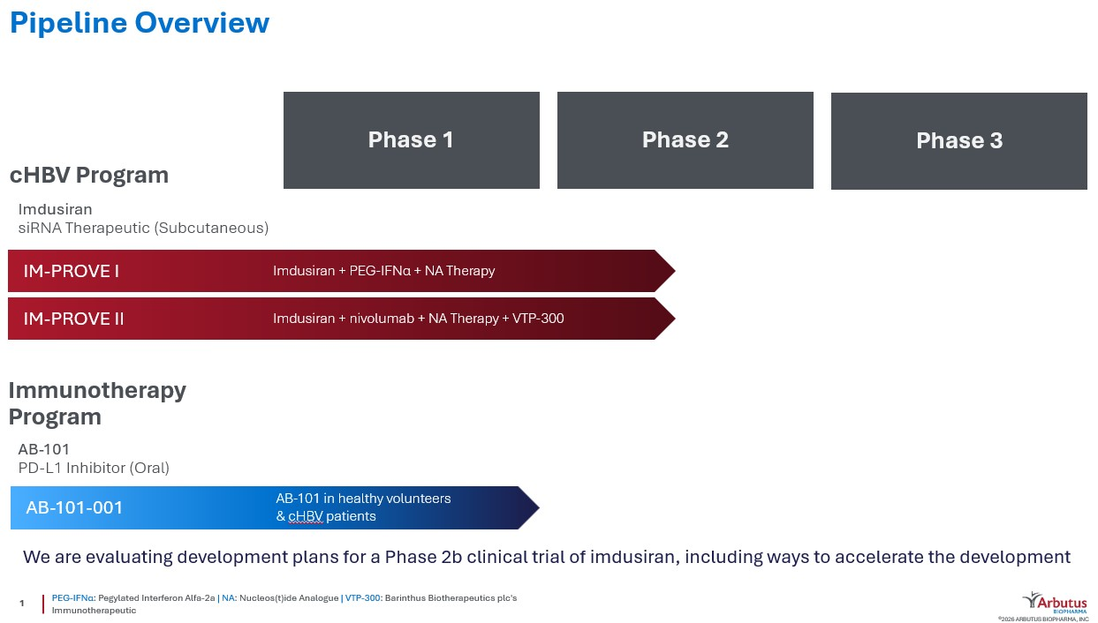

We continue to explore pipeline opportunities in the form of potential strategic alliances, in order to accelerate the development of these programs.

In April 2026, the FDA granted Fast Track designation for imdusiran for the treatment of cHBV. The FDA’s Fast Track program is designed to facilitate the development and expedite the review of investigational therapies to treat serious conditions where the investigational therapy demonstrates the potential to address unmet medical need. A drug granted Fast Track designation may be eligible for several benefits, including earlier and more frequent meetings and communications with the FDA and the potential for rolling review of its application. If relevant criteria are met, investigational therapies that receive Fast Track designation may also qualify for Accelerated Approval or Priority Review of a Biologics License Application or New Drug Application.

In May 2026, we reached alignment with the FDA on the design and safety parameters of a proposed Phase 2b clinical trial evaluating imdusiran for the treatment of cHBV. We intend to incorporate the FDA’s feedback into a final Phase 2b protocol.

RNAi therapeutic (imdusiran, AB-729)

RNAi therapeutics represent a significant advancement in drug development. RNAi therapeutics utilize a natural pathway within cells to effectively silence genes by eliminating the disease-causing proteins that they code for. We are developing an RNAi therapeutic, imdusiran, that is designed to reduce HBV DNA, HBV RNA, HBsAg and other HBV antigen expression in people with cHBV infection. Reducing HBsAg in addition to other viral proteins and HBV DNA are widely believed to be key prerequisites to potentiate a patient’s effective immune response against the virus.

Imdusiran has the following advantages over other RNAi therapeutics in development for cHBV infection:
–Targeted to hepatocytes using our proprietary covalently conjugated GalNAc delivery technology which provides highly efficient liver-targeted uptake and enables subcutaneous dosing.
23
–Unique nucleotide sequence that is single trigger and targets all HBV transcripts including HBx from cccDNA and integrated HBV DNA.
–Specific chemical modifications and unique asymmetric RNA structure that reduces off-target effects while maintaining/enhancing potency and providing durable liver exposure and in vivo therapeutic effect.
–Delivered at a low dose and infrequently (4, 8 or 12 week intervals).
–Immune activation properties with HBV-specific T-cell immune restoration and a decrease in exhausted T-cells in responder patients.

IM-PROVE I Phase 2a proof-of-concept clinical trial evaluating imdusiran in combination with IFN

We have completed IM-PROVE I, a randomized, open label, multicenter Phase 2a proof-of-concept clinical trial investigating the safety and antiviral activity of imdusiran in combination with a short course of IFN and ongoing NA therapy in 43 stably NA-suppressed, HBeAg negative, non-cirrhotic patients with cHBV infection. Our primary intent for this trial was to initially lower HBsAg and other viral proteins, HBV DNA and HBV RNA levels with imdusiran and then administer IFN as an immunomodulator to promote anti-HBV immune responses. Our belief in this trial was that if we can lower HBsAg, other viral proteins and HBV DNA levels and promote immune responses, we may achieve sustained HBsAg seroclearance and HBV DNA <LLOQ, potentially leading to a functional cure. After patients received 24-weeks of dosing with imdusiran (60mg every 8 weeks, 4 doses) plus ongoing NA therapy, patients were randomized into one of four cohorts to receive a short course of IFN for either 12 or 24 weeks plus ongoing NA therapy, with or without up to two additional doses of imdusiran across an additional 16 week period. After completion of the assigned IFN treatment period, all patients remained on NA therapy for a 24-week follow-up period, and then discontinued NA treatment, provided they met protocol-defined NA therapy discontinuation criteria. Patients who discontinued NA therapy entered an intensive follow-up period for 48 weeks.

Select key data from 12 patients in Cohort A1 of this Phase 2a clinical trial who received 6 doses of imdusiran, 24 weeks of IFN and ongoing NA therapy, as presented at the AASLD – The Liver Meeting in November 2024, include:

•50% (3/6) of patients with baseline HBsAg <1000 IU/mL achieved functional cure.
•Overall, 25% (3/12) of patients achieved functional cure.
•Those patients who achieved functional cure also seroconverted with anti-HBs levels increasing as patients lost HBsAg.

At the EASL Congress in May 2025, we presented a poster characterizing the demographics and virological markers of the six cHBV patients across dosing cohorts in the IM-PROVE I Phase 2a clinical trial who achieved functional cure. The data showed that HBsAg at baseline was the only apparent marker in common associated with functional cure. In a second poster, we reported that patients who achieved functional cure in the 24-week IFN treatment cohorts experienced HBsAg seroclearance associated with transient HBV RNA elevations that were preceded by or coincided with increases in immunological markers. At the AASLD – The Liver Meeting in November 2025, we presented new analysis from our IM-PROVE I Phase 2a clinical trial showing beneficial clinical outcomes were observed across all evaluated HBV genotypes (A to D).

Additionally, a total of 10 patients in IM-PROVE I who did not achieve functional cure were still able to remain off NA therapy for at least 48 weeks after discontinuing NA therapy following treatment with imdusiran. Across all cohorts and all baseline HBsAg levels, 37% (16/43) of patients either achieved functional cure or remained off NA therapy for at least 48 weeks after discontinuing NA therapy following treatment with imdusiran at 60mg.

These data from the IM-PROVE I trial suggest that the combination of imdusiran and IFN was generally safe and well-tolerated. There were no serious adverse events related to imdusiran, IFN or NA therapy, and no adverse events leading to discontinuation. The most common imdusiran-related treatment emergent adverse events (TEAEs) were injection site bruising and transient alanine aminotransferase elevations, which occurred in association with decreasing HBsAg levels and/or markers of immune activation, and which returned to baseline values in all instances. The IFN-related TEAEs were consistent with the known safety profile of IFN.

IM-PROVE II Phase 2a proof-of-concept clinical trial evaluating imdusiran in combination with Barinthus’ VTP-300

Through a clinical collaboration agreement with Barinthus that we entered into in July 2021, we completed IM-PROVE II, a Phase 2a proof-of-concept clinical trial evaluating the safety, antiviral activity and immunogenicity of a combination treatment with Barinthus’ VTP-300, an HBV immunotherapeutic, administered after imdusiran in patients with cHBV infection. The initial trial design enrolled 40 NA-suppressed, HBeAg negative or positive, non-cirrhotic cHBV infected patients. Our primary
24
intent for this trial was to initially lower HBsAg and other viral proteins, HBV DNA and HBV RNA levels with imdusiran and then administer VTP-300 as an immunomodulator to promote anti-HBV immune responses. All patients received imdusiran (60mg every 8 weeks, 4 doses) plus NA therapy for 24 weeks. After week 24, treatment with imdusiran was stopped. Patients continued only on NA therapy and were randomized to receive VTP-300 or placebo at week 26 and week 30. At week 48, all patients were evaluated for eligibility to discontinue NA therapy and were followed for an additional 24 to 48 weeks. Subsequently, we amended the IM-PROVE II clinical trial protocol to include another cohort that received imdusiran, VTP-300, NA therapy and low dose nivolumab, an approved PD-1 inhibitor in oncology. In this additional cohort, patients received imdusiran (60mg every 8 weeks, 4 doses) plus NA therapy for 24 weeks, followed by administration of VTP-300 plus up to two low doses of nivolumab while remaining on NA therapy. At week 48, all patients were evaluated for eligibility to discontinue NA therapy, and were followed for an additional 24 to 48 weeks.

The cohort that included low dose nivolumab was the best performing cohort in the IM-PROVE II clinical trial. At the AASLD – The Liver Meeting in November 2024, we presented data from this clinical trial showing that the addition of low dose nivolumab increased rates of HBsAg seroclearance in cHBV patients and that 23% (3/13) of patients who received the treatment regimen with low dose nivolumab achieved HBsAg seroclearance by week 48. At the EASL Congress in May 2025, we presented data showing that 25% (2/8) of patients with low dose nivolumab added to the treatment regimen and with baseline HBsAg<1000 IU/mL achieved functional cure.

Additionally, a total of 31 patients in IM-PROVE II who did not achieve functional cure were still able to remain off NA therapy for at least 48 weeks after discontinuing NA therapy following treatment with imdusiran at 60mg. A total of 53% (33/62) of patients either achieved functional cure or remained off NA therapy for at least 48 weeks after discontinuing NA therapy following treatment with imdusiran at 60mg, across all cohorts and all baseline HBsAg levels, and both HBeAg negative and positive patients. Treatment with imdusiran, VTP-300, NA therapy and low dose nivolumab in this clinical trial was generally safe and well-tolerated. There were no serious adverse events, immune-related adverse events, or discontinuations due to adverse events.

The IM-PROVE II clinical trial was managed by us, subject to oversight by a joint development committee comprised of representatives from both companies. We and Barinthus retained full rights to our respective product candidates and split all costs associated with the clinical trial. Pursuant to the agreement, the parties could have undertaken a larger Phase 2b clinical trial depending on the results of the initial Phase 2a clinical trial. However, in January 2025, Barinthus announced a shift in its strategic business focus that included postponing further development of VTP-300. The parties do not intend to undertake a larger Phase 2b with this combination treatment regimen.

At the AASLD - The Liver Meeting in November 2025, we presented cumulative data across all of our imdusiran clinical trials demonstrating that imdusiran was safe and well-tolerated at all tested repeat doses of 60mg or 90mg, and that beneficial clinical outcomes in our Phase 2a clinical trials were potentially linked to immune reawakening in patients.

Imdusiran Treatment Without Immunotherapeutic

In our single and multiple ascending dose Phase 1b clinical trial for imdusiran, we enrolled HBeAg negative and positive patients, as well as HBV DNA positive patients not on NA therapy. Across all arms, which included doses up to 180mg, 71% (44/62) of patients achieved HBsAg levels below 100 IU/mL, including 5% (3/62) of patients who achieved HBsAg seroclearance. Additionally, 56% (5/9) of patients who elected to discontinue NA therapy remained off NA therapy for at least three years after discontinuation. Furthermore, all patients in all imdusiran clinical trials showed significant early decreases in HBsAg levels, often observed after the first or second dose of imdusiran. In Group B of IM-PROVE II, after just 24 weeks of imdusiran dosing at just 60mg with only background NA therapy and no other combination agent, 37% (7/19) of patients were able to remain off NA therapy for at least 48 weeks after discontinuing NA therapy, including one patient who achieved HBsAg seroclearance. Based on the effect imdusiran alone appears to have on reducing HBsAg levels and suppressing HBV DNA and HBV RNA replication, we are also evaluating imdusiran as a treatment without any immunotherapeutic.

Oral PD-L1 Inhibitor (AB-101)

PD-L1 inhibitors complement our pipeline of agents and could potentially be an important part of a combination therapy for the treatment of HBV by activating the immune system. Highly functional HBV-specific T-cells within our immune system are believed to be required for long-term HBV viral resolution. However, HBV-specific T-cells become functionally defective, and greatly reduced in number during cHBV infection. One approach to boost HBV-specific T-cells is to prevent PD-L1 proteins from binding to PD-1, which would otherwise lead to inhibition of the HBV-specific immune function of T-cells.

25
AB-101 is our proprietary oral small-molecule PD-L1 inhibitor candidate that we believe will allow for controlled checkpoint blockade while minimizing the systemic safety issues often seen with checkpoint inhibitor antibody therapies. AB-101 is differentiated from monoclonal antibody checkpoint inhibitors such as durvalumab (anti-PD-L1) and nivolumab (anti-PD-1) because it is liver centric, has a much shorter duration of effect in preclinical models (which may provide dosing and safety advantages), and has a novel mechanism of action as it binds to PD-L1 on the surface of cells causing dimerization, internalization and degradation of the PD-L1 protein.

Phase 1a/1b clinical trial to evaluate safety, tolerability and PK/PD of AB-101 (AB-101-001)

AB-101-001 is a Phase 1a/1b clinical trial designed to investigate the safety, tolerability and PK/PD of single and multiple-ascending oral doses of AB-101 for up to 28 days in healthy subjects and patients with cHBV infection. The trial consisted of three parts starting with single ascending doses in healthy subjects, followed by multiple ascending doses in healthy subjects and culminating with multiple doses in patients with cHBV infection. Safety and PK/PD assessments were performed prior to dose escalation in all parts of the clinical trial.

Part 1 of this clinical trial enrolled five sequential cohorts of eight healthy subjects each (6 active: 2 placebo) receiving a single dose of AB-101 at increasing dose levels. In Part 1, all five evaluable subjects in the 40mg cohort showed evidence of 100% receptor occupancy. Part 2 of this clinical trial enrolled three sequential cohorts of ten healthy subjects that each received 10, 25 or 40mg of AB-101 (8 active: 2 placebo) daily for seven days. In Part 2, all subjects in the 40mg cohort showed evidence of high receptor occupancy between 74-100%, with six of the eight subjects demonstrating 100% receptor occupancy during the seven-day dosing period. Across Parts 1 and 2, eleven of the thirteen evaluable healthy subjects that received either single or multiple doses of 40mg of AB-101 achieved 100% receptor occupancy. The data from Part 1 and Part 2 showed that AB-101 was well-tolerated with evidence of high receptor occupancy.

Part 3 of this clinical trial evaluated repeat doses of AB-101 for 28 days in 20 patients with cHBV. At the EASL Congress in May 2025, we presented data showing that a single dose of 10mg of AB-101 for 28 days in cHBV patients was well tolerated with PD-L1 receptor occupancy similar to that seen in healthy subjects at this dose. At the AASLD - The Liver Meeting in November 2025, we presented a Poster of Distinction highlighting maximal PD-L1 receptor occupancy between 68-100% at the 30mg daily dose. Two patients experienced HBsAg declines of 86.4% and 98.8%, respectively. Treatment with AB-101 in Part 3 of this clinical trial was generally safe and well-tolerated. There were no serious adverse events related to AB-101 and no evidence of liver dysfunction.

Other Collaborations, Royalty Entitlements and Intellectual Property Litigation

Collaboration with Qilu Pharmaceutical Co., Ltd. (Qilu)

In December 2021, we entered into a technology transfer and license agreement (the Qilu License Agreement) with Qilu, pursuant to which we granted Qilu a sublicensable, royalty-bearing license, under certain intellectual property owned by us, which was non-exclusive as to development and manufacturing and exclusive with respect to commercialization of imdusiran, including pharmaceutical products that include imdusiran, for the treatment or prevention of HBV in China, Hong Kong, Macau and Taiwan (Greater China and Taiwan).

In partial consideration for the rights granted by us, Qilu paid us a one-time upfront cash payment of $40 million on January 5, 2022 and agreed to pay us up to $245 million, net of withholding taxes, upon the achievement of certain technology transfer, development, regulatory and commercialization milestones. Qilu also agreed to pay us double-digit royalties into the low twenties percent based upon annual net sales of imdusiran in Greater China and Taiwan. The royalties were to be payable on a product-by-product and region-by-region basis, subject to certain limitations.

Qilu was responsible for all costs related to developing, obtaining regulatory approval for, and commercializing imdusiran for the treatment or prevention of HBV in Greater China and Taiwan. Qilu was required to use commercially reasonable efforts to develop, seek regulatory approval for, and commercialize at least one imdusiran product candidate in Greater China and Taiwan. A joint development committee was established between us and Qilu to coordinate and review the development, manufacturing and commercialization plans. Both parties also entered into a supply agreement and related quality agreement pursuant to which we would manufacture and supply Qilu with all quantities of imdusiran necessary for Qilu to develop and commercialize in Greater China and Taiwan until we had completed manufacturing technology transfer to Qilu and Qilu had received all approvals required for it or its designated contract manufacturing organization to manufacture imdusiran in Greater China and Taiwan.

26
Concurrent with the execution of the Qilu License Agreement, we entered into a Share Purchase Agreement (the Share Purchase Agreement) with Anchor Life Limited, a company established pursuant to the applicable laws and regulations of Hong Kong and an affiliate of Qilu (the Investor), pursuant to which the Investor purchased 3,579,952 of our common shares at a purchase price of USD $4.19 per share, which was a 15% premium on the thirty-day average closing price of our common shares as of the close of trading on December 10, 2021 (the Share Transaction). We received $15.0 million of gross proceeds from the Share Transaction on January 6, 2022. The common shares sold to the Investor in the Share Transaction represented approximately 2.5% of our common shares outstanding immediately prior to the execution of the Share Purchase Agreement.

In June 2025, we and Qilu mutually agreed to conclude our strategic partnership and terminate the Qilu License Agreement and related agreements, and we now once again hold global rights for imdusiran. As no obligations remained under the Qilu License Agreement, we recognized all previously deferred revenue in the second quarter of 2025.

Alnylam Pharmaceuticals, Inc. (Alnylam) and Acuitas Therapeutics, Inc. (Acuitas)

In 2012, we entered into a license agreement with Alnylam that entitles Alnylam to develop and commercialize products with our LNP technology in exchange for milestone and royalty payments. We have two royalty entitlements to global net sales of ONPATTRO® (Patisiran) (ONPATTRO), an RNA interference therapeutic currently being sold by Alnylam. In addition, we are entitled to receive payments upon the achievement of contractual milestones related to Alnylam’s use of our proprietary LNP technology in other products.

Alnylam’s ONPATTRO, which represents the first approved application of our LNP technology, was approved by the FDA and the European Medicines Agency (EMA) during the third quarter of 2018 and was launched by Alnylam immediately upon approval in the United States. Under the terms of this license agreement, we are entitled to tiered royalty payments on global net sales of ONPATTRO ranging from 1.00% - 2.33% after offsets, with the highest tier applicable to annual net sales above $500 million. This royalty interest was sold to the Ontario Municipal Employees Retirement System (OMERS), effective as of January 1, 2019, for $20 million in gross proceeds before advisory fees. OMERS will retain this entitlement until it has received $30 million in royalties, at which point 100% of this royalty entitlement on future global net sales of ONPATTRO will revert to us. OMERS has assumed the risk of collecting up to $30 million of future royalty payments from Alnylam and we are not obligated to reimburse OMERS if it fails to collect any such future royalties. If this royalty entitlement reverts to us, it has the potential to provide an active royalty stream or to be otherwise monetized again in full or in part. From the inception of the royalty sale through June 30, 2026, an aggregate of $26.9 million of royalties have been earned by OMERS.

We also are receiving a second royalty interest ranging from 0.75% to 1.125% on global net sales of ONPATTRO, with 0.75% applying to sales greater than $500 million, originating from a settlement agreement and subsequent license agreement with Acuitas. This royalty entitlement from Acuitas has been retained by us and was not part of the royalty entitlement sale to OMERS.

In 2025, Alnylam began using our proprietary LNP technology in a product candidate to treat hepatocellular carcinoma (HCC), underscoring the important role our LNP technology plays in the delivery of nucleic acids to the body.

Genevant Sciences, Ltd.

In April 2018, we entered into an agreement with Roivant Sciences Ltd. (Roivant), our largest shareholder, to launch Genevant Sciences Ltd., a company focused on nucleic acid- and gene editing-based therapeutics enabled by our LNP and ligand conjugate delivery technologies. We licensed rights to our LNP and ligand conjugate delivery platforms to Genevant outside of HBV, except to the extent certain rights had already been licensed to other third parties (the Genevant License). We retained all rights to our LNP and conjugate delivery platforms for HBV.

Under the Genevant License, as amended, if a third-party sublicensee of intellectual property licensed by Genevant from us commercializes a sublicensed product, we become entitled to receive a specified percentage of certain revenue that may be received by Genevant for such sublicense, including royalties, commercial milestones and other sales-related revenue, or, if less, tiered low single-digit royalties on net sales of the sublicensed product. The specified percentage is 20% in the case of a mere sublicense (i.e., naked sublicense) by Genevant without additional contribution and 14% in the case of a bona fide collaboration with Genevant.

Additionally, if Genevant receives proceeds from an action for infringement by any third parties of our intellectual property licensed to Genevant, we would be entitled to receive, after deduction of litigation costs, 20% of the proceeds received by
27
Genevant or, if less, tiered low single-digit royalties on net sales of the infringing product (inclusive of the proceeds from litigation or settlement, which would be treated as net sales).

In July 2020, Roivant recapitalized Genevant through an equity investment and conversion of previously issued convertible debt securities held by Roivant. We participated in the recapitalization of Genevant with an equity investment of $2.5 million. In connection with the recapitalization, the three parties entered into an Amended and Restated Shareholders Agreement that provides Roivant with substantial control of Genevant. We have the right to have a non-voting observer attend meetings of Genevant’s Board of Directors.

As of June 30, 2026, we owned approximately 16% of the outstanding common equity of Genevant and the carrying value of our investment in Genevant was zero. Our entitlement to receive future royalties or sublicensing revenue from Genevant was not impacted by the recapitalization.

Under the terms of the Moderna Settlement Agreement, Moderna made an aggregate $950.0 million Noncontingent Settlement Payment to us and Genevant on July 8, 2026. We received $178.4 million on July 8, 2026 as our share of the Noncontingent Settlement Payment, which included reimbursement of our litigation costs. In addition, Moderna is obligated to make an additional Contingent Settlement Payment of up to an aggregate $1.3 billion to us and Genevant upon the occurrence of certain events related to the Moderna §1498 Appeal, but which may be subject to repayment. The Company anticipates the payment of a material dividend from Genevant in the third quarter of calendar year 2026.

In March 2025, we and Genevant entered into an agreement (the RSV Agreement) that provided that we would be entitled to any award of damages in, or proceeds from the settlement of, our patent litigation against Moderna that was specifically allocated to infringing acts related to Moderna’s vaccine for respiratory syncytial virus (mRESVIA) and, in the event there was no such specific allocation to mRESVIA, we and Genevant would discuss an appropriate allocation in good faith. The Moderna Settlement Agreement did not specifically allocate any settlement proceeds to infringing acts related to mRESVIA. On July 15, 2026, we and Genevant entered into an agreement to terminate the RSV Agreement (the RSV Termination Agreement). Pursuant to the RSV Termination Agreement, we received a termination fee of $1.0 million from Genevant on July 21, 2026, and all rights or obligations under the RSV Agreement were terminated.

Patent Infringement Litigation vs. Pfizer and BioNTech

On April 4, 2023, we and Genevant filed a lawsuit in the United States District Court for the District of New Jersey against Pfizer/BioNTech seeking damages for infringement of United States Patent Nos. 9,504,651; 8,492,359; 11,141,378; 11,298,320; and 11,318,098 in the manufacture and sale of any COVID-19 mRNA-LNP vaccines. The patents relate to nucleic acid-lipid particles and their composition, manufacture, delivery and methods of use. In the lawsuit, we seek fair compensation for Pfizer’s and BioNTech’s use of our patented technology that was developed with great effort and at great expense, without which their COVID-19 mRNA-LNP vaccines would not have been successful. The claim construction hearing occurred in December 2024, and in September 2025, the court issued a claim construction ruling, which construed the disputed claim terms in a manner we generally consider to be favorable. The parties are awaiting further scheduling in the litigation.

In July 2026, we, along with Genevant, filed three international lawsuits seeking to enforce patents protecting our LNP technology against Pfizer/BioNTech and certain of their affiliates. We and Genevant are seeking monetary relief, as well as injunctions against Pfizer/BioNTech’s COVID-19 mRNA-LNP vaccines and any other products that would infringe the asserted patents.

The three international lawsuits are as follows:
•Canada: Federal Court of Canada File No. T-3200-26, seeking a permanent injunction and damages or, if Arbutus and Genevant elect, an accounting of Pfizer/BioNTech’s profits, attributable to infringement of Canadian Patent No. 2,721,333
•Unified Patent Court (UPC): Case UPC-CFI-0002562/2026, seeking permanent injunctions, as well as monetary damages, which can include recovery of Pfizer/BioNTech’s unfair profits from infringement of EP 4 241 767
•UPC: Case UPC-CFI-0002566/2026, seeking permanent injunctions, as well as monetary damages, which can include recovery of Pfizer/BioNTech’s unfair profits from infringement of EP 4 495 237
The UPC actions seek relief for infringing activities by Pfizer/BioNTech and certain of their affiliates in Austria, Belgium, Bulgaria, Denmark, Estonia, Finland, France, Germany, Italy, Latvia, Lithuania, Luxembourg, Malta, the Netherlands, Poland, Portugal, Romania, Slovenia, Spain, and Sweden.
28

Patent Infringement Litigation vs. Moderna

On February 28, 2022, we and Genevant filed a lawsuit in the United States District Court for the District of Delaware against Moderna seeking damages for infringement of United States Patent Nos. 8,058,069, 8,492,359, 8,822,668, 9,364,435, 9,504,651, and 11,141,378 in the manufacture and sale of MRNA-1273, Moderna’s vaccine for COVID-19. On March 3, 2025, we and Genevant filed five international lawsuits against Moderna seeking to enforce patents protecting our patented LNP technology. Together, these lawsuits comprise the Moderna LNP Litigation.

On March 3, 2026, we and Genevant entered into the Moderna Settlement Agreement with Moderna to resolve the Moderna LNP Litigation. Pursuant to the Moderna Settlement Agreement, all parties filed stipulated judgments and stipulations of dismissal for the respective courts or tribunals to enter judgment, dismiss with prejudice or withdraw (as the case may be) all claims in the Moderna LNP Litigation, except that Moderna was allowed to file the Moderna §1498 Appeal. The Moderna §1498 Appeal is an appeal of the consent judgment entered in the District Court solely with respect to whether §1498 bars our and Genevant’s claims for direct infringement and indirect infringement against Moderna for vaccine doses that were sold to the United States Government under a particular contract and characterized by the District Court as “vaccines that did not go directly to United States Government employees.”

Under the terms of the Moderna Settlement Agreement, Moderna made an aggregate $950.0 million Noncontingent Settlement Payment to us and Genevant on July 8, 2026. We received $178.4 million on July 8, 2026 as our share of the Noncontingent Settlement Payment, which included reimbursement of our litigation costs.

In addition, as described in more detail in, and subject to the terms of, the Moderna Settlement Agreement, Moderna will make an additional Contingent Settlement Payment of an aggregate $1.3 billion to us and Genevant (i) if the Court of Appeals for the Federal Circuit (whether by the initial panel, upon panel rehearing or en banc) affirms, or if there is a final non-appealable judgment that affirms, the rejection of Moderna’s affirmative defense pursuant to §1498 by the District Court in its entirety or otherwise holds that §1498 does not bar our and Genevant’s claim against Moderna as to either or both of direct infringement and indirect infringement with respect to all of the doses subject to the Moderna §1498 Appeal, or (ii) upon a voluntary dismissal of the Moderna §1498 Appeal (any of the foregoing (clause (i) or (ii) above), an Arbutus/Genevant §1498 Victory). If an appellate ruling were to hold that §1498 bars our and Genevant’s infringement claims as to some, but not all, of the doses subject to the Moderna §1498 Appeal, the Moderna Settlement Agreement provides that Moderna will pay us and Genevant a prorated amount of the Contingent Settlement Payment, calculated based on the number of doses for which §1498 bars our and Genevant’s infringement claims as clearly articulated by the Federal Circuit or, if not clearly articulated by the Federal Circuit, as mutually agreed by the parties or determined in an accelerated binding arbitration process.

Under certain circumstances, as described in more detail in, and subject to the terms of, the Moderna Settlement Agreement, if the Arbutus/Genevant §1498 Victory is subsequently overturned in Moderna’s favor in a final nonappealable decision, we and Genevant are required to return any Contingent Settlement Payment to Moderna, plus interest. If, following an Arbutus/Genevant §1498 Victory, either (i) Moderna does not timely appeal such Arbutus/Genevant §1498 Victory or (ii) such Arbutus/Genevant §1498 Victory is subsequently affirmed in a final nonappealable decision, Moderna will have no further right to a potential repayment of the Contingent Settlement Payment.

The Moderna Settlement Agreement includes mutual financial covenants to protect the payment or repayment of the Contingent Settlement Payment, as described above.

The Moderna Settlement Agreement also contains customary mutual releases in favor of each of us/Genevant and Moderna in respect of the Moderna LNP Litigation. In addition, the Moderna Settlement Agreement includes a fully paid-up, royalty free, irrevocable, non-exclusive, worldwide license and covenant not to sue granted to Moderna under any patents and patent applications owned or licensable by us or Genevant or our respective direct and indirect wholly owned subsidiaries that exist, or that claim priority to patents or patent applications that exist, as of the effective date of the Moderna Settlement Agreement, to make, sell and generally otherwise exploit Moderna’s SPIKEVAX™, mNEXSPIKE™ and mRESVIA™ vaccines and any other mRNA vaccines that include a lipid SM-102-based LNP formulation against an infectious disease and meet certain conditions, as well as a covenant not to sue with respect to certain other of our and Genevant’s patents and Moderna products.

On March 19, 2026, we and Genevant filed a complaint against the United States in the United States Court of Federal Claims, seeking to recover compensation for Moderna’s infringement for vaccine doses that were sold to the United States Government under a particular contract and were deemed by the District Court to be doses that were provided directly to United States Government employees. The complaint also includes a protective request to recover compensation from the United States for any other vaccine doses where, as a result of the Moderna §1498 Appeal, §1498 is deemed to bar our and Genevant’s claims for direct infringement and indirect infringement against Moderna.
29

Moderna and Merck European Oppositions

On April 5, 2018, Moderna and Merck, Sharp & Dohme Corporation (together with its successors and affiliates, Merck) filed Notices of Opposition to our European patent EP 2279254 (the ’254 Patent) with the European Patent Office (EPO), requesting that the ’254 Patent be revoked in its entirety for all contracting states. From 2018 until 2024, various hearings were held by different divisions of the EPO regarding requests submitted by all parties. Oral proceedings were held in June 2024, and the Opposition Division of the EPO upheld the ’254 Patent but declined our and Genevant’s request to broaden certain claims in the ’254 Patent. Both parties appealed the Opposition Division’s decision, and on January 15, 2026, in a verbal decision, the Board of Appeal of the EPO revoked the ’254 Patent. We are awaiting a written decision from the Board of Appeal of the EPO regarding the revocation. We disagree with the outcome, and upon receipt of the written decision, we plan to file a petition for review by the Enlarged Board of Appeal of the EPO. The revocation was based on an EPO standard of “added matter” that does not apply in the United States. In March 2026, pursuant to the Moderna Settlement Agreement, Moderna withdrew from this revocation proceeding. In May 2026, we entered into an agreement with Merck (the Merck Agreement) where we, among other things, acknowledged that the Moderna Settlement Agreement covered a vaccine being jointly developed by Moderna and Merck and we agreed not to sue Merck regarding such vaccine, in exchange for Merck withdrawing from the revocation proceeding. On May 6, 2026, Merck withdrew from this revocation proceeding. We do not expect the EPO revocation decision to have an impact on the potential outcome, or timing, of our patent infringement litigation pending against Pfizer/BioNTech.

On April 29, 2025, Moderna filed a revocation action on our European patent EP 4241767 (the ’767 patent) with the EPO, requesting that the patent be revoked in its entirety for all contracting states. In July 2025, Merck, Arrowhouse GmbH and Keltie LLP filed three additional revocation actions against the ’767 patent. Initial briefing has been completed and we are currently awaiting an initial hearing date. In March 2026, pursuant to the Moderna Settlement Agreement, Moderna withdrew from this revocation proceeding. On May 6, 2026, pursuant to the Merck Agreement, Merck withdrew from this revocation proceeding.

While we are the patent owner, the ’254 Patent, the ’767 Patent, and the other patents in our LNP portfolio have been licensed to Genevant under the Genevant License.

Potential Additional Payments Related to the Acquisition of Enantigen Therapeutics, Inc.

In October 2014, Arbutus Inc., our wholly-owned subsidiary, acquired all of the outstanding shares of Enantigen Therapeutics, Inc. (Enantigen) pursuant to a stock purchase agreement. The amount paid to Enantigen’s selling shareholders could be up to an additional $102.5 million in sales performance milestones in connection with the sale of the first commercialized product by us for the treatment of HBV, regardless of whether such product is based upon assets acquired under this stock purchase agreement, and a low single-digit royalty on net sales of such first commercialized HBV product, up to a maximum royalty payment of $1.0 million that, if paid, would be offset against our performance milestone payment obligations.

30

CRITICAL ACCOUNTING POLICIES AND SIGNIFICANT JUDGMENTS AND ESTIMATES

This management’s discussion and analysis of our financial condition and results of operations is based on our condensed consolidated financial statements, which have been prepared in accordance with United States generally accepted accounting principles. The preparation of these financial statements requires us to make estimates and assumptions that affect the reported amounts of assets, liabilities, revenues, and expenses. Our estimates are based on our historical experience and on various other factors that we believe are reasonable under the circumstances, the results of which form the basis for making judgments about the carrying value of assets and liabilities that are not readily apparent from other sources. Actual results may differ from these estimates under different assumptions or conditions.

We believe there have been no significant changes in our critical accounting policies and estimates as discussed in “Item 7. Management’s Discussion and Analysis of Financial Condition and Results of Operations” of our Annual Report on Form 10-K for the year ended December 31, 2025.

RECENT ACCOUNTING PRONOUNCEMENTS

From time to time, new accounting pronouncements are issued by the Financial Accounting Standards Board or other standard setting bodies that are adopted by us as of the specified effective date. Unless otherwise discussed, we believe that the impact of recently issued standards that are not yet effective will not have a material impact on our financial position or results of operations upon adoption.

Please refer to Note 2 to our condensed consolidated financial statements included in “Part I, Item 1-Financial Statements (Unaudited)” of this Form 10-Q for a description of recent accounting pronouncements applicable to our business.

RESULTS OF OPERATIONS

The following summarizes the results of our operations for the periods shown:
 |  |  | Three Months Ended June 30, |  |  |  |  |  |  |  |  |  |  |  | Six Months Ended June 30,
 |  |  | 2026 |  |  |  |  |  | 2025 |  |  |  |  |  | 2026 |  |  |  |  |  | 2025
 |  |  | (in thousands)
Total revenue |  |  | $ | 1,014 |  |  |  |  | $ | 10,739 |  |  |  |  | $ | 180,140 |  |  |  |  | $ | 12,503
Operating expenses |  |  | 6,978 |  |  |  |  |  | 9,251 |  |  |  |  |  | 17,196 |  |  |  |  |  | 36,714
(Loss) income from operations |  |  | (5,964) |  |  |  |  |  | 1,488 |  |  |  |  |  | 162,944 |  |  |  |  |  | (24,211)
Other income |  |  | 821 |  |  |  |  |  | 1,035 |  |  |  |  |  | 1,608 |  |  |  |  |  | 2,208
Net (loss) income |  |  | $ | (5,143) |  |  |  |  | $ | 2,523 |  |  |  |  | $ | 164,552 |  |  |  |  | $ | (22,003)

31

Revenue

Revenues are summarized in the following tables:
 |  |  | Three Months Ended June 30,
 |  |  | 2026 |  |  |  |  |  | % of Total |  |  |  |  |  | 2025 |  |  |  |  |  | % of Total
 |  |  | (in thousands, except percentages)
Revenue from collaborations and licenses
Acuitas Therapeutics, Inc. |  |  | $ | 202 |  |  |  |  | 20 |  | % |  |  |  | $ | 591 |  |  |  |  | 6 |  | %
Qilu Pharmaceutical Co., Ltd. |  |  | — |  |  |  |  |  | — |  | % |  |  |  | 9,622 |  |  |  |  |  | 90 |  | %
License revenue from Genevant |  |  | 632 |  |  |  |  |  | 62 |  | % |  |  |  | — |  |  |  |  |  | — |  | %
Non-cash royalty revenue
Alnylam Pharmaceuticals, Inc. |  |  | 180 |  |  |  |  |  | 18 |  | % |  |  |  | 526 |  |  |  |  |  | 5 |  | %
Total revenue |  |  | $ | 1,014 |  |  |  |  | 100 |  | % |  |  |  | $ | 10,739 |  |  |  |  | 100 |  | %
 |  |  | Six Months Ended June 30,
 |  |  | 2026 |  |  |  |  |  | % of Total |  |  |  |  |  | 2025 |  |  |  |  |  | % of Total
 |  |  | (in thousands, except percentages)
Revenue from collaborations and licenses
Acuitas Therapeutics, Inc. |  |  | $ | 406 |  |  |  |  | — |  | % |  |  |  | $ | 1,095 |  |  |  |  | 9 |  | %
Qilu Pharmaceutical Co., Ltd. |  |  | — |  |  |  |  |  | — |  | % |  |  |  | 10,434 |  |  |  |  |  | 83 |  | %
License revenue from Genevant |  |  | 179,373 |  |  |  |  |  | 100 |  | % |  |  |  | — |  |  |  |  |  | — |  | %
Non-cash royalty revenue
Alnylam Pharmaceuticals, Inc. |  |  | 361 |  |  |  |  |  | — |  | % |  |  |  | 974 |  |  |  |  |  | 8 |  | %
Total revenue |  |  | $ | 180,140 |  |  |  |  | 100 |  | % |  |  |  | $ | 12,503 |  |  |  |  | 100 |  | %

Total revenue decreased $9.7 million for the three months ended June 30, 2026 compared to the same period in 2025, due primarily to recognizing all $9.6 million of previously deferred revenue upon the conclusion of our strategic partnership with Qilu in 2025.

Total revenue increased $167.6 million for the six months ended June 30, 2026 compared to the same period in 2025, primarily due to recognizing revenue of $178.4 million for our share of the Noncontingent Settlement Payment in 2026, partially offset by recognizing all $9.6 million of previously deferred revenue upon the conclusion of our strategic partnership with Qilu in 2025.

32

Operating expenses

Operating expenses are summarized in the following tables:
 |  |  | Three Months Ended June 30,
 |  |  | 2026 |  |  |  |  |  | % of Total |  |  |  |  |  | 2025 |  |  |  |  |  | % of Total
 |  |  | (in thousands, except percentages)
Research and development |  |  | $ | 2,898 |  |  |  |  | 42 |  | % |  |  |  | $ | 5,498 |  |  |  |  | 59 |  | %
General and administrative |  |  | 3,867 |  |  |  |  |  | 55 |  | % |  |  |  | 3,328 |  |  |  |  |  | 36 |  | %
Change in fair value of contingent consideration |  |  | 213 |  |  |  |  |  | 3 |  | % |  |  |  | 260 |  |  |  |  |  | 3 |  | %
Restructuring costs |  |  | — |  |  |  |  |  | — |  | % |  |  |  | 165 |  |  |  |  |  | 2 |  | %
Total operating expenses |  |  | $ | 6,978 |  |  |  |  | 100 |  | % |  |  |  | $ | 9,251 |  |  |  |  | 100 |  | %
 |  |  | Six Months Ended June 30,
 |  |  | 2026 |  |  |  |  |  | % of Total |  |  |  |  |  | 2025 |  |  |  |  |  | % of Total
 |  |  | (in thousands, except percentages)
Research and development |  |  | $ | 7,018 |  |  |  |  | 41 |  | % |  |  |  | $ | 14,457 |  |  |  |  | 39 |  | %
General and administrative |  |  | 9,756 |  |  |  |  |  | 57 |  | % |  |  |  | 9,160 |  |  |  |  |  | 25 |  | %
Change in fair value of contingent consideration |  |  | 422 |  |  |  |  |  | 2 |  | % |  |  |  | 559 |  |  |  |  |  | 2 |  | %
Restructuring costs |  |  | — |  |  |  |  |  | — |  | % |  |  |  | 12,538 |  |  |  |  |  | 34 |  | %
Total operating expenses |  |  | $ | 17,196 |  |  |  |  | 100 |  | % |  |  |  | $ | 36,714 |  |  |  |  | 100 |  | %

Research and development

Research and development expenses consist primarily of personnel expenses, fees paid to clinical research organizations and contract manufacturers, consumables and materials, consulting, and other third-party expenses to support our clinical and preclinical activities, as well as a portion of stock-based compensation and general overhead costs.

Research and development expenses decreased $2.6 million and $7.4 million for the three and six months ended June 30, 2026, respectively, compared to the same periods in 2025. The decreases were due primarily to cost savings from our decisions to reduce our workforce and discontinue in-house scientific research, as well as lower clinical trial costs as studies neared completion.

A significant portion of our research and development expenses are not tracked by project as they benefit multiple projects or our technology platform and because our most-advanced programs are not yet in late-stage clinical development.

General and administrative

General and administrative expenses increased $0.5 million for each of the three and six months ended June 30, 2026 as compared to the same periods in 2025, due primarily to an increase in litigation-related legal fees driven by the settlement with Moderna, partially offset by cost-cutting efforts by the Company, which drove reductions in employee compensation-related expenses.

33

Change in fair value of contingent consideration

Contingent consideration is a liability related to our acquisition of Enantigen Therapeutics, Inc. in October 2014. In general, as time passes and assuming no changes to the assumptions related to the contingency, the fair value of the contingent consideration increases as the progress of our programs gets closer to triggering contingent payments based on certain sales milestones of our first commercial product for cHBV. As imdusiran continues to progress through clinical trials, we will adjust our assumptions regarding probability of success commensurate with the progression of the program, which will increase the fair value of the liability.

Restructuring

In March 2025, our Board took action to reduce our workforce by 57%. The Board also decided to exit our corporate headquarters in Warminster, Pennsylvania and to discontinue in-house scientific research. In connection with these actions, we incurred a one-time restructuring charge in the first half of 2025 of $12.5 million, which includes approximately $6.1 million of cash severance and continued benefits paid, $2.4 million of non-cash expense related to the modification of equity awards, non-cash impairment charges for leasehold improvements and laboratory equipment of $1.9 million and $0.9 million, respectively, $0.9 million related to impairment of the right-of-use asset associated with the lease of our corporate headquarters and a $0.4 million accrual of lease-related operating expenses.

As of June 30, 2026, there was an aggregate of $0.2 million of accrued restructuring costs for medical benefits and lease-related operating expenses included in accounts payable and accrued liabilities.

Other income (loss)

The components of our other income (loss) are summarized in the following table:
 |  |  | Three Months Ended June 30, |  |  |  |  |  |  |  |  |  |  |  | Six Months Ended June 30,
 |  |  | 2026 |  |  |  |  |  | 2025 |  |  |  |  |  | 2026 |  |  |  |  |  | 2025
 |  |  | (in thousands)
Interest income |  |  | $ | 842 |  |  |  |  | $ | 1,042 |  |  |  |  | $ | 1,657 |  |  |  |  | $ | 2,239
Interest expense |  |  | (18) |  |  |  |  |  | (28) |  |  |  |  |  | (35) |  |  |  |  |  | (56)
Foreign exchange (loss) gain |  |  | (3) |  |  |  |  |  | 21 |  |  |  |  |  | (14) |  |  |  |  |  | 25
Total other income |  |  | $ | 821 |  |  |  |  | $ | 1,035 |  |  |  |  | $ | 1,608 |  |  |  |  | $ | 2,208

Interest income

The decrease in interest income for the three and six months ended June 30, 2026 compared to the same periods in 2025 was due primarily to less interest earned on our cash and investment balances due to a lower average balance and a general decrease in market interest rates.

Interest expense

Interest expense for the three and six months ended June 30, 2026 and 2025 consisted primarily of non-cash amortization of discount and issuance costs related to the sale of a portion of our ONPATTRO royalty interest to OMERS in July 2019. The decrease is related to the declining balance of the unamortized discount and issuance costs.

34

LIQUIDITY AND CAPITAL RESOURCES

The following table summarizes our cash flow activities for the periods indicated:
 |  |  | Six Months Ended June 30,
 |  |  | 2026 |  |  |  |  |  | 2025
 |  |  | (in thousands)
Net income (loss) |  |  | $ | 164,552 |  |  |  |  | $ | (22,003)
Non-cash items |  |  | 2,422 |  |  |  |  |  | 5,834
Change in deferred license revenue |  |  | — |  |  |  |  |  | (10,434)
Receivable from Genevant license |  |  | (179,373) |  |  |  |  |  | —
Net change in other operating items |  |  | (1,729) |  |  |  |  |  | (2,537)
Net cash used in operating activities |  |  | (14,128) |  |  |  |  |  | (29,140)
Net cash provided by investing activities |  |  | 538 |  |  |  |  |  | 26,960
Net cash provided by financing activities |  |  | 14,767 |  |  |  |  |  | 3,237
Effect of foreign exchange rate changes on cash and cash equivalents |  |  | (14) |  |  |  |  |  | 25
Increase in cash and cash equivalents |  |  | 1,163 |  |  |  |  |  | 1,082
Cash and cash equivalents, beginning of period |  |  | 18,008 |  |  |  |  |  | 36,330
Cash and cash equivalents, end of period |  |  | $ | 19,171 |  |  |  |  | $ | 37,412

Since our incorporation, we have financed our operations through sales of equity, debt, revenues from research and development collaborations and licenses with corporate partners, royalty monetization, interest income on funds available for investment, and government contracts, grants and tax credits.

For the six months ended June 30, 2026, $14.1 million of cash was used in operating activities compared to $29.1 million used in operating activities for the six months ended June 30, 2025, a decrease of $15.0 million. The decrease was due primarily to our decisions to decrease our workforce and further streamline the organization to focus our efforts on advancing the clinical development of imdusiran and AB-101.

For the six months ended June 30, 2026, net cash provided by investing activities was $0.5 million, resulting primarily from maturities of investments in marketable securities of $38.0 million, partially offset by additional investments in marketable securities of $37.5 million. For the six months ended June 30, 2025, net cash provided by investing activities was $27.0 million, which resulted primarily from maturities of investments in marketable securities of $90.2 million, partially offset by additional investments in marketable securities of $63.2 million.

For the six months ended June 30, 2026, net cash provided by financing activities was $14.8 million, which was primarily related to $14.7 million in proceeds from the issuance of common shares pursuant to the exercise of stock options. For the six months ended June 30, 2025, net cash provided by financing activities was $3.2 million, which included $3.1 million in proceeds from the issuance of common shares pursuant to the exercise of stock options.

Sources of Liquidity

As of June 30, 2026, we had cash, cash equivalents and investments in marketable securities of $92.6 million. We had no outstanding debt as of June 30, 2026.

Noncontingent Settlement Payment

On July 8, 2026, we received $178.4 million as our share of the Noncontingent Settlement Payment, which included reimbursement of our litigation costs.

Royalty Entitlements

We have a royalty entitlement on ONPATTRO, a drug developed by Alnylam that incorporates our LNP technology and was approved by the FDA and the EMA during the third quarter of 2018 and was launched by Alnylam immediately upon approval in the United States. In July 2019, we sold a portion of this royalty interest to OMERS, effective as of January 1, 2019, for $20
35

million in gross proceeds before advisory fees. OMERS will retain this entitlement until it has received $30 million in royalties, at which point 100% of such royalty interest on future global net sales of ONPATTRO will revert to us. OMERS has assumed the risk of collecting up to $30 million of future royalty payments from Alnylam and we are not obligated to reimburse OMERS if it fails to collect any such future royalties. From the inception of the royalty sale through June 30, 2026, we have recorded an aggregate of $26.9 million of non-cash royalty revenue for royalties earned by OMERS. If this royalty entitlement reverts to us, it has the potential to provide an active royalty stream or to be otherwise monetized again in full or in part. In addition to the royalty from the Alnylam LNP license agreement, we are also receiving a second, lower royalty interest on global net sales of ONPATTRO originating from a settlement agreement and subsequent license agreement with Acuitas. The royalty from Acuitas has been retained by us and was not part of the royalty sale to OMERS. In addition, we are entitled to receive payments upon the achievement of contractual milestones related to Alnylam’s use of our proprietary LNP technology in other product candidates.

In December 2021, we entered into a technology transfer and exclusive license agreement with Qilu pursuant to which we granted Qilu an exclusive (with certain exceptions), sublicensable, royalty-bearing license, under certain intellectual property owned by us, to develop, manufacture and commercialize imdusiran for the treatment or prevention of cHBV infection in Greater China and Taiwan. In partial consideration for the rights granted by us, Qilu paid us a one-time upfront cash payment of $40 million and made an equity investment of $15.0 million, both received in January 2022, and agreed to pay us up to $245 million, net of withholding taxes, upon the achievement of certain technology transfer, development, regulatory and commercialization milestones. Qilu also agreed to pay us double digit royalties into the low twenties percent based upon annual net sales of imdusiran in Greater China and Taiwan. In June 2025, we and Qilu mutually agreed to conclude our strategic partnership, and we now once again hold global rights for imdusiran.

Cash requirements

With the organizational changes announced during the first quarter of 2025, and our ongoing cost management efforts, we expect to maintain our reduced net cash burn in 2026. In the future, substantial additional funds would be required to continue with the active development of our pipeline products and technologies. In particular, our funding needs may vary depending on a number of factors including:

•costs associated with prosecuting and enforcing our patent claims and other intellectual property rights, including our ongoing patent infringement matter against Pfizer/BioNTech, the Moderna §1498 Appeal, and our lawsuit against the United States;
•a potential return of capital to our shareholders in connection with proceeds from the Moderna Settlement Agreement;
•revenue earned from our legacy collaborative partnerships and licensing agreements, including potential royalty payments from Alnylam’s ONPATTRO;
•revenue earned from ongoing collaborative partnerships, including milestone and royalty payments;
•the potential requirement to make milestone payments related to our legacy agreements;
•the extent to which we continue the development of our product candidates, add new product candidates to our pipeline, or form collaborative relationships or licensing arrangements to advance our product candidates;
•delays in the development of our product candidates due to preclinical and clinical findings;
•our decisions to in-license or acquire additional products, product candidates or technology for development;
•our ability to attract and retain development or commercialization partners, and their effectiveness in carrying out the development and ultimate commercialization of one or more of our product candidates;
•whether batches of product candidates that we manufacture fail to meet specifications resulting in clinical trial delays and investigational and remanufacturing costs;
•the decisions, and the timing of decisions, made by health regulatory agencies regarding our technology and product candidates; and
•competing products, product candidates and technological and market developments.

We may seek funding to maintain and advance our business from a variety of sources including public or private equity or debt financing, potential monetization transactions, collaborative or licensing arrangements with pharmaceutical companies and government grants and contracts. If we seek additional funding, there can be no assurance that funding will be available at all or on acceptable terms to maintain and advance our business.

36

If we decide to seek funding and such adequate funding is not available, we may be required to delay, reduce or eliminate one or more of our development programs or reduce expenses associated with our non-core activities. We may need to obtain funds through arrangements with collaborators or others that may require us to relinquish most or all of our rights to product candidates at an earlier stage of development or on less favorable terms than we would otherwise seek if we were better funded. Insufficient financing may also mean failing to prosecute our patents or relinquishing rights to some of our technologies that we would otherwise develop or commercialize.

OFF-BALANCE SHEET ARRANGEMENTS

We do not have any off-balance sheet arrangements that have or are reasonably likely to have a current or future effect on our financial condition, changes in financial condition, revenues or expenses, results of operations, liquidity, capital expenditures or capital resources that is material to investors.

ITEM 3. QUANTITATIVE AND QUALITATIVE DISCLOSURES ABOUT MARKET RISK

The information under this item is not required to be provided by smaller reporting companies.

ITEM 4. CONTROLS AND PROCEDURES

Evaluation of Disclosure Controls and Procedures

Our management, with the participation of our principal executive officer and principal financial officer, evaluated the effectiveness of our disclosure controls and procedures as of June 30, 2026. The term “disclosure controls and procedures”, as defined in Rules 13a-15(e) and 15d-15(e) under the Securities Exchange Act of 1934, as amended (the Exchange Act), means controls and other procedures of a company that are designed to ensure that information required to be disclosed by us in the reports that we file or submit under the Exchange Act is recorded, processed, summarized and reported within the time periods specified in the SEC’s rules and forms, and that such information is accumulated and communicated to our management, including our principal executive officer and principal financial officer, as appropriate, to allow timely decisions regarding required disclosure, particularly during the period in which this Quarterly Report on Form 10-Q was being prepared. Management recognizes that any controls and procedures, no matter how well designed and operated, can provide only reasonable assurance of achieving their desired objectives, and our management necessarily applies its judgment in evaluating the cost-benefit relationship of possible controls and procedures. Based on the evaluation of our disclosure controls and procedures as of June 30, 2026, our principal executive officer and principal financial officer concluded that, as of such date, our disclosure controls and procedures were effective at the reasonable assurance level.

Changes in Internal Control over Financial Reporting

There have been no changes in our internal control over financial reporting (as defined in Rules 13a–15(f) and 15d–15(f) under the Exchange Act) during the three months ended June 30, 2026 that have materially affected, or are reasonably likely to materially affect, our internal control over financial reporting.

37

PART II. OTHER INFORMATION

ITEM 1. LEGAL PROCEEDINGS

Patent Infringement Litigation vs. Pfizer and BioNTech

On April 4, 2023, we and Genevant filed a lawsuit in the United States District Court for the District of New Jersey against Pfizer/BioNTech seeking damages for infringement of United States Patent Nos. 9,504,651; 8,492,359; 11,141,378; 11,298,320; and 11,318,098 in the manufacture and sale of any COVID-19 mRNA-LNP vaccines. The patents relate to nucleic acid-lipid particles and their composition, manufacture, delivery and methods of use. In the lawsuit, we seek fair compensation for Pfizer’s and BioNTech’s use of our patented technology that was developed with great effort and at great expense, without which their COVID-19 mRNA-LNP vaccines would not have been successful. The claim construction hearing occurred in December 2024, and in September 2025, the court issued a claim construction ruling, which construed the disputed claim terms in a manner we generally consider to be favorable. The parties are awaiting further scheduling in the litigation.

In July 2026, we, along with Genevant, filed three international lawsuits seeking to enforce patents protecting our LNP technology against Pfizer/BioNTech and certain of their affiliates. We and Genevant are seeking monetary relief, as well as injunctions against Pfizer/BioNTech’s COVID-19 mRNA-LNP vaccines and any other products that would infringe the asserted patents.

The three international lawsuits are as follows:
•Canada: Federal Court of Canada File No. T-3200-26, seeking a permanent injunction and damages or, if Arbutus and Genevant elect, an accounting of Pfizer/BioNTech’s profits, attributable to infringement of Canadian Patent No. 2,721,333
•Unified Patent Court (UPC): Case UPC-CFI-0002562/2026, seeking permanent injunctions, as well as monetary damages, which can include recovery of Pfizer/BioNTech’s unfair profits from infringement of EP 4 241 767
•UPC: Case UPC-CFI-0002566/2026, seeking permanent injunctions, as well as monetary damages, which can include recovery of Pfizer/BioNTech’s unfair profits from infringement of EP 4 495 237
The UPC actions seek relief for infringing activities by Pfizer/BioNTech and certain of their affiliates in Austria, Belgium, Bulgaria, Denmark, Estonia, Finland, France, Germany, Italy, Latvia, Lithuania, Luxembourg, Malta, the Netherlands, Poland, Portugal, Romania, Slovenia, Spain, and Sweden.

Patent Infringement Litigation vs. Moderna

On February 28, 2022, we and Genevant filed a lawsuit in the United States District Court for the District of Delaware against Moderna seeking damages for infringement of United States Patent Nos. 8,058,069, 8,492,359, 8,822,668, 9,364,435, 9,504,651, and 11,141,378 in the manufacture and sale of MRNA-1273, Moderna’s vaccine for COVID-19. On March 3, 2025, we and Genevant filed five international lawsuits against Moderna seeking to enforce patents protecting our patented LNP technology. Together, these lawsuits comprise the Moderna LNP Litigation.

On March 3, 2026, we and Genevant entered into the Moderna Settlement Agreement with Moderna to resolve the Moderna LNP Litigation. Pursuant to the Moderna Settlement Agreement, all parties filed stipulated judgments and stipulations of dismissal for the respective courts or tribunals to enter judgment, dismiss with prejudice or withdraw (as the case may be) all claims in the Moderna LNP Litigation, except that Moderna was allowed to file the Moderna §1498 Appeal. The Moderna §1498 Appeal is an appeal of the consent judgment entered in the District Court solely with respect to whether §1498 bars our and Genevant’s claims for direct infringement and indirect infringement against Moderna for vaccine doses that were sold to the United States Government under a particular contract and characterized by the District Court as “vaccines that did not go directly to United States Government employees.”

Under the terms of the Moderna Settlement Agreement, Moderna made an aggregate $950.0 million Noncontingent Settlement Payment to us and Genevant on July 8, 2026. We received $178.4 million on July 8, 2026 as our share of the Noncontingent Settlement Payment, which included reimbursement of our litigation costs.

In addition, as described in more detail in, and subject to the terms of, the Moderna Settlement Agreement, Moderna will make an additional Contingent Settlement Payment of an aggregate $1.3 billion to us and Genevant (i) if the Court of Appeals for the Federal Circuit (whether by the initial panel, upon panel rehearing or en banc) affirms, or if there is a final non-appealable
38

judgment that affirms, the rejection of Moderna’s affirmative defense pursuant to §1498 by the District Court in its entirety or otherwise holds that §1498 does not bar our and Genevant’s claim against Moderna as to either or both of direct infringement and indirect infringement with respect to all of the doses subject to the Moderna §1498 Appeal, or (ii) upon a voluntary dismissal of the Moderna §1498 Appeal (any of the foregoing (clause (i) or (ii) above), an Arbutus/Genevant §1498 Victory). If an appellate ruling were to hold that §1498 bars our and Genevant’s infringement claims as to some, but not all, of the doses subject to the Moderna §1498 Appeal, the Moderna Settlement Agreement provides that Moderna will pay us and Genevant a prorated amount of the Contingent Settlement Payment, calculated based on the number of doses for which §1498 bars our and Genevant’s infringement claims as clearly articulated by the Federal Circuit or, if not clearly articulated by the Federal Circuit, as mutually agreed by the parties or determined in an accelerated binding arbitration process.

Under certain circumstances, as described in more detail in, and subject to the terms of, the Moderna Settlement Agreement, if the Arbutus/Genevant §1498 Victory is subsequently overturned in Moderna’s favor in a final nonappealable decision, we and Genevant are required to return any Contingent Settlement Payment to Moderna, plus interest. If, following an Arbutus/Genevant §1498 Victory, either (i) Moderna does not timely appeal such Arbutus/Genevant §1498 Victory or (ii) such Arbutus/Genevant §1498 Victory is subsequently affirmed in a final nonappealable decision, Moderna will have no further right to a potential repayment of the Contingent Settlement Payment.

The Moderna Settlement Agreement includes mutual financial covenants to protect the payment or repayment of the Contingent Settlement Payment, as described above.

The Moderna Settlement Agreement also contains customary mutual releases in favor of each of us/Genevant and Moderna in respect of the Moderna LNP Litigation. In addition, the Moderna Settlement Agreement includes a fully paid-up, royalty free, irrevocable, non-exclusive, worldwide license and covenant not to sue granted to Moderna under any patents and patent applications owned or licensable by us or Genevant or our respective direct and indirect wholly owned subsidiaries that exist, or that claim priority to patents or patent applications that exist, as of the effective date of the Moderna Settlement Agreement, to make, sell and generally otherwise exploit Moderna’s SPIKEVAX™, mNEXSPIKE™ and mRESVIA™ vaccines and any other mRNA vaccines that include a lipid SM-102-based LNP formulation against an infectious disease and meet certain conditions, as well as a covenant not to sue with respect to certain other of our and Genevant’s patents and Moderna products.

On March 19, 2026, we and Genevant filed a complaint against the United States in the United States Court of Federal Claims, seeking to recover compensation for Moderna’s infringement for vaccine doses that were sold to the United States Government under a particular contract and were deemed by the District Court to be doses that were provided directly to United States Government employees. The complaint also includes a protective request to recover compensation from the United States for any other vaccine doses where, as a result of the Moderna §1498 Appeal, §1498 is deemed to bar our and Genevant’s claims for direct infringement and indirect infringement against Moderna.

Moderna and Merck European Oppositions

On April 5, 2018, Moderna and Merck, Sharp & Dohme Corporation (together with its successors and affiliates, Merck) filed Notices of Opposition to our European patent EP 2279254 (the ’254 Patent) with the European Patent Office (EPO), requesting that the ’254 Patent be revoked in its entirety for all contracting states. From 2018 until 2024, various hearings were held by different divisions of the EPO regarding requests submitted by all parties. Oral proceedings were held in June 2024, and the Opposition Division of the EPO upheld the ’254 Patent but declined our and Genevant’s request to broaden certain claims in the ’254 Patent. Both parties appealed the Opposition Division’s decision, and on January 15, 2026, in a verbal decision, the Board of Appeal of the EPO revoked the ’254 Patent. We are awaiting a written decision from the Board of Appeal of the EPO regarding the revocation. We disagree with the outcome, and upon receipt of the written decision, we plan to file a petition for review by the Enlarged Board of Appeal of the EPO. The revocation was based on an EPO standard of “added matter” that does not apply in the United States. In March 2026, pursuant to the Moderna Settlement Agreement, Moderna withdrew from this revocation proceeding. In May 2026, we entered into an agreement with Merck (the Merck Agreement) where we, among other things, acknowledged that the Moderna Settlement Agreement covered a vaccine being jointly developed by Moderna and Merck and we agreed not to sue Merck regarding such vaccine, in exchange for Merck withdrawing from the revocation proceeding. On May 6, 2026, Merck withdrew from this revocation proceeding. We do not expect the EPO revocation decision to have an impact on the potential outcome, or timing, of our patent infringement litigation pending against Pfizer/BioNTech.

On April 29, 2025, Moderna filed a revocation action on our European patent EP 4241767 (the ’767 patent) with the EPO, requesting that the patent be revoked in its entirety for all contracting states. In July 2025, Merck, Arrowhouse GmbH and Keltie LLP filed three additional revocation actions against the ’767 patent. Initial briefing has been completed and we are currently awaiting an initial hearing date. In March 2026, pursuant to the Moderna Settlement Agreement, Moderna withdrew from this revocation proceeding. On May 6, 2026, pursuant to the Merck Agreement, Merck withdrew from this revocation proceeding.

39

While we are the patent owner, the ’254 Patent, the ’767 Patent, and the other patents in our LNP portfolio have been licensed to Genevant under the Genevant License.

Other Matters

We are also involved with various legal matters arising in the ordinary course of business. We make provisions for liabilities when it is both probable that a liability has been incurred and the amount of the loss can be reasonably estimated. Such provisions are reviewed at least quarterly and adjusted to reflect the impact of any settlement negotiations, judicial and administrative rulings, advice of legal counsel, and other information and events pertaining to a particular case. Litigation is inherently unpredictable. Although the ultimate resolution of these various matters cannot be determined at this time, we do not believe that such matters, individually or in the aggregate, will have a material adverse effect on our consolidated results of operations, cash flows, or financial condition.

ITEM 1A. RISK FACTORS

There have been no material changes in our risk factors from those disclosed in our Annual Report on Form 10-K for the fiscal year ended December 31, 2025.

ITEM 2. UNREGISTERED SALES OF EQUITY SECURITIES AND USE OF PROCEEDS

None.

ITEM 3. DEFAULTS UPON SENIOR SECURITIES

None.

ITEM 4. MINE SAFETY DISCLOSURES

Not applicable.

ITEM 5. OTHER INFORMATION

Trading Plans

During the three months ended June 30, 2026, none of our directors or officers adopted, modified or terminated a “Rule 10b5-1 trading arrangement” or a “non-Rule 10b5-1 trading arrangement” as such terms are defined under Item 408 of Regulation S-K.

40

ITEM 6. EXHIBITS

EXHIBIT INDEX
Number |  |  |  |  |  | Description
3.1 |  |  |  |  |  | Notice of Articles and Articles of the Company, as amended (incorporated herein by reference to Exhibit 3.1 to the Registrant’s Annual Report on Form 10-K for the year ended December 31, 2017, filed with the SEC on March 16, 2018).
3.2 |  |  |  |  |  | Amendment to Articles of the Company (incorporated herein by reference to Exhibit 3.1 to the Registrant’s Quarterly Report on Form 10-Q for the quarter ended September 30, 2018, filed with the SEC on November 7, 2018).
10.1 |  |  |  |  |  | Arbutus Biopharma Corporation 2026 Omnibus Share and Incentive Plan (incorporated herein by reference to Exhibit 10.1 to the Registrant’s Current Report on Form 8-K, filed with the SEC on May 27, 2026).
10.2 |  |  |  |  |  | Forms of Arbutus Biopharma Corporation Option Agreement for the 2026 Omnibus Share and Incentive Plan.
10.3 |  |  |  |  |  | Forms of Arbutus Biopharma Corporation Restricted Stock Agreement for the 2026 Omnibus Share and Incentive Plan.
31.1* |  |  |  |  |  | Certification of Principal Executive Officer pursuant to Rule 13a-14(a) or 15d-14(a) of the Securities Exchange Act of 1934, as adopted pursuant to Section 302 of the Sarbanes-Oxley Act of 2002.
31.2* |  |  |  |  |  | Certification of Principal Financial Officer pursuant to Rule 13a-14(a) or 15d-14(a) of the Securities Exchange Act of 1934, as adopted pursuant to Section 302 of the Sarbanes-Oxley Act of 2002.
32.1** |  |  |  |  |  | Certification of Principal Executive Officer pursuant to 18 U.S.C. Section 1350, as adopted pursuant to Section 906 of the Sarbanes-Oxley Act of 2002.
32.2** |  |  |  |  |  | Certification of Principal Financial Officer pursuant to 18 U.S.C. Section 1350, as adopted pursuant to Section 906 of the Sarbanes-Oxley Act of 2002.
101 |  |  |  |  |  | The following materials from Arbutus Biopharma Corporation’s Quarterly Report on Form 10-Q for the quarter ended June 30, 2026, formatted in inline XBRL (eXtensible Business Reporting Language): (i) Condensed Consolidated Balance Sheets; (ii) Condensed Consolidated Statements of Operations; (iii) Condensed Consolidated Statements of Comprehensive Income (Loss); (iv) Condensed Consolidated Statements of Stockholders’ Equity; (v) Condensed Consolidated Statements of Cash Flows; and (vi) Notes to Condensed Consolidated Financial Statements.
104 |  |  |  |  |  | Cover page interactive data file (embedded within the inline XBRL document and included in Exhibit 101).

* Filed herewith.
** Furnished herewith.

41

SIGNATURES
Pursuant to the requirements of the Securities Exchange Act of 1934, the registrant has duly caused this report to be signed on its behalf by the undersigned, thereunto duly authorized on August 12, 2026.

 |  |  | ARBUTUS BIOPHARMA CORPORATION
 |  |  | By: |  |  | /s/ Lindsay Androski
 |  |  |  |  |  | Lindsay Androski
 |  |  |  |  |  | President and Chief Executive Officer
 |  |  |  |  |  | (Principal Executive Officer)
 |  |  | By: |  |  | /s/ Tuan Nguyen
 |  |  |  |  |  | Tuan Nguyen
 |  |  |  |  |  | Chief Financial Officer
 |  |  |  |  |  | (Principal Financial Officer and Principal Accounting Officer)
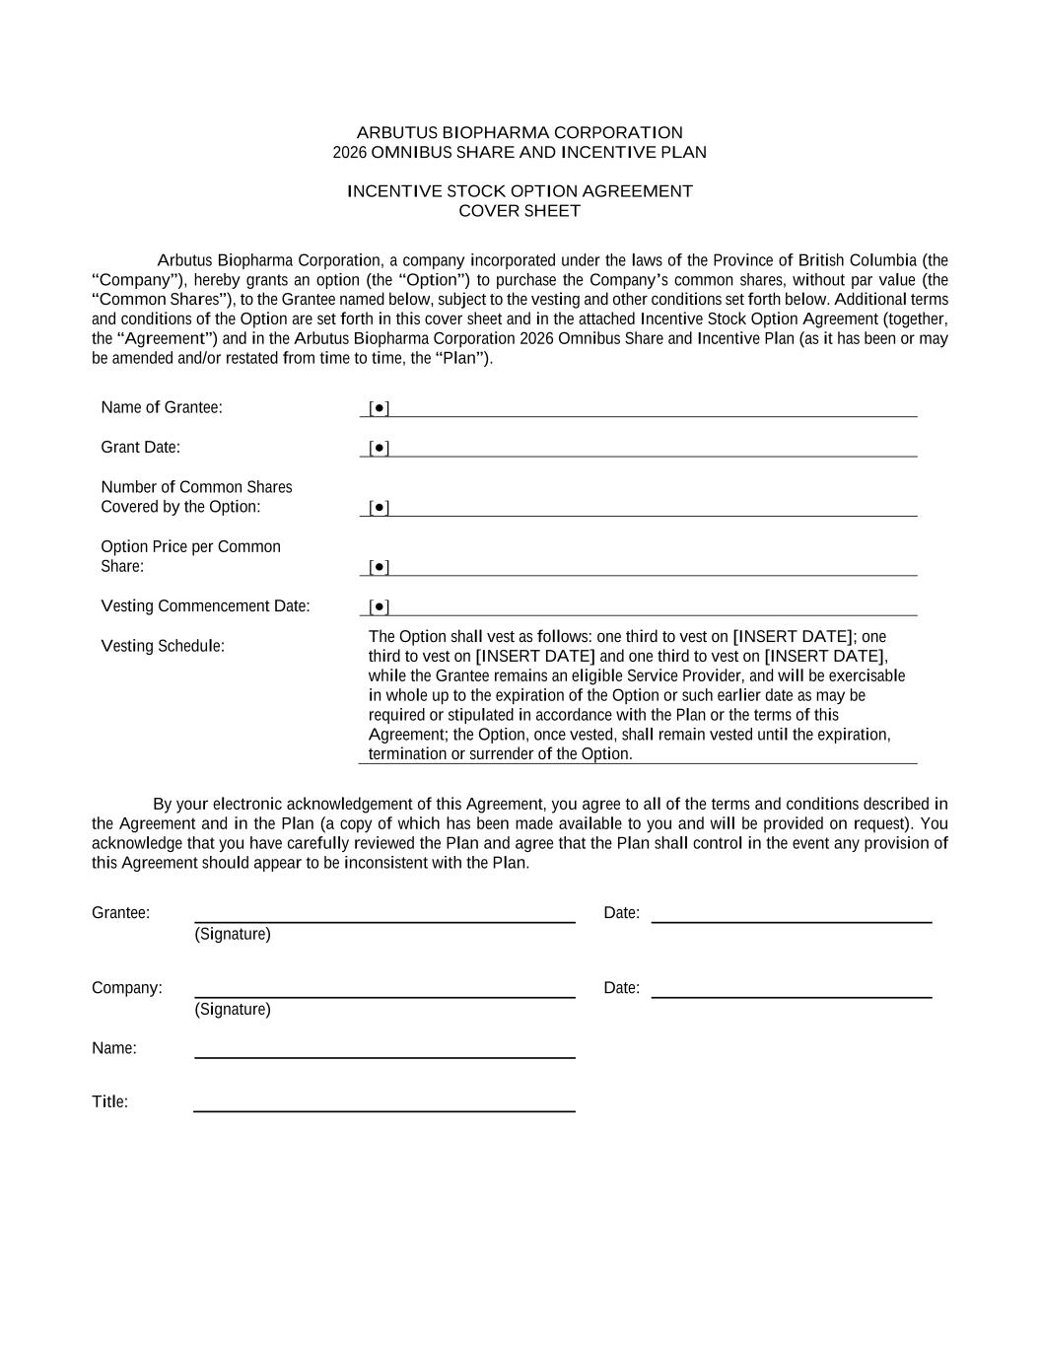
42

ARBUTUS BIOPHARMA CORPORATION 2026 OMNIBUS SHARE AND INCENTIVE PLAN INCENTIVE STOCK OPTION AGREEMENT COVER SHEET Arbutus Biopharma Corporation, a company incorporated under the laws of the Province of British Columbia (the “Company”), hereby grants an option (the “Option”) to purchase the Company’s common shares, without par value (the “Common Shares”), to the Grantee named below, subject to the vesting and other conditions set forth below. Additional terms and conditions of the Option are set forth in this cover sheet and in the attached Incentive Stock Option Agreement (together, the “Agreement”) and in the Arbutus Biopharma Corporation 2026 Omnibus Share and Incentive Plan (as it has been or may be amended and/or restated from time to time, the “Plan”). Name of Grantee: [●] Grant Date: [●] Number of Common Shares Covered by the Option: [●] Option Price per Common Share: [●] Vesting Commencement Date: [●] Vesting Schedule: The Option shall vest as follows: one third to vest on [INSERT DATE]; one third to vest on [INSERT DATE] and one third to vest on [INSERT DATE], while the Grantee remains an eligible Service Provider, and will be exercisable in whole up to the expiration of the Option or such earlier date as may be required or stipulated in accordance with the Plan or the terms of this Agreement; the Option, once vested, shall remain vested until the expiration, termination or surrender of the Option. By your electronic acknowledgement of this Agreement, you agree to all of the terms and conditions described in the Agreement and in the Plan (a copy of which has been made available to you and will be provided on request). You acknowledge that you have carefully reviewed the Plan and agree that the Plan shall control in the event any provision of this Agreement should appear to be inconsistent with the Plan. Grantee: Date: (Signature) Company: Date: (Signature) Name: Title:


Attachment This is not a share certificate or a negotiable instrument.

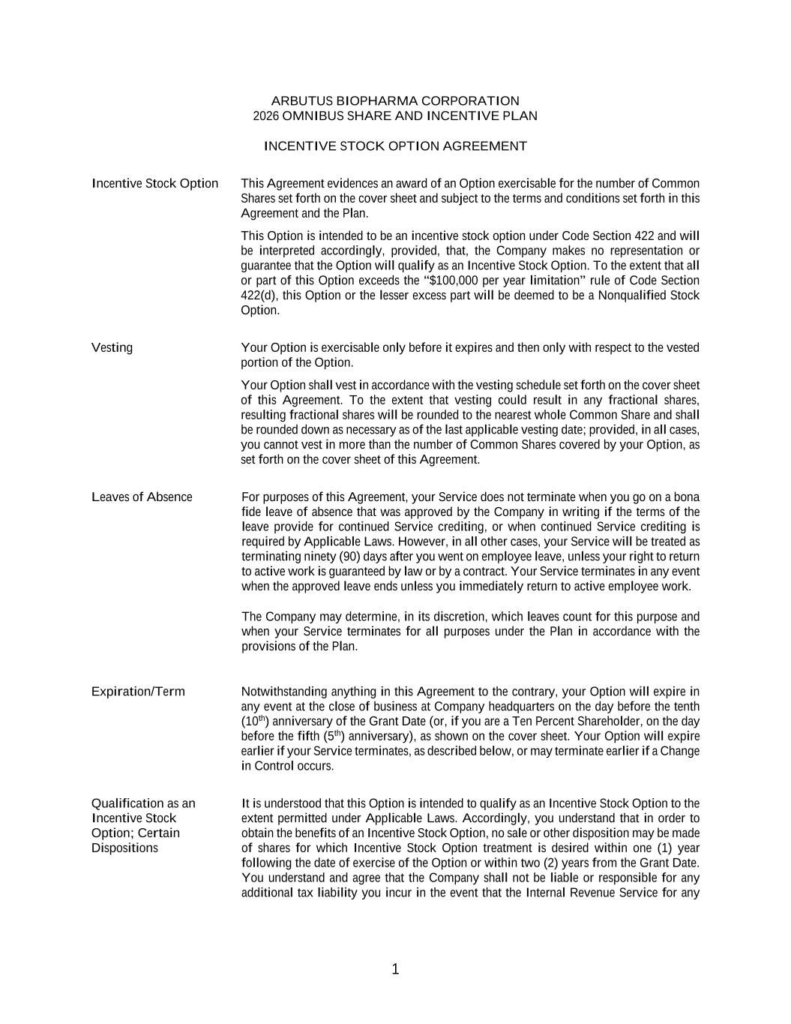
1 ARBUTUS BIOPHARMA CORPORATION 2026 OMNIBUS SHARE AND INCENTIVE PLAN INCENTIVE STOCK OPTION AGREEMENT Incentive Stock Option This Agreement evidences an award of an Option exercisable for the number of Common Shares set forth on the cover sheet and subject to the terms and conditions set forth in this Agreement and the Plan. This Option is intended to be an incentive stock option under Code Section 422 and will be interpreted accordingly, provided, that, the Company makes no representation or guarantee that the Option will qualify as an Incentive Stock Option. To the extent that all or part of this Option exceeds the “$100,000 per year limitation” rule of Code Section 422(d), this Option or the lesser excess part will be deemed to be a Nonqualified Stock Option. Vesting Your Option is exercisable only before it expires and then only with respect to the vested portion of the Option. Your Option shall vest in accordance with the vesting schedule set forth on the cover sheet of this Agreement. To the extent that vesting could result in any fractional shares, resulting fractional shares will be rounded to the nearest whole Common Share and shall be rounded down as necessary as of the last applicable vesting date; provided, in all cases, you cannot vest in more than the number of Common Shares covered by your Option, as set forth on the cover sheet of this Agreement. Leaves of Absence For purposes of this Agreement, your Service does not terminate when you go on a bona fide leave of absence that was approved by the Company in writing if the terms of the leave provide for continued Service crediting, or when continued Service crediting is required by Applicable Laws. However, in all other cases, your Service will be treated as terminating ninety (90) days after you went on employee leave, unless your right to return to active work is guaranteed by law or by a contract. Your Service terminates in any event when the approved leave ends unless you immediately return to active employee work. The Company may determine, in its discretion, which leaves count for this purpose and when your Service terminates for all purposes under the Plan in accordance with the provisions of the Plan. Expiration/Term Notwithstanding anything in this Agreement to the contrary, your Option will expire in any event at the close of business at Company headquarters on the day before the tenth (10th) anniversary of the Grant Date (or, if you are a Ten Percent Shareholder, on the day before the fifth (5th) anniversary), as shown on the cover sheet. Your Option will expire earlier if your Service terminates, as described below, or may terminate earlier if a Change in Control occurs. Qualification as an Incentive Stock Option; Certain Dispositions It is understood that this Option is intended to qualify as an Incentive Stock Option to the extent permitted under Applicable Laws. Accordingly, you understand that in order to obtain the benefits of an Incentive Stock Option, no sale or other disposition may be made of shares for which Incentive Stock Option treatment is desired within one (1) year following the date of exercise of the Option or within two (2) years from the Grant Date. You understand and agree that the Company shall not be liable or responsible for any additional tax liability you incur in the event that the Internal Revenue Service for any

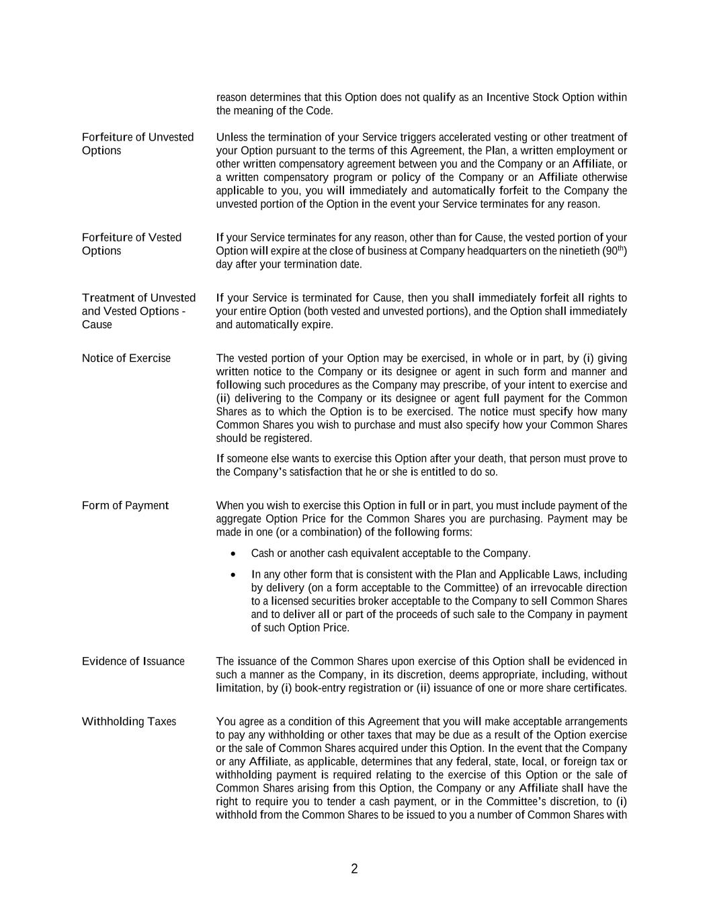
2 reason determines that this Option does not qualify as an Incentive Stock Option within the meaning of the Code. Forfeiture of Unvested Options Unless the termination of your Service triggers accelerated vesting or other treatment of your Option pursuant to the terms of this Agreement, the Plan, a written employment or other written compensatory agreement between you and the Company or an Affiliate, or a written compensatory program or policy of the Company or an Affiliate otherwise applicable to you, you will immediately and automatically forfeit to the Company the unvested portion of the Option in the event your Service terminates for any reason. Forfeiture of Vested Options If your Service terminates for any reason, other than for Cause, the vested portion of your Option will expire at the close of business at Company headquarters on the ninetieth (90th) day after your termination date. Treatment of Unvested and Vested Options - Cause If your Service is terminated for Cause, then you shall immediately forfeit all rights to your entire Option (both vested and unvested portions), and the Option shall immediately and automatically expire. Notice of Exercise The vested portion of your Option may be exercised, in whole or in part, by (i) giving written notice to the Company or its designee or agent in such form and manner and following such procedures as the Company may prescribe, of your intent to exercise and (ii) delivering to the Company or its designee or agent full payment for the Common Shares as to which the Option is to be exercised. The notice must specify how many Common Shares you wish to purchase and must also specify how your Common Shares should be registered. If someone else wants to exercise this Option after your death, that person must prove to the Company’s satisfaction that he or she is entitled to do so. Form of Payment When you wish to exercise this Option in full or in part, you must include payment of the aggregate Option Price for the Common Shares you are purchasing. Payment may be made in one (or a combination) of the following forms: • Cash or another cash equivalent acceptable to the Company. • In any other form that is consistent with the Plan and Applicable Laws, including by delivery (on a form acceptable to the Committee) of an irrevocable direction to a licensed securities broker acceptable to the Company to sell Common Shares and to deliver all or part of the proceeds of such sale to the Company in payment of such Option Price. Evidence of Issuance The issuance of the Common Shares upon exercise of this Option shall be evidenced in such a manner as the Company, in its discretion, deems appropriate, including, without limitation, by (i) book-entry registration or (ii) issuance of one or more share certificates. Withholding Taxes You agree as a condition of this Agreement that you will make acceptable arrangements to pay any withholding or other taxes that may be due as a result of the Option exercise or the sale of Common Shares acquired under this Option. In the event that the Company or any Affiliate, as applicable, determines that any federal, state, local, or foreign tax or withholding payment is required relating to the exercise of this Option or the sale of Common Shares arising from this Option, the Company or any Affiliate shall have the right to require you to tender a cash payment, or in the Committee’s discretion, to (i) withhold from the Common Shares to be issued to you a number of Common Shares with

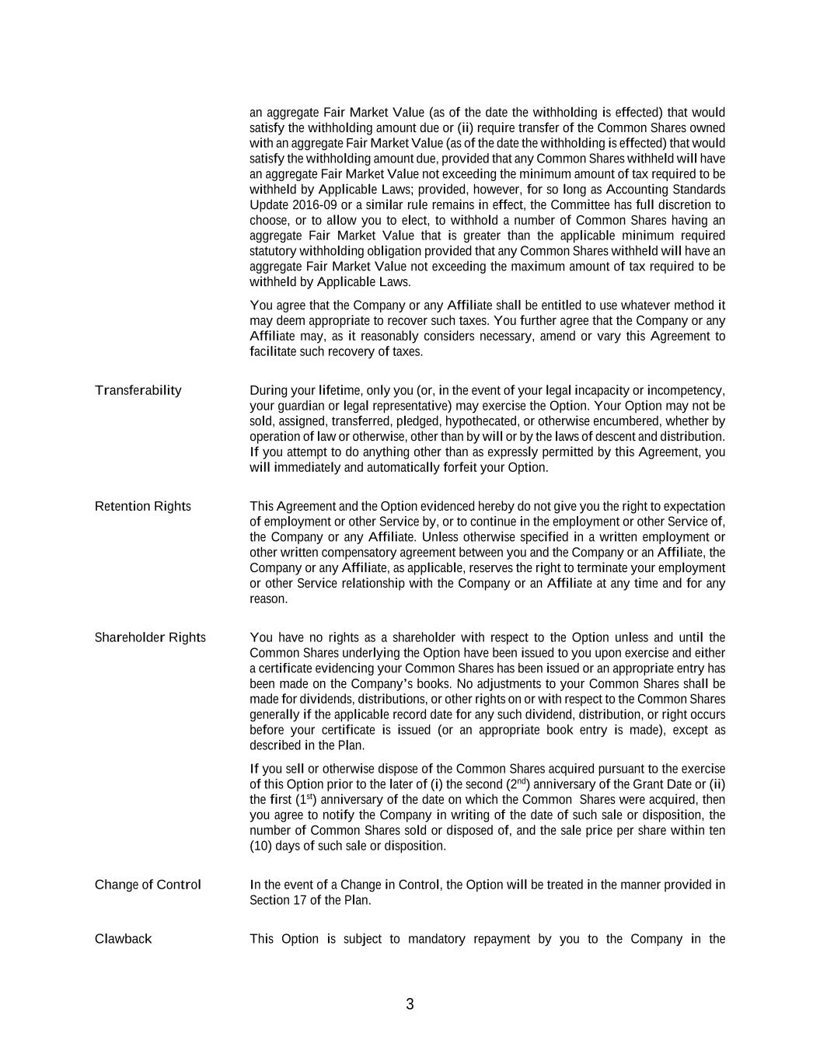
3 an aggregate Fair Market Value (as of the date the withholding is effected) that would satisfy the withholding amount due or (ii) require transfer of the Common Shares owned with an aggregate Fair Market Value (as of the date the withholding is effected) that would satisfy the withholding amount due, provided that any Common Shares withheld will have an aggregate Fair Market Value not exceeding the minimum amount of tax required to be withheld by Applicable Laws; provided, however, for so long as Accounting Standards Update 2016-09 or a similar rule remains in effect, the Committee has full discretion to choose, or to allow you to elect, to withhold a number of Common Shares having an aggregate Fair Market Value that is greater than the applicable minimum required statutory withholding obligation provided that any Common Shares withheld will have an aggregate Fair Market Value not exceeding the maximum amount of tax required to be withheld by Applicable Laws. You agree that the Company or any Affiliate shall be entitled to use whatever method it may deem appropriate to recover such taxes. You further agree that the Company or any Affiliate may, as it reasonably considers necessary, amend or vary this Agreement to facilitate such recovery of taxes. Transferability During your lifetime, only you (or, in the event of your legal incapacity or incompetency, your guardian or legal representative) may exercise the Option. Your Option may not be sold, assigned, transferred, pledged, hypothecated, or otherwise encumbered, whether by operation of law or otherwise, other than by will or by the laws of descent and distribution. If you attempt to do anything other than as expressly permitted by this Agreement, you will immediately and automatically forfeit your Option. Retention Rights This Agreement and the Option evidenced hereby do not give you the right to expectation of employment or other Service by, or to continue in the employment or other Service of, the Company or any Affiliate. Unless otherwise specified in a written employment or other written compensatory agreement between you and the Company or an Affiliate, the Company or any Affiliate, as applicable, reserves the right to terminate your employment or other Service relationship with the Company or an Affiliate at any time and for any reason. Shareholder Rights You have no rights as a shareholder with respect to the Option unless and until the Common Shares underlying the Option have been issued to you upon exercise and either a certificate evidencing your Common Shares has been issued or an appropriate entry has been made on the Company’s books. No adjustments to your Common Shares shall be made for dividends, distributions, or other rights on or with respect to the Common Shares generally if the applicable record date for any such dividend, distribution, or right occurs before your certificate is issued (or an appropriate book entry is made), except as described in the Plan. If you sell or otherwise dispose of the Common Shares acquired pursuant to the exercise of this Option prior to the later of (i) the second (2nd) anniversary of the Grant Date or (ii) the first (1st) anniversary of the date on which the Common Shares were acquired, then you agree to notify the Company in writing of the date of such sale or disposition, the number of Common Shares sold or disposed of, and the sale price per share within ten (10) days of such sale or disposition. Change of Control In the event of a Change in Control, the Option will be treated in the manner provided in Section 17 of the Plan. Clawback This Option is subject to mandatory repayment by you to the Company in the

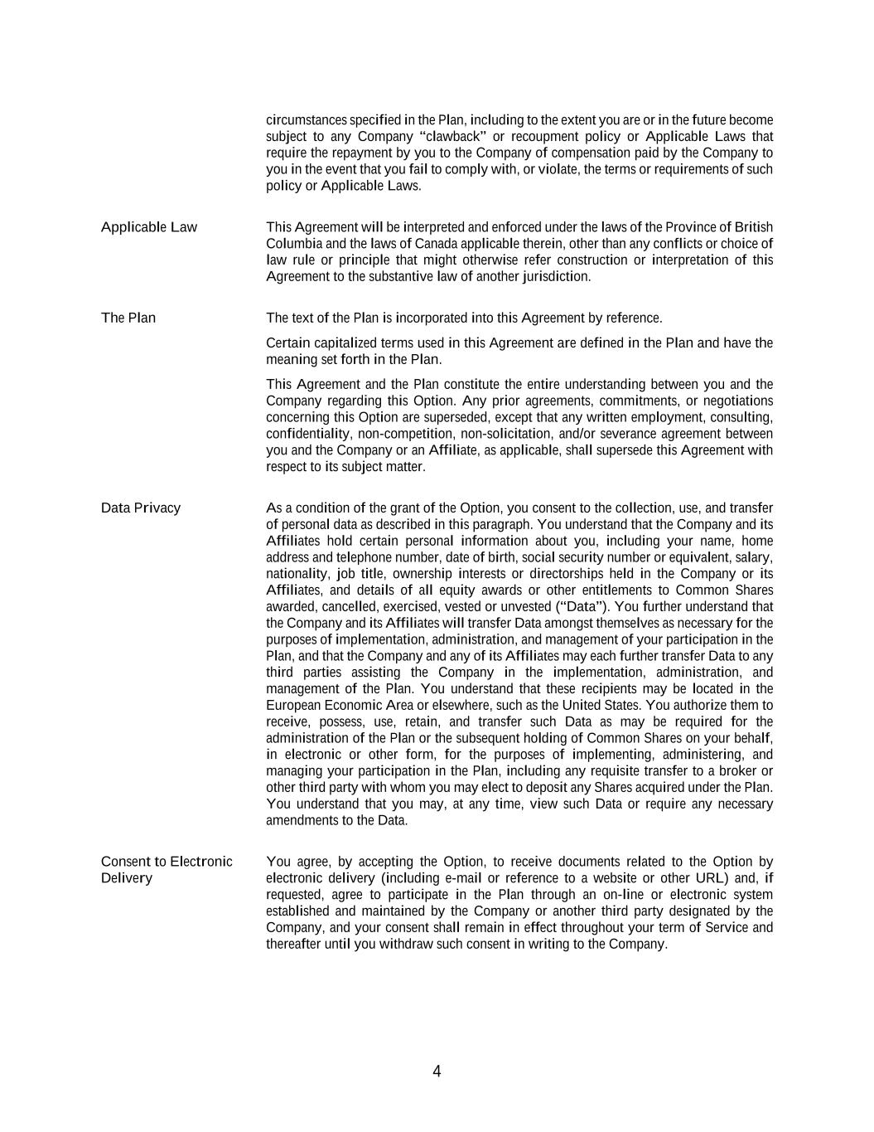
4 circumstances specified in the Plan, including to the extent you are or in the future become subject to any Company “clawback” or recoupment policy or Applicable Laws that require the repayment by you to the Company of compensation paid by the Company to you in the event that you fail to comply with, or violate, the terms or requirements of such policy or Applicable Laws. Applicable Law This Agreement will be interpreted and enforced under the laws of the Province of British Columbia and the laws of Canada applicable therein, other than any conflicts or choice of law rule or principle that might otherwise refer construction or interpretation of this Agreement to the substantive law of another jurisdiction. The Plan The text of the Plan is incorporated into this Agreement by reference. Certain capitalized terms used in this Agreement are defined in the Plan and have the meaning set forth in the Plan. This Agreement and the Plan constitute the entire understanding between you and the Company regarding this Option. Any prior agreements, commitments, or negotiations concerning this Option are superseded, except that any written employment, consulting, confidentiality, non-competition, non-solicitation, and/or severance agreement between you and the Company or an Affiliate, as applicable, shall supersede this Agreement with respect to its subject matter. Data Privacy As a condition of the grant of the Option, you consent to the collection, use, and transfer of personal data as described in this paragraph. You understand that the Company and its Affiliates hold certain personal information about you, including your name, home address and telephone number, date of birth, social security number or equivalent, salary, nationality, job title, ownership interests or directorships held in the Company or its Affiliates, and details of all equity awards or other entitlements to Common Shares awarded, cancelled, exercised, vested or unvested (“Data”). You further understand that the Company and its Affiliates will transfer Data amongst themselves as necessary for the purposes of implementation, administration, and management of your participation in the Plan, and that the Company and any of its Affiliates may each further transfer Data to any third parties assisting the Company in the implementation, administration, and management of the Plan. You understand that these recipients may be located in the European Economic Area or elsewhere, such as the United States. You authorize them to receive, possess, use, retain, and transfer such Data as may be required for the administration of the Plan or the subsequent holding of Common Shares on your behalf, in electronic or other form, for the purposes of implementing, administering, and managing your participation in the Plan, including any requisite transfer to a broker or other third party with whom you may elect to deposit any Shares acquired under the Plan. You understand that you may, at any time, view such Data or require any necessary amendments to the Data. Consent to Electronic Delivery You agree, by accepting the Option, to receive documents related to the Option by electronic delivery (including e-mail or reference to a website or other URL) and, if requested, agree to participate in the Plan through an on-line or electronic system established and maintained by the Company or another third party designated by the Company, and your consent shall remain in effect throughout your term of Service and thereafter until you withdraw such consent in writing to the Company.

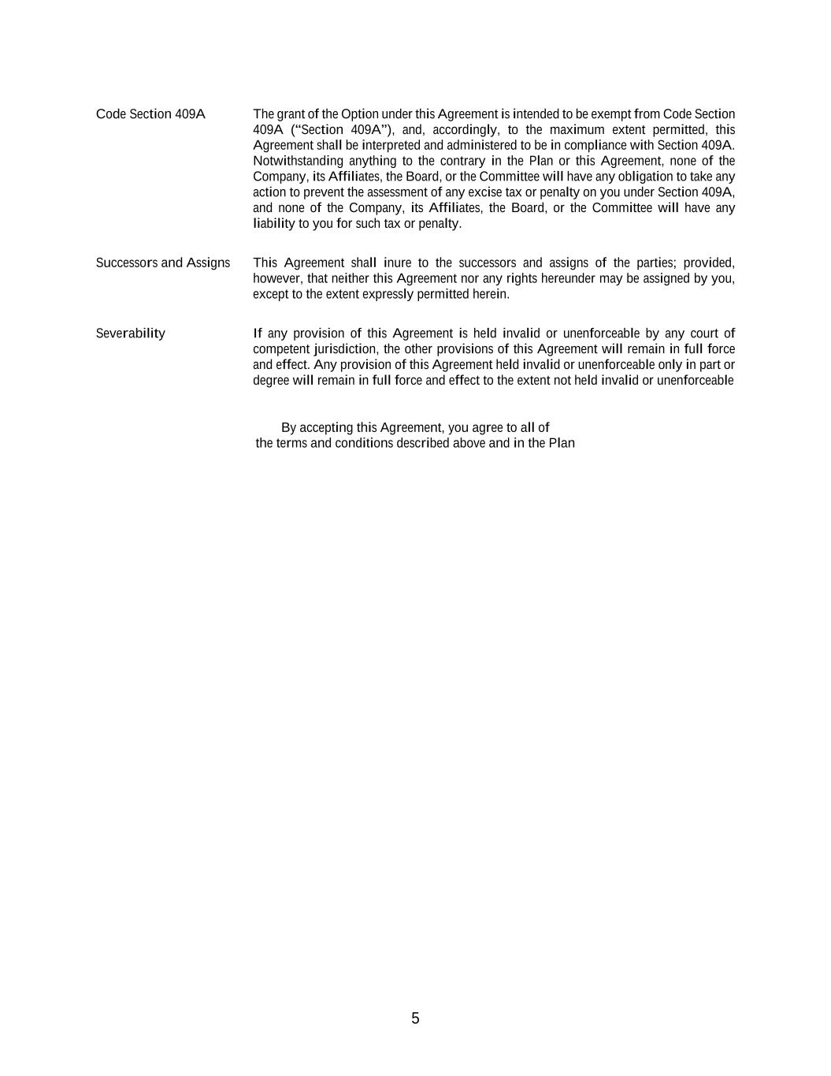
5 Code Section 409A The grant of the Option under this Agreement is intended to be exempt from Code Section 409A (“Section 409A”), and, accordingly, to the maximum extent permitted, this Agreement shall be interpreted and administered to be in compliance with Section 409A. Notwithstanding anything to the contrary in the Plan or this Agreement, none of the Company, its Affiliates, the Board, or the Committee will have any obligation to take any action to prevent the assessment of any excise tax or penalty on you under Section 409A, and none of the Company, its Affiliates, the Board, or the Committee will have any liability to you for such tax or penalty. Successors and Assigns This Agreement shall inure to the successors and assigns of the parties; provided, however, that neither this Agreement nor any rights hereunder may be assigned by you, except to the extent expressly permitted herein. Severability If any provision of this Agreement is held invalid or unenforceable by any court of competent jurisdiction, the other provisions of this Agreement will remain in full force and effect. Any provision of this Agreement held invalid or unenforceable only in part or degree will remain in full force and effect to the extent not held invalid or unenforceable By accepting this Agreement, you agree to all of the terms and conditions described above and in the Plan

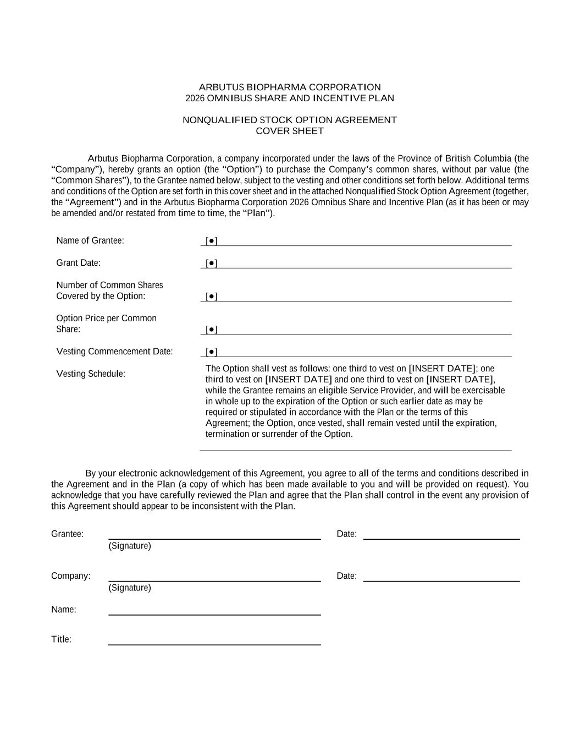
ARBUTUS BIOPHARMA CORPORATION 2026 OMNIBUS SHARE AND INCENTIVE PLAN NONQUALIFIED STOCK OPTION AGREEMENT COVER SHEET Arbutus Biopharma Corporation, a company incorporated under the laws of the Province of British Columbia (the “Company”), hereby grants an option (the “Option”) to purchase the Company’s common shares, without par value (the “Common Shares”), to the Grantee named below, subject to the vesting and other conditions set forth below. Additional terms and conditions of the Option are set forth in this cover sheet and in the attached Nonqualified Stock Option Agreement (together, the “Agreement”) and in the Arbutus Biopharma Corporation 2026 Omnibus Share and Incentive Plan (as it has been or may be amended and/or restated from time to time, the “Plan”). Name of Grantee: [●] Grant Date: [●] Number of Common Shares Covered by the Option: [●] Option Price per Common Share: [●] Vesting Commencement Date: [●] Vesting Schedule: The Option shall vest as follows: one third to vest on [INSERT DATE]; one third to vest on [INSERT DATE] and one third to vest on [INSERT DATE], while the Grantee remains an eligible Service Provider, and will be exercisable in whole up to the expiration of the Option or such earlier date as may be required or stipulated in accordance with the Plan or the terms of this Agreement; the Option, once vested, shall remain vested until the expiration, termination or surrender of the Option. By your electronic acknowledgement of this Agreement, you agree to all of the terms and conditions described in the Agreement and in the Plan (a copy of which has been made available to you and will be provided on request). You acknowledge that you have carefully reviewed the Plan and agree that the Plan shall control in the event any provision of this Agreement should appear to be inconsistent with the Plan. Grantee: Date: (Signature) Company: Date: (Signature) Name: Title:


Attachment This is not a share certificate or a negotiable instrument.

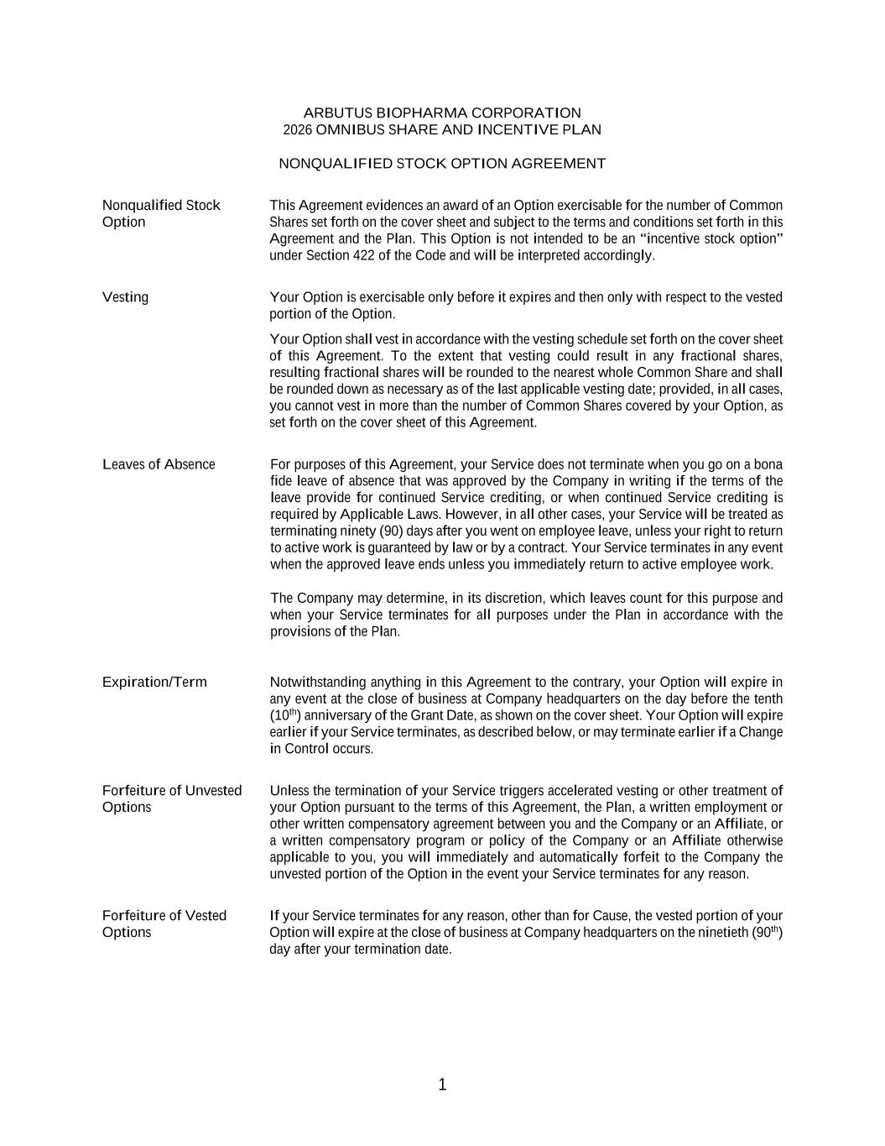
1 ARBUTUS BIOPHARMA CORPORATION 2026 OMNIBUS SHARE AND INCENTIVE PLAN NONQUALIFIED STOCK OPTION AGREEMENT Nonqualified Stock Option This Agreement evidences an award of an Option exercisable for the number of Common Shares set forth on the cover sheet and subject to the terms and conditions set forth in this Agreement and the Plan. This Option is not intended to be an “incentive stock option” under Section 422 of the Code and will be interpreted accordingly. Vesting Your Option is exercisable only before it expires and then only with respect to the vested portion of the Option. Your Option shall vest in accordance with the vesting schedule set forth on the cover sheet of this Agreement. To the extent that vesting could result in any fractional shares, resulting fractional shares will be rounded to the nearest whole Common Share and shall be rounded down as necessary as of the last applicable vesting date; provided, in all cases, you cannot vest in more than the number of Common Shares covered by your Option, as set forth on the cover sheet of this Agreement. Leaves of Absence For purposes of this Agreement, your Service does not terminate when you go on a bona fide leave of absence that was approved by the Company in writing if the terms of the leave provide for continued Service crediting, or when continued Service crediting is required by Applicable Laws. However, in all other cases, your Service will be treated as terminating ninety (90) days after you went on employee leave, unless your right to return to active work is guaranteed by law or by a contract. Your Service terminates in any event when the approved leave ends unless you immediately return to active employee work. The Company may determine, in its discretion, which leaves count for this purpose and when your Service terminates for all purposes under the Plan in accordance with the provisions of the Plan. Expiration/Term Notwithstanding anything in this Agreement to the contrary, your Option will expire in any event at the close of business at Company headquarters on the day before the tenth (10th) anniversary of the Grant Date, as shown on the cover sheet. Your Option will expire earlier if your Service terminates, as described below, or may terminate earlier if a Change in Control occurs. Forfeiture of Unvested Options Unless the termination of your Service triggers accelerated vesting or other treatment of your Option pursuant to the terms of this Agreement, the Plan, a written employment or other written compensatory agreement between you and the Company or an Affiliate, or a written compensatory program or policy of the Company or an Affiliate otherwise applicable to you, you will immediately and automatically forfeit to the Company the unvested portion of the Option in the event your Service terminates for any reason. Forfeiture of Vested Options If your Service terminates for any reason, other than for Cause, the vested portion of your Option will expire at the close of business at Company headquarters on the ninetieth (90th) day after your termination date.

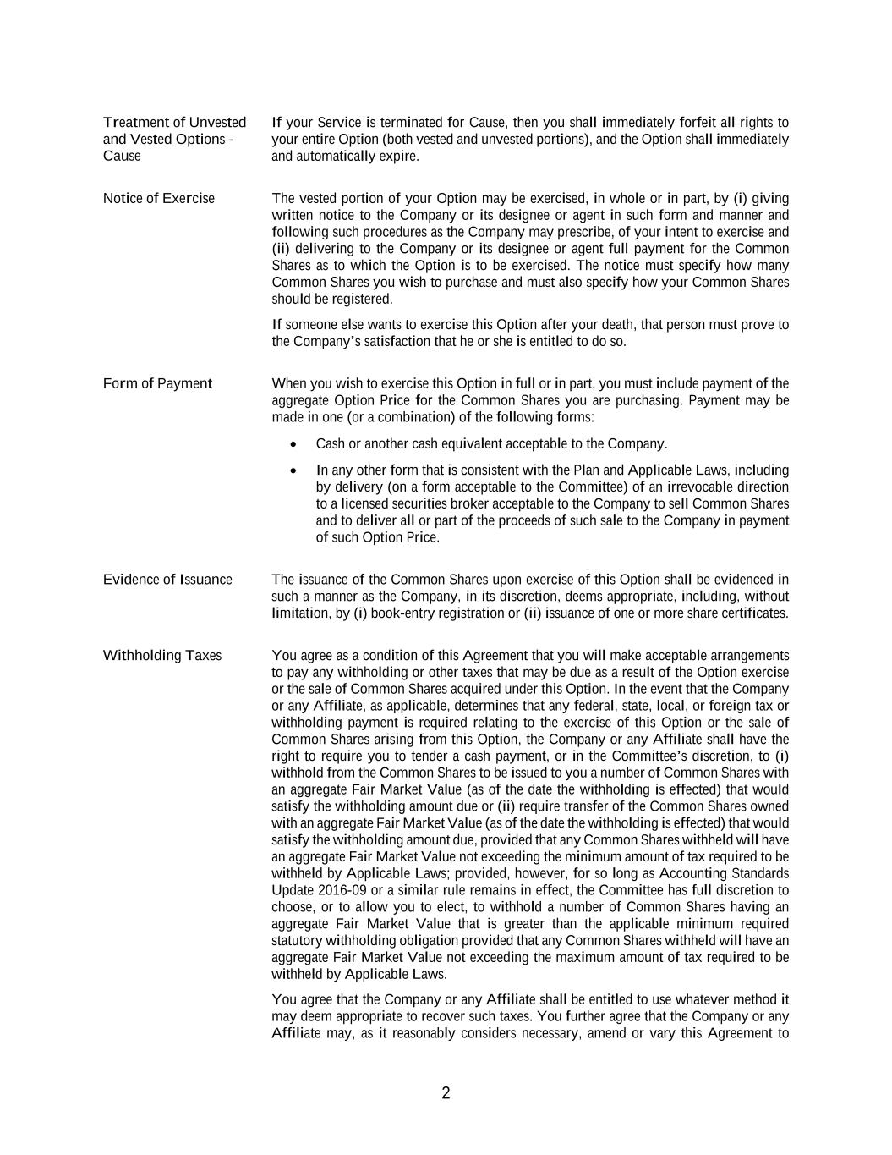
2 Treatment of Unvested and Vested Options - Cause If your Service is terminated for Cause, then you shall immediately forfeit all rights to your entire Option (both vested and unvested portions), and the Option shall immediately and automatically expire. Notice of Exercise The vested portion of your Option may be exercised, in whole or in part, by (i) giving written notice to the Company or its designee or agent in such form and manner and following such procedures as the Company may prescribe, of your intent to exercise and (ii) delivering to the Company or its designee or agent full payment for the Common Shares as to which the Option is to be exercised. The notice must specify how many Common Shares you wish to purchase and must also specify how your Common Shares should be registered. If someone else wants to exercise this Option after your death, that person must prove to the Company’s satisfaction that he or she is entitled to do so. Form of Payment When you wish to exercise this Option in full or in part, you must include payment of the aggregate Option Price for the Common Shares you are purchasing. Payment may be made in one (or a combination) of the following forms: • Cash or another cash equivalent acceptable to the Company. • In any other form that is consistent with the Plan and Applicable Laws, including by delivery (on a form acceptable to the Committee) of an irrevocable direction to a licensed securities broker acceptable to the Company to sell Common Shares and to deliver all or part of the proceeds of such sale to the Company in payment of such Option Price. Evidence of Issuance The issuance of the Common Shares upon exercise of this Option shall be evidenced in such a manner as the Company, in its discretion, deems appropriate, including, without limitation, by (i) book-entry registration or (ii) issuance of one or more share certificates. Withholding Taxes You agree as a condition of this Agreement that you will make acceptable arrangements to pay any withholding or other taxes that may be due as a result of the Option exercise or the sale of Common Shares acquired under this Option. In the event that the Company or any Affiliate, as applicable, determines that any federal, state, local, or foreign tax or withholding payment is required relating to the exercise of this Option or the sale of Common Shares arising from this Option, the Company or any Affiliate shall have the right to require you to tender a cash payment, or in the Committee’s discretion, to (i) withhold from the Common Shares to be issued to you a number of Common Shares with an aggregate Fair Market Value (as of the date the withholding is effected) that would satisfy the withholding amount due or (ii) require transfer of the Common Shares owned with an aggregate Fair Market Value (as of the date the withholding is effected) that would satisfy the withholding amount due, provided that any Common Shares withheld will have an aggregate Fair Market Value not exceeding the minimum amount of tax required to be withheld by Applicable Laws; provided, however, for so long as Accounting Standards Update 2016-09 or a similar rule remains in effect, the Committee has full discretion to choose, or to allow you to elect, to withhold a number of Common Shares having an aggregate Fair Market Value that is greater than the applicable minimum required statutory withholding obligation provided that any Common Shares withheld will have an aggregate Fair Market Value not exceeding the maximum amount of tax required to be withheld by Applicable Laws. You agree that the Company or any Affiliate shall be entitled to use whatever method it may deem appropriate to recover such taxes. You further agree that the Company or any Affiliate may, as it reasonably considers necessary, amend or vary this Agreement to

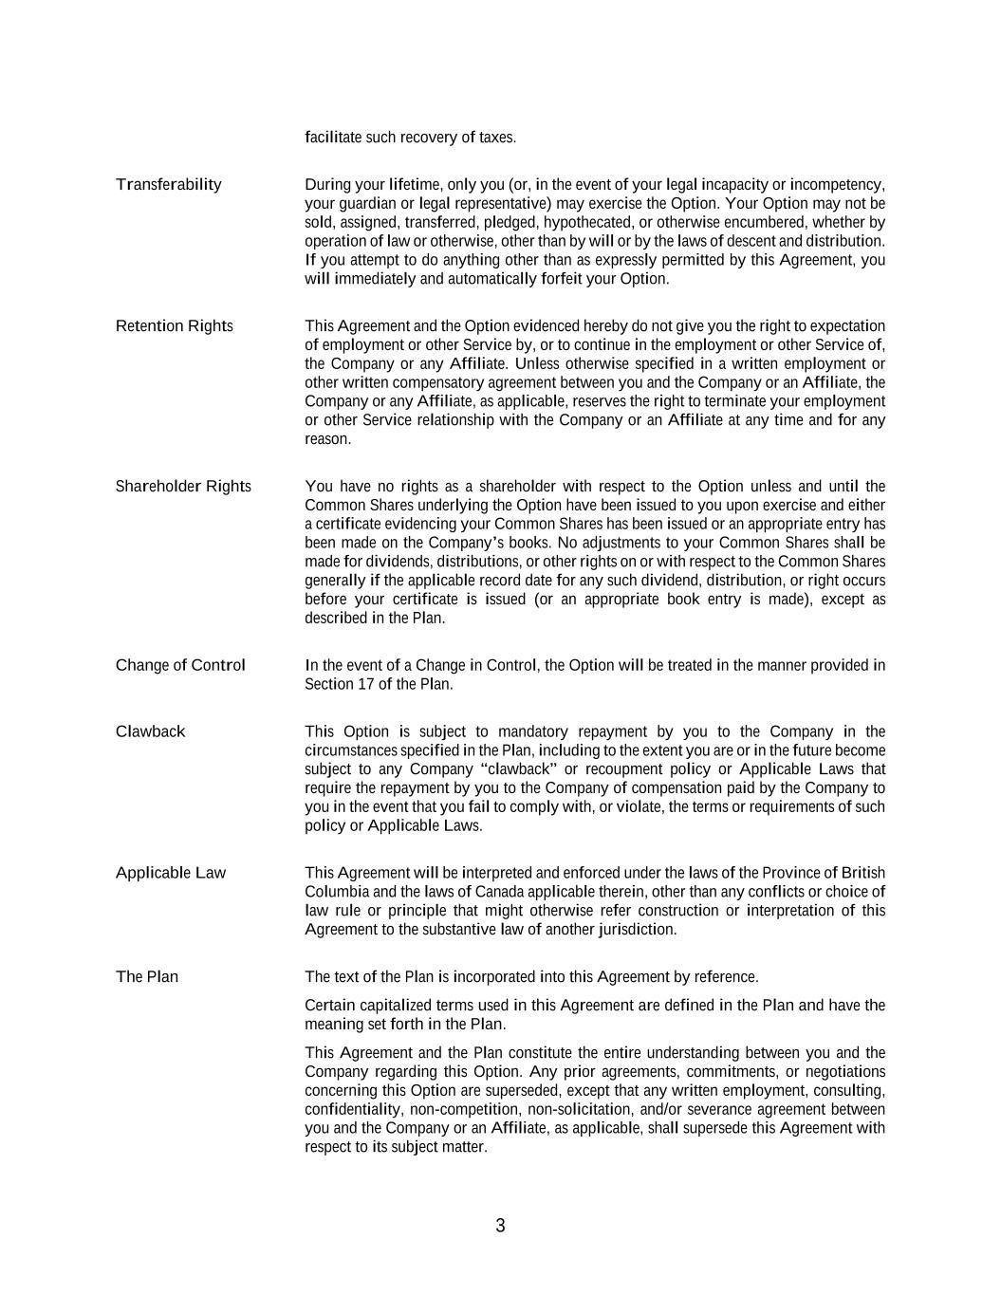
3 facilitate such recovery of taxes. Transferability During your lifetime, only you (or, in the event of your legal incapacity or incompetency, your guardian or legal representative) may exercise the Option. Your Option may not be sold, assigned, transferred, pledged, hypothecated, or otherwise encumbered, whether by operation of law or otherwise, other than by will or by the laws of descent and distribution. If you attempt to do anything other than as expressly permitted by this Agreement, you will immediately and automatically forfeit your Option. Retention Rights This Agreement and the Option evidenced hereby do not give you the right to expectation of employment or other Service by, or to continue in the employment or other Service of, the Company or any Affiliate. Unless otherwise specified in a written employment or other written compensatory agreement between you and the Company or an Affiliate, the Company or any Affiliate, as applicable, reserves the right to terminate your employment or other Service relationship with the Company or an Affiliate at any time and for any reason. Shareholder Rights You have no rights as a shareholder with respect to the Option unless and until the Common Shares underlying the Option have been issued to you upon exercise and either a certificate evidencing your Common Shares has been issued or an appropriate entry has been made on the Company’s books. No adjustments to your Common Shares shall be made for dividends, distributions, or other rights on or with respect to the Common Shares generally if the applicable record date for any such dividend, distribution, or right occurs before your certificate is issued (or an appropriate book entry is made), except as described in the Plan. Change of Control In the event of a Change in Control, the Option will be treated in the manner provided in Section 17 of the Plan. Clawback This Option is subject to mandatory repayment by you to the Company in the circumstances specified in the Plan, including to the extent you are or in the future become subject to any Company “clawback” or recoupment policy or Applicable Laws that require the repayment by you to the Company of compensation paid by the Company to you in the event that you fail to comply with, or violate, the terms or requirements of such policy or Applicable Laws. Applicable Law This Agreement will be interpreted and enforced under the laws of the Province of British Columbia and the laws of Canada applicable therein, other than any conflicts or choice of law rule or principle that might otherwise refer construction or interpretation of this Agreement to the substantive law of another jurisdiction. The Plan The text of the Plan is incorporated into this Agreement by reference. Certain capitalized terms used in this Agreement are defined in the Plan and have the meaning set forth in the Plan. This Agreement and the Plan constitute the entire understanding between you and the Company regarding this Option. Any prior agreements, commitments, or negotiations concerning this Option are superseded, except that any written employment, consulting, confidentiality, non-competition, non-solicitation, and/or severance agreement between you and the Company or an Affiliate, as applicable, shall supersede this Agreement with respect to its subject matter.

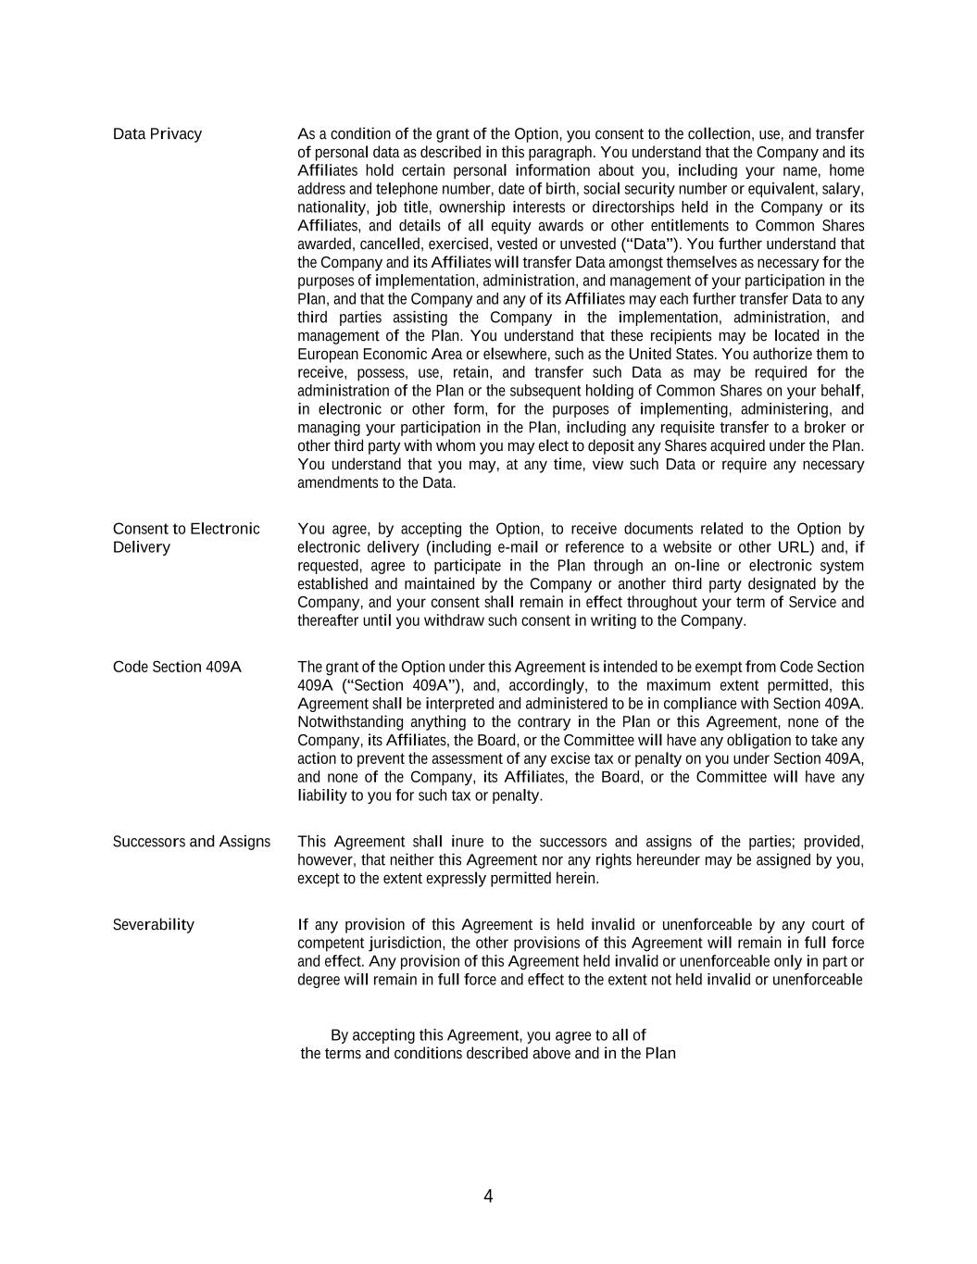
4 Data Privacy As a condition of the grant of the Option, you consent to the collection, use, and transfer of personal data as described in this paragraph. You understand that the Company and its Affiliates hold certain personal information about you, including your name, home address and telephone number, date of birth, social security number or equivalent, salary, nationality, job title, ownership interests or directorships held in the Company or its Affiliates, and details of all equity awards or other entitlements to Common Shares awarded, cancelled, exercised, vested or unvested (“Data”). You further understand that the Company and its Affiliates will transfer Data amongst themselves as necessary for the purposes of implementation, administration, and management of your participation in the Plan, and that the Company and any of its Affiliates may each further transfer Data to any third parties assisting the Company in the implementation, administration, and management of the Plan. You understand that these recipients may be located in the European Economic Area or elsewhere, such as the United States. You authorize them to receive, possess, use, retain, and transfer such Data as may be required for the administration of the Plan or the subsequent holding of Common Shares on your behalf, in electronic or other form, for the purposes of implementing, administering, and managing your participation in the Plan, including any requisite transfer to a broker or other third party with whom you may elect to deposit any Shares acquired under the Plan. You understand that you may, at any time, view such Data or require any necessary amendments to the Data. Consent to Electronic Delivery You agree, by accepting the Option, to receive documents related to the Option by electronic delivery (including e-mail or reference to a website or other URL) and, if requested, agree to participate in the Plan through an on-line or electronic system established and maintained by the Company or another third party designated by the Company, and your consent shall remain in effect throughout your term of Service and thereafter until you withdraw such consent in writing to the Company. Code Section 409A The grant of the Option under this Agreement is intended to be exempt from Code Section 409A (“Section 409A”), and, accordingly, to the maximum extent permitted, this Agreement shall be interpreted and administered to be in compliance with Section 409A. Notwithstanding anything to the contrary in the Plan or this Agreement, none of the Company, its Affiliates, the Board, or the Committee will have any obligation to take any action to prevent the assessment of any excise tax or penalty on you under Section 409A, and none of the Company, its Affiliates, the Board, or the Committee will have any liability to you for such tax or penalty. Successors and Assigns This Agreement shall inure to the successors and assigns of the parties; provided, however, that neither this Agreement nor any rights hereunder may be assigned by you, except to the extent expressly permitted herein. Severability If any provision of this Agreement is held invalid or unenforceable by any court of competent jurisdiction, the other provisions of this Agreement will remain in full force and effect. Any provision of this Agreement held invalid or unenforceable only in part or degree will remain in full force and effect to the extent not held invalid or unenforceable By accepting this Agreement, you agree to all of the terms and conditions described above and in the Plan

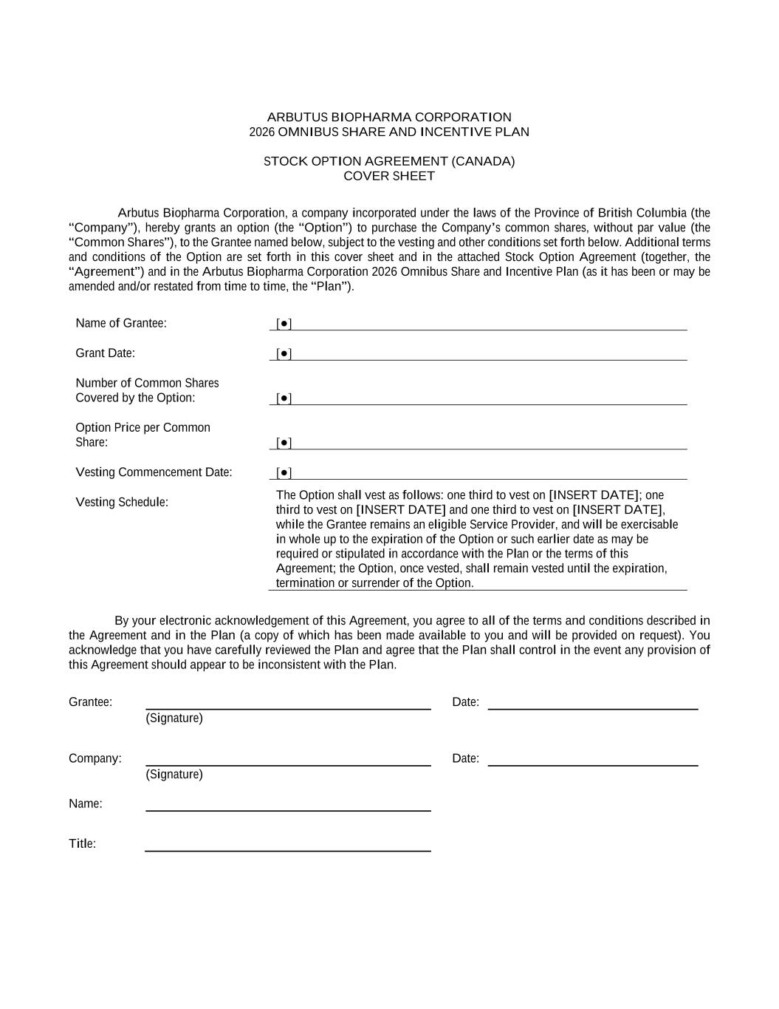
ARBUTUS BIOPHARMA CORPORATION 2026 OMNIBUS SHARE AND INCENTIVE PLAN STOCK OPTION AGREEMENT (CANADA) COVER SHEET Arbutus Biopharma Corporation, a company incorporated under the laws of the Province of British Columbia (the “Company”), hereby grants an option (the “Option”) to purchase the Company’s common shares, without par value (the “Common Shares”), to the Grantee named below, subject to the vesting and other conditions set forth below. Additional terms and conditions of the Option are set forth in this cover sheet and in the attached Stock Option Agreement (together, the “Agreement”) and in the Arbutus Biopharma Corporation 2026 Omnibus Share and Incentive Plan (as it has been or may be amended and/or restated from time to time, the “Plan”). Name of Grantee: [●] Grant Date: [●] Number of Common Shares Covered by the Option: [●] Option Price per Common Share: [●] Vesting Commencement Date: [●] Vesting Schedule: The Option shall vest as follows: one third to vest on [INSERT DATE]; one third to vest on [INSERT DATE] and one third to vest on [INSERT DATE], while the Grantee remains an eligible Service Provider, and will be exercisable in whole up to the expiration of the Option or such earlier date as may be required or stipulated in accordance with the Plan or the terms of this Agreement; the Option, once vested, shall remain vested until the expiration, termination or surrender of the Option. By your electronic acknowledgement of this Agreement, you agree to all of the terms and conditions described in the Agreement and in the Plan (a copy of which has been made available to you and will be provided on request). You acknowledge that you have carefully reviewed the Plan and agree that the Plan shall control in the event any provision of this Agreement should appear to be inconsistent with the Plan. Grantee: Date: (Signature) Company: Date: (Signature) Name: Title:

Attachment This is not a share certificate or a negotiable instrument.

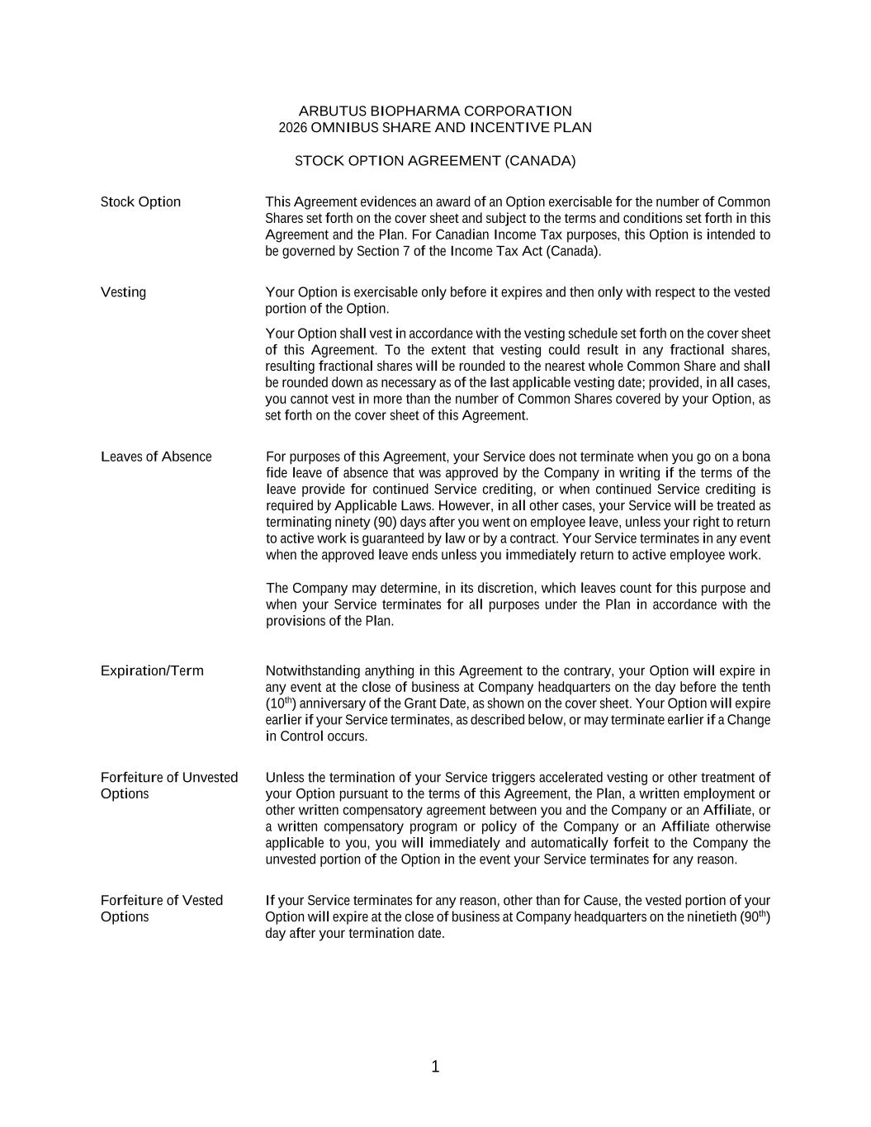
1 ARBUTUS BIOPHARMA CORPORATION 2026 OMNIBUS SHARE AND INCENTIVE PLAN STOCK OPTION AGREEMENT (CANADA) Stock Option This Agreement evidences an award of an Option exercisable for the number of Common Shares set forth on the cover sheet and subject to the terms and conditions set forth in this Agreement and the Plan. For Canadian Income Tax purposes, this Option is intended to be governed by Section 7 of the Income Tax Act (Canada). Vesting Your Option is exercisable only before it expires and then only with respect to the vested portion of the Option. Your Option shall vest in accordance with the vesting schedule set forth on the cover sheet of this Agreement. To the extent that vesting could result in any fractional shares, resulting fractional shares will be rounded to the nearest whole Common Share and shall be rounded down as necessary as of the last applicable vesting date; provided, in all cases, you cannot vest in more than the number of Common Shares covered by your Option, as set forth on the cover sheet of this Agreement. Leaves of Absence For purposes of this Agreement, your Service does not terminate when you go on a bona fide leave of absence that was approved by the Company in writing if the terms of the leave provide for continued Service crediting, or when continued Service crediting is required by Applicable Laws. However, in all other cases, your Service will be treated as terminating ninety (90) days after you went on employee leave, unless your right to return to active work is guaranteed by law or by a contract. Your Service terminates in any event when the approved leave ends unless you immediately return to active employee work. The Company may determine, in its discretion, which leaves count for this purpose and when your Service terminates for all purposes under the Plan in accordance with the provisions of the Plan. Expiration/Term Notwithstanding anything in this Agreement to the contrary, your Option will expire in any event at the close of business at Company headquarters on the day before the tenth (10th) anniversary of the Grant Date, as shown on the cover sheet. Your Option will expire earlier if your Service terminates, as described below, or may terminate earlier if a Change in Control occurs. Forfeiture of Unvested Options Unless the termination of your Service triggers accelerated vesting or other treatment of your Option pursuant to the terms of this Agreement, the Plan, a written employment or other written compensatory agreement between you and the Company or an Affiliate, or a written compensatory program or policy of the Company or an Affiliate otherwise applicable to you, you will immediately and automatically forfeit to the Company the unvested portion of the Option in the event your Service terminates for any reason. Forfeiture of Vested Options If your Service terminates for any reason, other than for Cause, the vested portion of your Option will expire at the close of business at Company headquarters on the ninetieth (90th) day after your termination date.

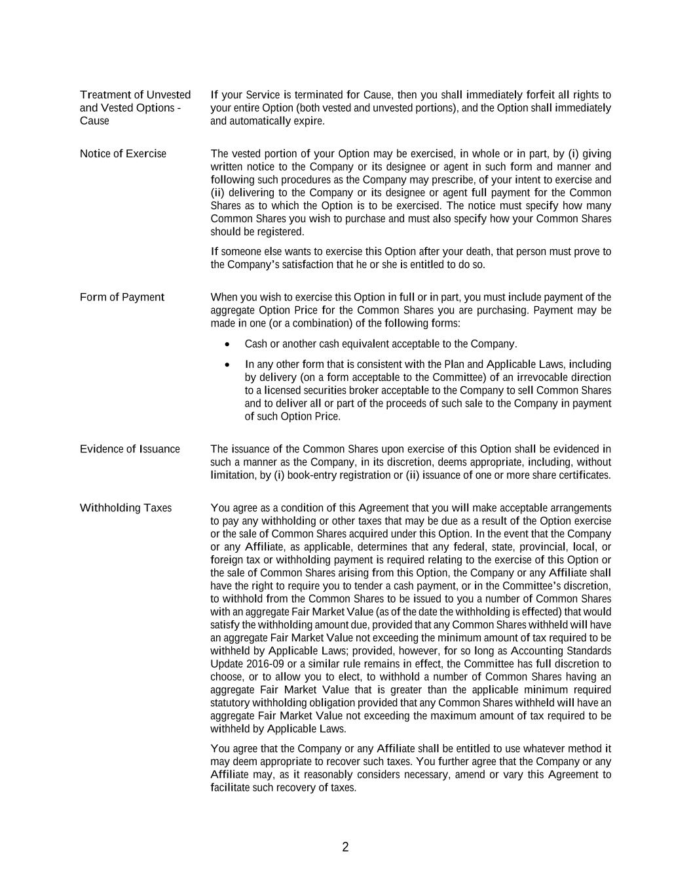
2 Treatment of Unvested and Vested Options - Cause If your Service is terminated for Cause, then you shall immediately forfeit all rights to your entire Option (both vested and unvested portions), and the Option shall immediately and automatically expire. Notice of Exercise The vested portion of your Option may be exercised, in whole or in part, by (i) giving written notice to the Company or its designee or agent in such form and manner and following such procedures as the Company may prescribe, of your intent to exercise and (ii) delivering to the Company or its designee or agent full payment for the Common Shares as to which the Option is to be exercised. The notice must specify how many Common Shares you wish to purchase and must also specify how your Common Shares should be registered. If someone else wants to exercise this Option after your death, that person must prove to the Company’s satisfaction that he or she is entitled to do so. Form of Payment When you wish to exercise this Option in full or in part, you must include payment of the aggregate Option Price for the Common Shares you are purchasing. Payment may be made in one (or a combination) of the following forms: • Cash or another cash equivalent acceptable to the Company. • In any other form that is consistent with the Plan and Applicable Laws, including by delivery (on a form acceptable to the Committee) of an irrevocable direction to a licensed securities broker acceptable to the Company to sell Common Shares and to deliver all or part of the proceeds of such sale to the Company in payment of such Option Price. Evidence of Issuance The issuance of the Common Shares upon exercise of this Option shall be evidenced in such a manner as the Company, in its discretion, deems appropriate, including, without limitation, by (i) book-entry registration or (ii) issuance of one or more share certificates. Withholding Taxes You agree as a condition of this Agreement that you will make acceptable arrangements to pay any withholding or other taxes that may be due as a result of the Option exercise or the sale of Common Shares acquired under this Option. In the event that the Company or any Affiliate, as applicable, determines that any federal, state, provincial, local, or foreign tax or withholding payment is required relating to the exercise of this Option or the sale of Common Shares arising from this Option, the Company or any Affiliate shall have the right to require you to tender a cash payment, or in the Committee’s discretion, to withhold from the Common Shares to be issued to you a number of Common Shares with an aggregate Fair Market Value (as of the date the withholding is effected) that would satisfy the withholding amount due, provided that any Common Shares withheld will have an aggregate Fair Market Value not exceeding the minimum amount of tax required to be withheld by Applicable Laws; provided, however, for so long as Accounting Standards Update 2016-09 or a similar rule remains in effect, the Committee has full discretion to choose, or to allow you to elect, to withhold a number of Common Shares having an aggregate Fair Market Value that is greater than the applicable minimum required statutory withholding obligation provided that any Common Shares withheld will have an aggregate Fair Market Value not exceeding the maximum amount of tax required to be withheld by Applicable Laws. You agree that the Company or any Affiliate shall be entitled to use whatever method it may deem appropriate to recover such taxes. You further agree that the Company or any Affiliate may, as it reasonably considers necessary, amend or vary this Agreement to facilitate such recovery of taxes.

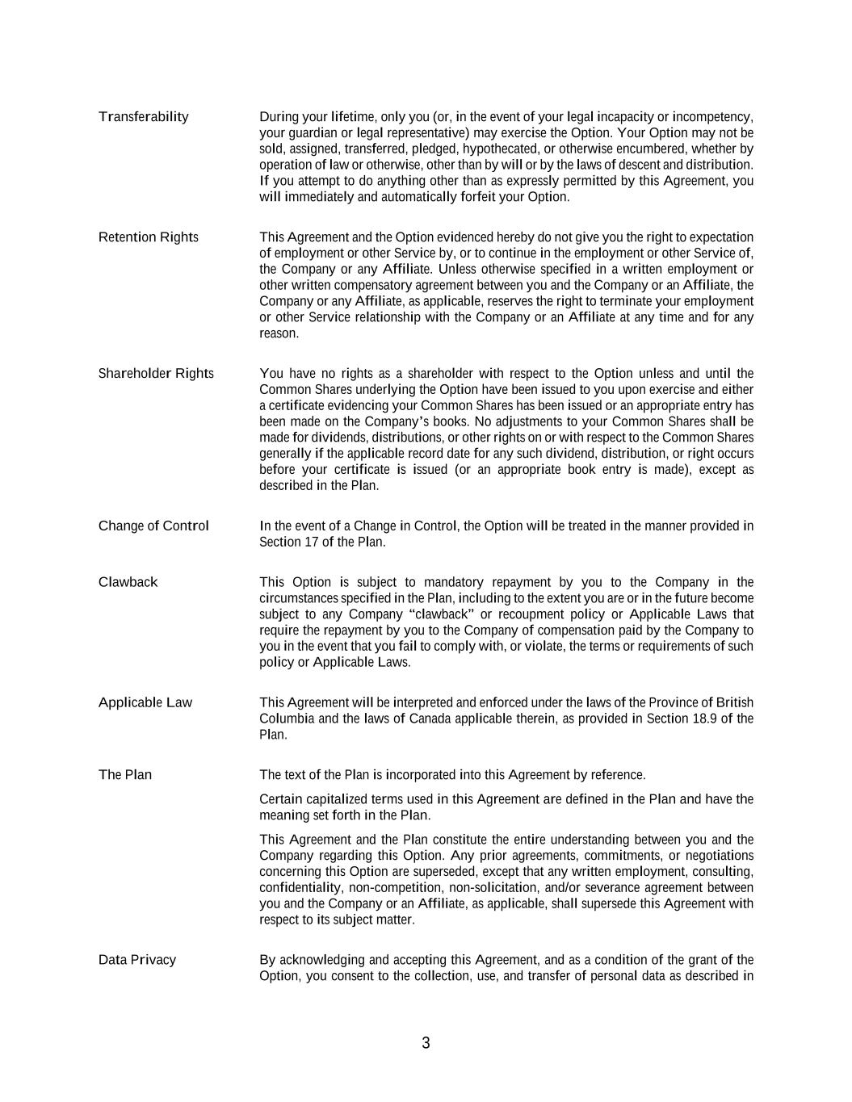
3 Transferability During your lifetime, only you (or, in the event of your legal incapacity or incompetency, your guardian or legal representative) may exercise the Option. Your Option may not be sold, assigned, transferred, pledged, hypothecated, or otherwise encumbered, whether by operation of law or otherwise, other than by will or by the laws of descent and distribution. If you attempt to do anything other than as expressly permitted by this Agreement, you will immediately and automatically forfeit your Option. Retention Rights This Agreement and the Option evidenced hereby do not give you the right to expectation of employment or other Service by, or to continue in the employment or other Service of, the Company or any Affiliate. Unless otherwise specified in a written employment or other written compensatory agreement between you and the Company or an Affiliate, the Company or any Affiliate, as applicable, reserves the right to terminate your employment or other Service relationship with the Company or an Affiliate at any time and for any reason. Shareholder Rights You have no rights as a shareholder with respect to the Option unless and until the Common Shares underlying the Option have been issued to you upon exercise and either a certificate evidencing your Common Shares has been issued or an appropriate entry has been made on the Company’s books. No adjustments to your Common Shares shall be made for dividends, distributions, or other rights on or with respect to the Common Shares generally if the applicable record date for any such dividend, distribution, or right occurs before your certificate is issued (or an appropriate book entry is made), except as described in the Plan. Change of Control In the event of a Change in Control, the Option will be treated in the manner provided in Section 17 of the Plan. Clawback This Option is subject to mandatory repayment by you to the Company in the circumstances specified in the Plan, including to the extent you are or in the future become subject to any Company “clawback” or recoupment policy or Applicable Laws that require the repayment by you to the Company of compensation paid by the Company to you in the event that you fail to comply with, or violate, the terms or requirements of such policy or Applicable Laws. Applicable Law This Agreement will be interpreted and enforced under the laws of the Province of British Columbia and the laws of Canada applicable therein, as provided in Section 18.9 of the Plan. The Plan The text of the Plan is incorporated into this Agreement by reference. Certain capitalized terms used in this Agreement are defined in the Plan and have the meaning set forth in the Plan. This Agreement and the Plan constitute the entire understanding between you and the Company regarding this Option. Any prior agreements, commitments, or negotiations concerning this Option are superseded, except that any written employment, consulting, confidentiality, non-competition, non-solicitation, and/or severance agreement between you and the Company or an Affiliate, as applicable, shall supersede this Agreement with respect to its subject matter. Data Privacy By acknowledging and accepting this Agreement, and as a condition of the grant of the Option, you consent to the collection, use, and transfer of personal data as described in

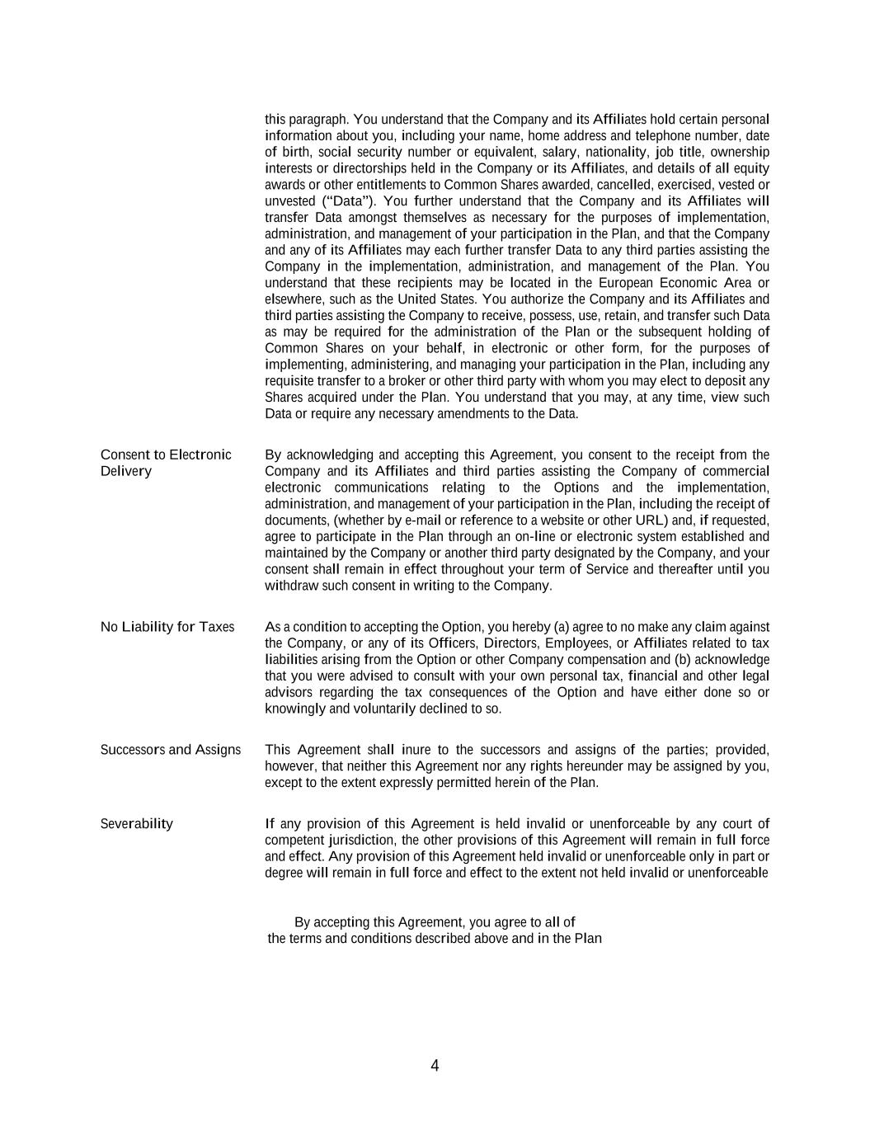
4 this paragraph. You understand that the Company and its Affiliates hold certain personal information about you, including your name, home address and telephone number, date of birth, social security number or equivalent, salary, nationality, job title, ownership interests or directorships held in the Company or its Affiliates, and details of all equity awards or other entitlements to Common Shares awarded, cancelled, exercised, vested or unvested (“Data”). You further understand that the Company and its Affiliates will transfer Data amongst themselves as necessary for the purposes of implementation, administration, and management of your participation in the Plan, and that the Company and any of its Affiliates may each further transfer Data to any third parties assisting the Company in the implementation, administration, and management of the Plan. You understand that these recipients may be located in the European Economic Area or elsewhere, such as the United States. You authorize the Company and its Affiliates and third parties assisting the Company to receive, possess, use, retain, and transfer such Data as may be required for the administration of the Plan or the subsequent holding of Common Shares on your behalf, in electronic or other form, for the purposes of implementing, administering, and managing your participation in the Plan, including any requisite transfer to a broker or other third party with whom you may elect to deposit any Shares acquired under the Plan. You understand that you may, at any time, view such Data or require any necessary amendments to the Data. Consent to Electronic Delivery By acknowledging and accepting this Agreement, you consent to the receipt from the Company and its Affiliates and third parties assisting the Company of commercial electronic communications relating to the Options and the implementation, administration, and management of your participation in the Plan, including the receipt of documents, (whether by e-mail or reference to a website or other URL) and, if requested, agree to participate in the Plan through an on-line or electronic system established and maintained by the Company or another third party designated by the Company, and your consent shall remain in effect throughout your term of Service and thereafter until you withdraw such consent in writing to the Company. No Liability for Taxes As a condition to accepting the Option, you hereby (a) agree to no make any claim against the Company, or any of its Officers, Directors, Employees, or Affiliates related to tax liabilities arising from the Option or other Company compensation and (b) acknowledge that you were advised to consult with your own personal tax, financial and other legal advisors regarding the tax consequences of the Option and have either done so or knowingly and voluntarily declined to so. Successors and Assigns This Agreement shall inure to the successors and assigns of the parties; provided, however, that neither this Agreement nor any rights hereunder may be assigned by you, except to the extent expressly permitted herein of the Plan. Severability If any provision of this Agreement is held invalid or unenforceable by any court of competent jurisdiction, the other provisions of this Agreement will remain in full force and effect. Any provision of this Agreement held invalid or unenforceable only in part or degree will remain in full force and effect to the extent not held invalid or unenforceable By accepting this Agreement, you agree to all of the terms and conditions described above and in the Plan

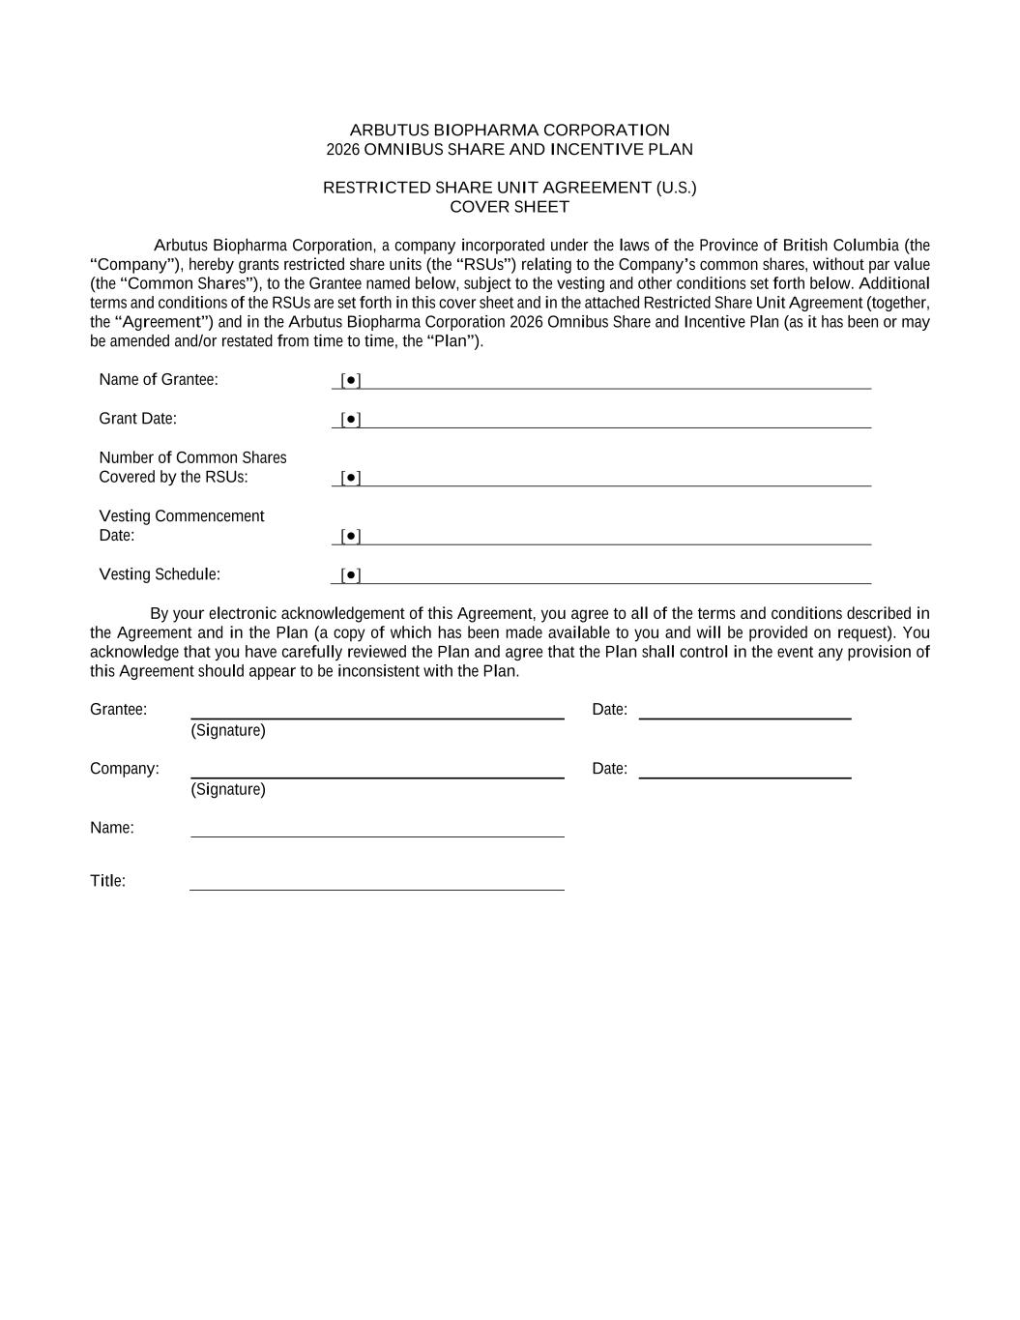
ARBUTUS BIOPHARMA CORPORATION 2026 OMNIBUS SHARE AND INCENTIVE PLAN RESTRICTED SHARE UNIT AGREEMENT (U.S.) COVER SHEET Arbutus Biopharma Corporation, a company incorporated under the laws of the Province of British Columbia (the “Company”), hereby grants restricted share units (the “RSUs”) relating to the Company’s common shares, without par value (the “Common Shares”), to the Grantee named below, subject to the vesting and other conditions set forth below. Additional terms and conditions of the RSUs are set forth in this cover sheet and in the attached Restricted Share Unit Agreement (together, the “Agreement”) and in the Arbutus Biopharma Corporation 2026 Omnibus Share and Incentive Plan (as it has been or may be amended and/or restated from time to time, the “Plan”). Name of Grantee: [●] Grant Date: [●] Number of Common Shares Covered by the RSUs: [●] Vesting Commencement Date: [●] Vesting Schedule: [●] By your electronic acknowledgement of this Agreement, you agree to all of the terms and conditions described in the Agreement and in the Plan (a copy of which has been made available to you and will be provided on request). You acknowledge that you have carefully reviewed the Plan and agree that the Plan shall control in the event any provision of this Agreement should appear to be inconsistent with the Plan. Grantee: Date: (Signature) Company: Date: (Signature) Name: Title:


Attachment This is not a share certificate or a negotiable instrument.

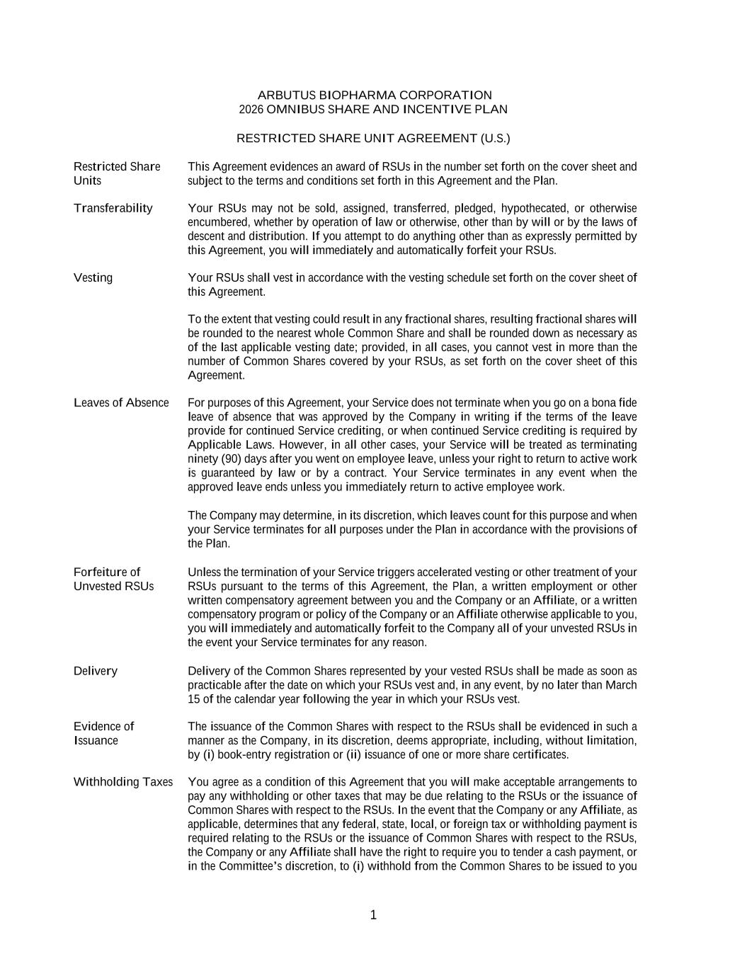
1 ARBUTUS BIOPHARMA CORPORATION 2026 OMNIBUS SHARE AND INCENTIVE PLAN RESTRICTED SHARE UNIT AGREEMENT (U.S.) Restricted Share Units This Agreement evidences an award of RSUs in the number set forth on the cover sheet and subject to the terms and conditions set forth in this Agreement and the Plan. Transferability Your RSUs may not be sold, assigned, transferred, pledged, hypothecated, or otherwise encumbered, whether by operation of law or otherwise, other than by will or by the laws of descent and distribution. If you attempt to do anything other than as expressly permitted by this Agreement, you will immediately and automatically forfeit your RSUs. Vesting Your RSUs shall vest in accordance with the vesting schedule set forth on the cover sheet of this Agreement. To the extent that vesting could result in any fractional shares, resulting fractional shares will be rounded to the nearest whole Common Share and shall be rounded down as necessary as of the last applicable vesting date; provided, in all cases, you cannot vest in more than the number of Common Shares covered by your RSUs, as set forth on the cover sheet of this Agreement. Leaves of Absence For purposes of this Agreement, your Service does not terminate when you go on a bona fide leave of absence that was approved by the Company in writing if the terms of the leave provide for continued Service crediting, or when continued Service crediting is required by Applicable Laws. However, in all other cases, your Service will be treated as terminating ninety (90) days after you went on employee leave, unless your right to return to active work is guaranteed by law or by a contract. Your Service terminates in any event when the approved leave ends unless you immediately return to active employee work. The Company may determine, in its discretion, which leaves count for this purpose and when your Service terminates for all purposes under the Plan in accordance with the provisions of the Plan. Forfeiture of Unvested RSUs Unless the termination of your Service triggers accelerated vesting or other treatment of your RSUs pursuant to the terms of this Agreement, the Plan, a written employment or other written compensatory agreement between you and the Company or an Affiliate, or a written compensatory program or policy of the Company or an Affiliate otherwise applicable to you, you will immediately and automatically forfeit to the Company all of your unvested RSUs in the event your Service terminates for any reason. Delivery Delivery of the Common Shares represented by your vested RSUs shall be made as soon as practicable after the date on which your RSUs vest and, in any event, by no later than March 15 of the calendar year following the year in which your RSUs vest. Evidence of Issuance The issuance of the Common Shares with respect to the RSUs shall be evidenced in such a manner as the Company, in its discretion, deems appropriate, including, without limitation, by (i) book-entry registration or (ii) issuance of one or more share certificates. Withholding Taxes You agree as a condition of this Agreement that you will make acceptable arrangements to pay any withholding or other taxes that may be due relating to the RSUs or the issuance of Common Shares with respect to the RSUs. In the event that the Company or any Affiliate, as applicable, determines that any federal, state, local, or foreign tax or withholding payment is required relating to the RSUs or the issuance of Common Shares with respect to the RSUs, the Company or any Affiliate shall have the right to require you to tender a cash payment, or in the Committee’s discretion, to (i) withhold from the Common Shares to be issued to you

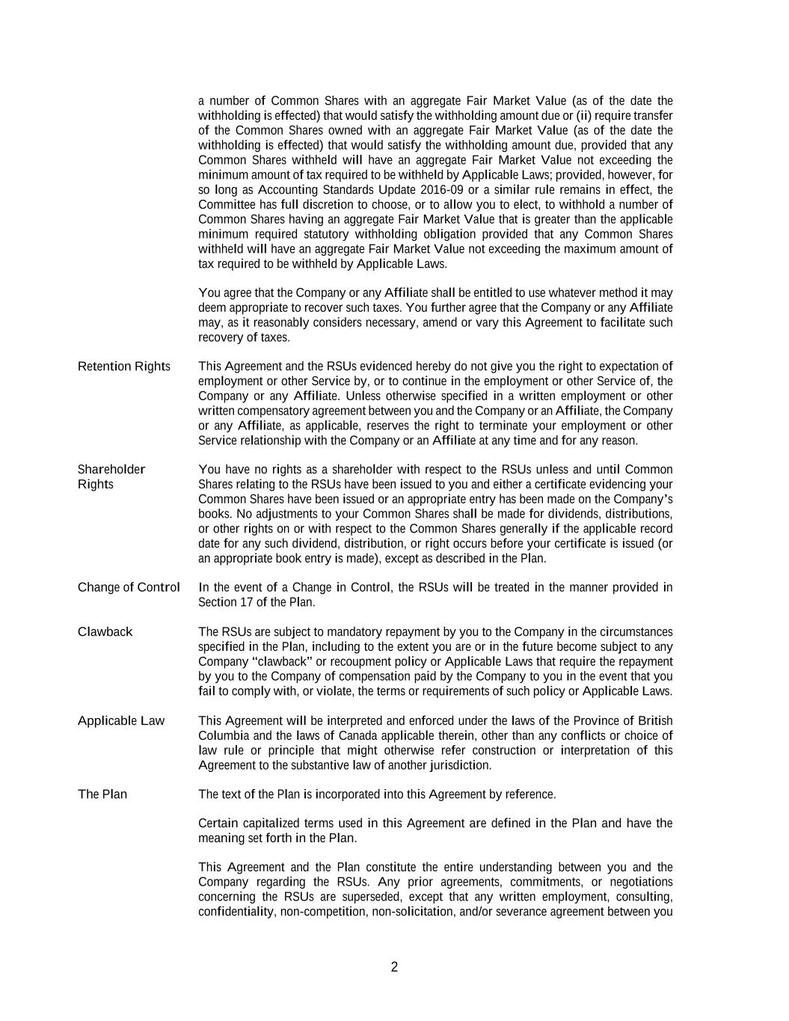
2 a number of Common Shares with an aggregate Fair Market Value (as of the date the withholding is effected) that would satisfy the withholding amount due or (ii) require transfer of the Common Shares owned with an aggregate Fair Market Value (as of the date the withholding is effected) that would satisfy the withholding amount due, provided that any Common Shares withheld will have an aggregate Fair Market Value not exceeding the minimum amount of tax required to be withheld by Applicable Laws; provided, however, for so long as Accounting Standards Update 2016-09 or a similar rule remains in effect, the Committee has full discretion to choose, or to allow you to elect, to withhold a number of Common Shares having an aggregate Fair Market Value that is greater than the applicable minimum required statutory withholding obligation provided that any Common Shares withheld will have an aggregate Fair Market Value not exceeding the maximum amount of tax required to be withheld by Applicable Laws. You agree that the Company or any Affiliate shall be entitled to use whatever method it may deem appropriate to recover such taxes. You further agree that the Company or any Affiliate may, as it reasonably considers necessary, amend or vary this Agreement to facilitate such recovery of taxes. Retention Rights This Agreement and the RSUs evidenced hereby do not give you the right to expectation of employment or other Service by, or to continue in the employment or other Service of, the Company or any Affiliate. Unless otherwise specified in a written employment or other written compensatory agreement between you and the Company or an Affiliate, the Company or any Affiliate, as applicable, reserves the right to terminate your employment or other Service relationship with the Company or an Affiliate at any time and for any reason. Shareholder Rights You have no rights as a shareholder with respect to the RSUs unless and until Common Shares relating to the RSUs have been issued to you and either a certificate evidencing your Common Shares have been issued or an appropriate entry has been made on the Company’s books. No adjustments to your Common Shares shall be made for dividends, distributions, or other rights on or with respect to the Common Shares generally if the applicable record date for any such dividend, distribution, or right occurs before your certificate is issued (or an appropriate book entry is made), except as described in the Plan. Change of Control In the event of a Change in Control, the RSUs will be treated in the manner provided in Section 17 of the Plan. Clawback The RSUs are subject to mandatory repayment by you to the Company in the circumstances specified in the Plan, including to the extent you are or in the future become subject to any Company “clawback” or recoupment policy or Applicable Laws that require the repayment by you to the Company of compensation paid by the Company to you in the event that you fail to comply with, or violate, the terms or requirements of such policy or Applicable Laws. Applicable Law This Agreement will be interpreted and enforced under the laws of the Province of British Columbia and the laws of Canada applicable therein, other than any conflicts or choice of law rule or principle that might otherwise refer construction or interpretation of this Agreement to the substantive law of another jurisdiction. The Plan The text of the Plan is incorporated into this Agreement by reference. Certain capitalized terms used in this Agreement are defined in the Plan and have the meaning set forth in the Plan. This Agreement and the Plan constitute the entire understanding between you and the Company regarding the RSUs. Any prior agreements, commitments, or negotiations concerning the RSUs are superseded, except that any written employment, consulting, confidentiality, non-competition, non-solicitation, and/or severance agreement between you

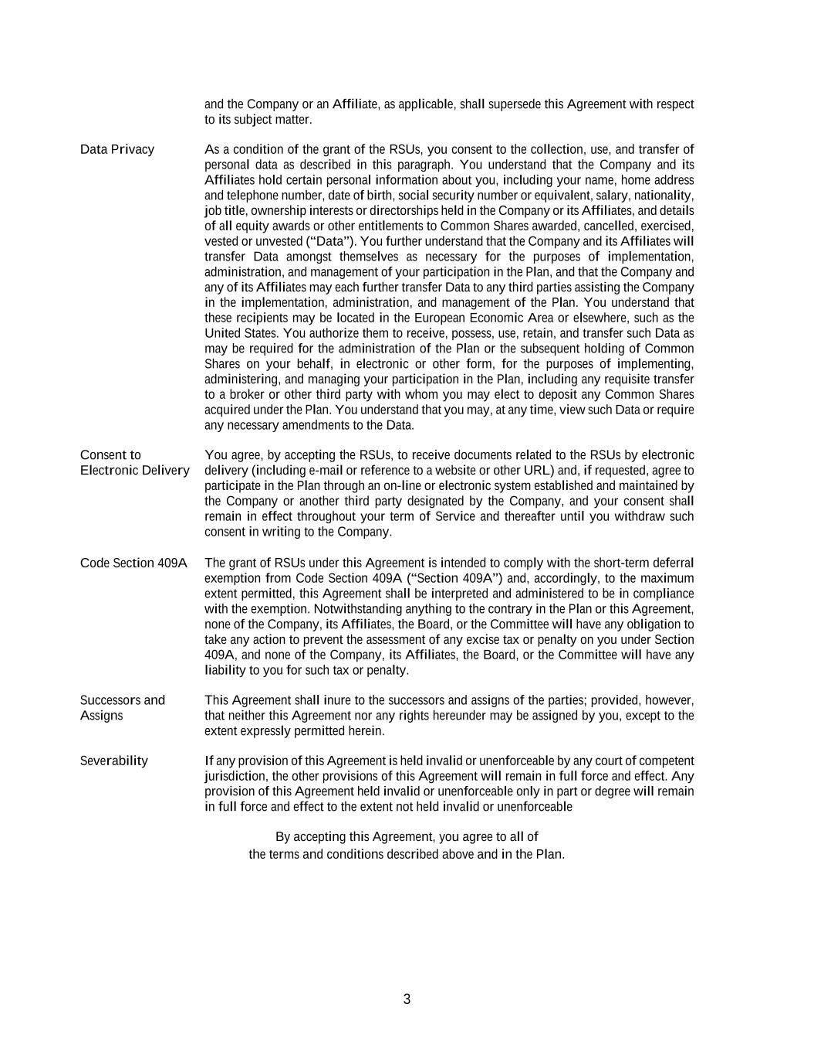
3 and the Company or an Affiliate, as applicable, shall supersede this Agreement with respect to its subject matter. Data Privacy As a condition of the grant of the RSUs, you consent to the collection, use, and transfer of personal data as described in this paragraph. You understand that the Company and its Affiliates hold certain personal information about you, including your name, home address and telephone number, date of birth, social security number or equivalent, salary, nationality, job title, ownership interests or directorships held in the Company or its Affiliates, and details of all equity awards or other entitlements to Common Shares awarded, cancelled, exercised, vested or unvested (“Data”). You further understand that the Company and its Affiliates will transfer Data amongst themselves as necessary for the purposes of implementation, administration, and management of your participation in the Plan, and that the Company and any of its Affiliates may each further transfer Data to any third parties assisting the Company in the implementation, administration, and management of the Plan. You understand that these recipients may be located in the European Economic Area or elsewhere, such as the United States. You authorize them to receive, possess, use, retain, and transfer such Data as may be required for the administration of the Plan or the subsequent holding of Common Shares on your behalf, in electronic or other form, for the purposes of implementing, administering, and managing your participation in the Plan, including any requisite transfer to a broker or other third party with whom you may elect to deposit any Common Shares acquired under the Plan. You understand that you may, at any time, view such Data or require any necessary amendments to the Data. Consent to Electronic Delivery You agree, by accepting the RSUs, to receive documents related to the RSUs by electronic delivery (including e-mail or reference to a website or other URL) and, if requested, agree to participate in the Plan through an on-line or electronic system established and maintained by the Company or another third party designated by the Company, and your consent shall remain in effect throughout your term of Service and thereafter until you withdraw such consent in writing to the Company. Code Section 409A The grant of RSUs under this Agreement is intended to comply with the short-term deferral exemption from Code Section 409A (“Section 409A”) and, accordingly, to the maximum extent permitted, this Agreement shall be interpreted and administered to be in compliance with the exemption. Notwithstanding anything to the contrary in the Plan or this Agreement, none of the Company, its Affiliates, the Board, or the Committee will have any obligation to take any action to prevent the assessment of any excise tax or penalty on you under Section 409A, and none of the Company, its Affiliates, the Board, or the Committee will have any liability to you for such tax or penalty. Successors and Assigns This Agreement shall inure to the successors and assigns of the parties; provided, however, that neither this Agreement nor any rights hereunder may be assigned by you, except to the extent expressly permitted herein. Severability If any provision of this Agreement is held invalid or unenforceable by any court of competent jurisdiction, the other provisions of this Agreement will remain in full force and effect. Any provision of this Agreement held invalid or unenforceable only in part or degree will remain in full force and effect to the extent not held invalid or unenforceable By accepting this Agreement, you agree to all of the terms and conditions described above and in the Plan.

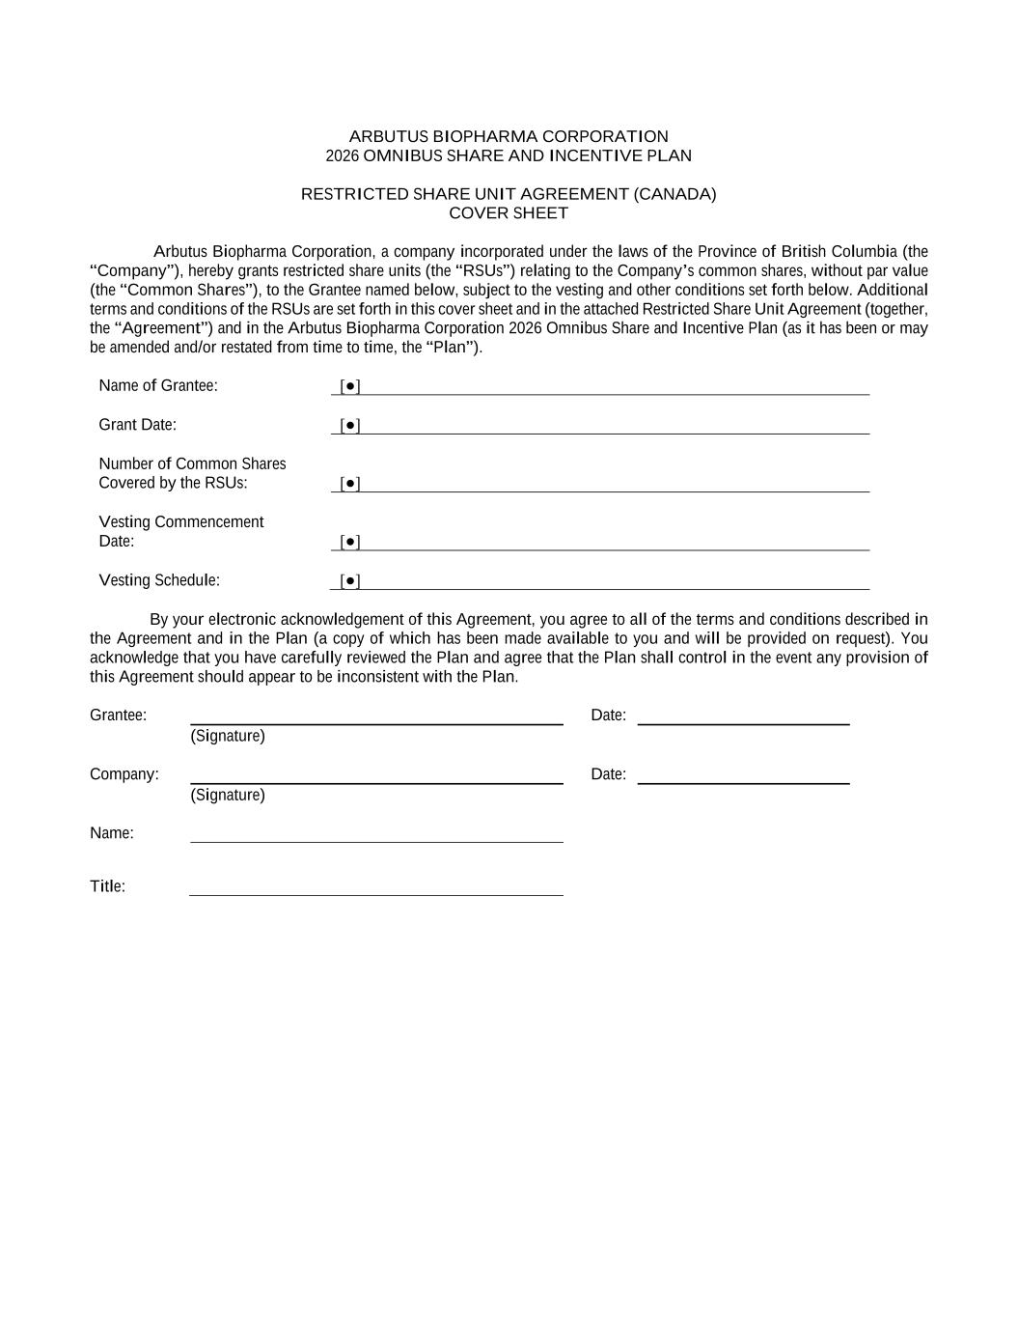
ARBUTUS BIOPHARMA CORPORATION 2026 OMNIBUS SHARE AND INCENTIVE PLAN RESTRICTED SHARE UNIT AGREEMENT (CANADA) COVER SHEET Arbutus Biopharma Corporation, a company incorporated under the laws of the Province of British Columbia (the “Company”), hereby grants restricted share units (the “RSUs”) relating to the Company’s common shares, without par value (the “Common Shares”), to the Grantee named below, subject to the vesting and other conditions set forth below. Additional terms and conditions of the RSUs are set forth in this cover sheet and in the attached Restricted Share Unit Agreement (together, the “Agreement”) and in the Arbutus Biopharma Corporation 2026 Omnibus Share and Incentive Plan (as it has been or may be amended and/or restated from time to time, the “Plan”). Name of Grantee: [●] Grant Date: [●] Number of Common Shares Covered by the RSUs: [●] Vesting Commencement Date: [●] Vesting Schedule: [●] By your electronic acknowledgement of this Agreement, you agree to all of the terms and conditions described in the Agreement and in the Plan (a copy of which has been made available to you and will be provided on request). You acknowledge that you have carefully reviewed the Plan and agree that the Plan shall control in the event any provision of this Agreement should appear to be inconsistent with the Plan. Grantee: Date: (Signature) Company: Date: (Signature) Name: Title:


Attachment This is not a share certificate or a negotiable instrument.

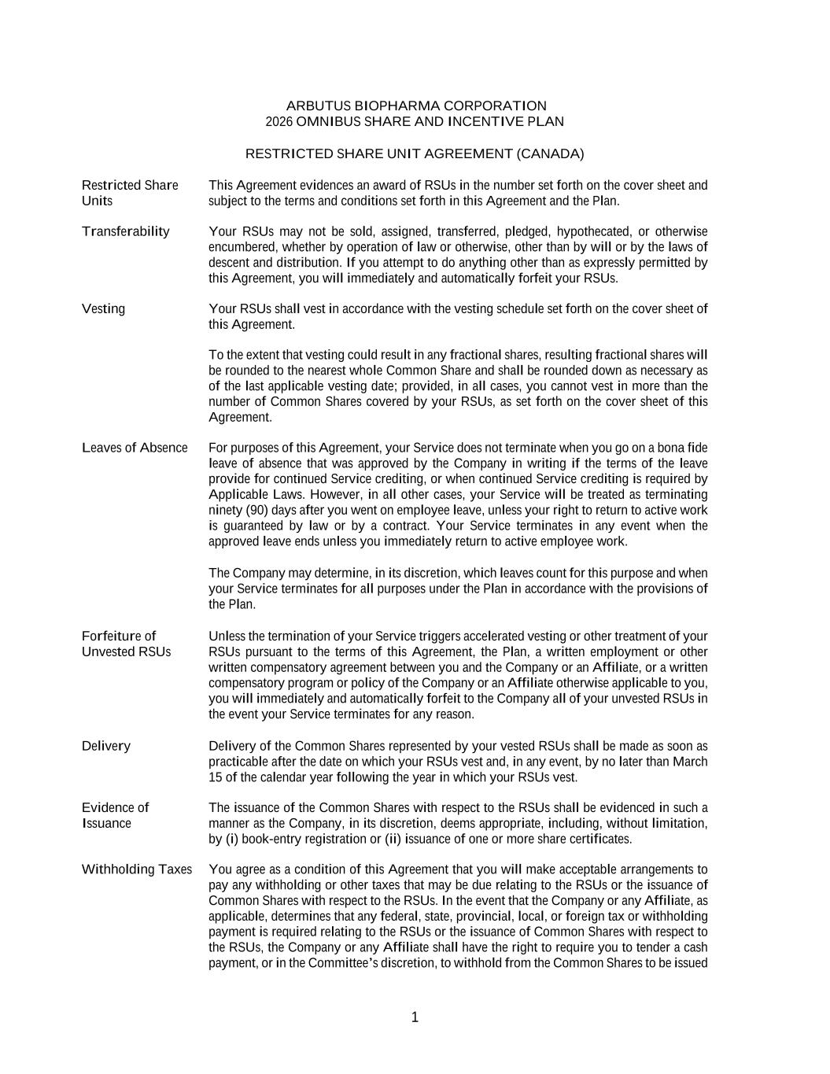
1 ARBUTUS BIOPHARMA CORPORATION 2026 OMNIBUS SHARE AND INCENTIVE PLAN RESTRICTED SHARE UNIT AGREEMENT (CANADA) Restricted Share Units This Agreement evidences an award of RSUs in the number set forth on the cover sheet and subject to the terms and conditions set forth in this Agreement and the Plan. Transferability Your RSUs may not be sold, assigned, transferred, pledged, hypothecated, or otherwise encumbered, whether by operation of law or otherwise, other than by will or by the laws of descent and distribution. If you attempt to do anything other than as expressly permitted by this Agreement, you will immediately and automatically forfeit your RSUs. Vesting Your RSUs shall vest in accordance with the vesting schedule set forth on the cover sheet of this Agreement. To the extent that vesting could result in any fractional shares, resulting fractional shares will be rounded to the nearest whole Common Share and shall be rounded down as necessary as of the last applicable vesting date; provided, in all cases, you cannot vest in more than the number of Common Shares covered by your RSUs, as set forth on the cover sheet of this Agreement. Leaves of Absence For purposes of this Agreement, your Service does not terminate when you go on a bona fide leave of absence that was approved by the Company in writing if the terms of the leave provide for continued Service crediting, or when continued Service crediting is required by Applicable Laws. However, in all other cases, your Service will be treated as terminating ninety (90) days after you went on employee leave, unless your right to return to active work is guaranteed by law or by a contract. Your Service terminates in any event when the approved leave ends unless you immediately return to active employee work. The Company may determine, in its discretion, which leaves count for this purpose and when your Service terminates for all purposes under the Plan in accordance with the provisions of the Plan. Forfeiture of Unvested RSUs Unless the termination of your Service triggers accelerated vesting or other treatment of your RSUs pursuant to the terms of this Agreement, the Plan, a written employment or other written compensatory agreement between you and the Company or an Affiliate, or a written compensatory program or policy of the Company or an Affiliate otherwise applicable to you, you will immediately and automatically forfeit to the Company all of your unvested RSUs in the event your Service terminates for any reason. Delivery Delivery of the Common Shares represented by your vested RSUs shall be made as soon as practicable after the date on which your RSUs vest and, in any event, by no later than March 15 of the calendar year following the year in which your RSUs vest. Evidence of Issuance The issuance of the Common Shares with respect to the RSUs shall be evidenced in such a manner as the Company, in its discretion, deems appropriate, including, without limitation, by (i) book-entry registration or (ii) issuance of one or more share certificates. Withholding Taxes You agree as a condition of this Agreement that you will make acceptable arrangements to pay any withholding or other taxes that may be due relating to the RSUs or the issuance of Common Shares with respect to the RSUs. In the event that the Company or any Affiliate, as applicable, determines that any federal, state, provincial, local, or foreign tax or withholding payment is required relating to the RSUs or the issuance of Common Shares with respect to the RSUs, the Company or any Affiliate shall have the right to require you to tender a cash payment, or in the Committee’s discretion, to withhold from the Common Shares to be issued

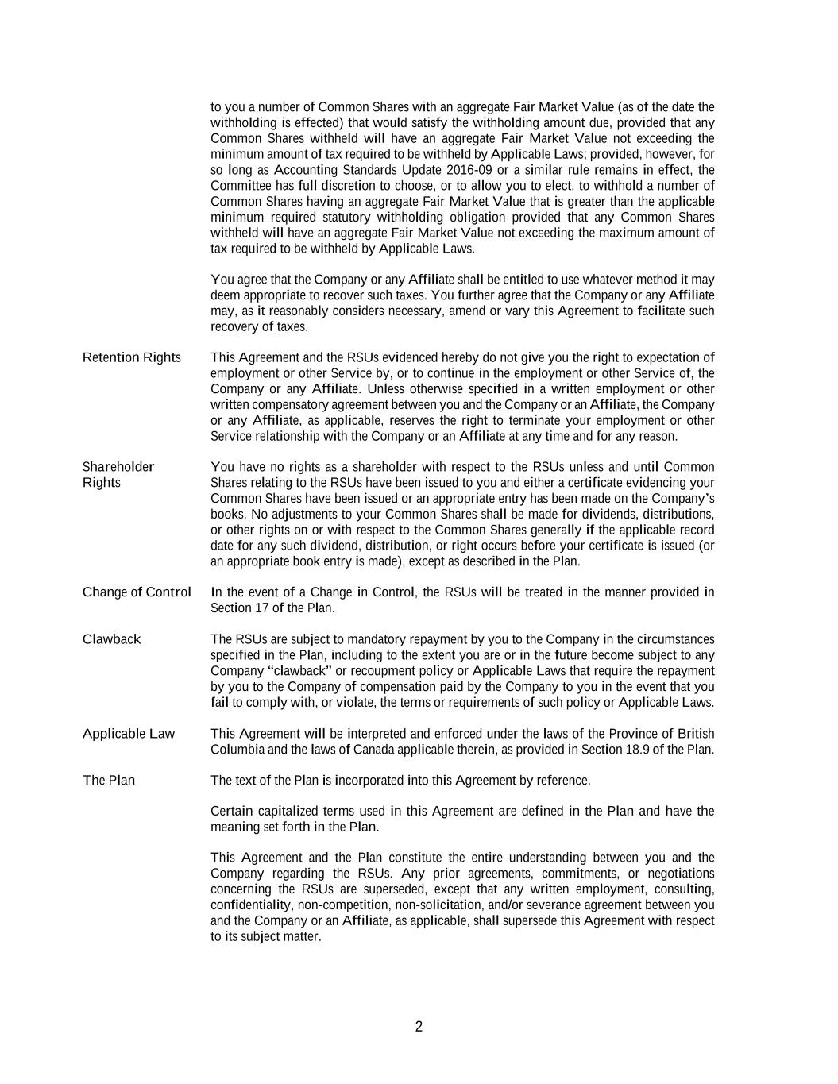
2 to you a number of Common Shares with an aggregate Fair Market Value (as of the date the withholding is effected) that would satisfy the withholding amount due, provided that any Common Shares withheld will have an aggregate Fair Market Value not exceeding the minimum amount of tax required to be withheld by Applicable Laws; provided, however, for so long as Accounting Standards Update 2016-09 or a similar rule remains in effect, the Committee has full discretion to choose, or to allow you to elect, to withhold a number of Common Shares having an aggregate Fair Market Value that is greater than the applicable minimum required statutory withholding obligation provided that any Common Shares withheld will have an aggregate Fair Market Value not exceeding the maximum amount of tax required to be withheld by Applicable Laws. You agree that the Company or any Affiliate shall be entitled to use whatever method it may deem appropriate to recover such taxes. You further agree that the Company or any Affiliate may, as it reasonably considers necessary, amend or vary this Agreement to facilitate such recovery of taxes. Retention Rights This Agreement and the RSUs evidenced hereby do not give you the right to expectation of employment or other Service by, or to continue in the employment or other Service of, the Company or any Affiliate. Unless otherwise specified in a written employment or other written compensatory agreement between you and the Company or an Affiliate, the Company or any Affiliate, as applicable, reserves the right to terminate your employment or other Service relationship with the Company or an Affiliate at any time and for any reason. Shareholder Rights You have no rights as a shareholder with respect to the RSUs unless and until Common Shares relating to the RSUs have been issued to you and either a certificate evidencing your Common Shares have been issued or an appropriate entry has been made on the Company’s books. No adjustments to your Common Shares shall be made for dividends, distributions, or other rights on or with respect to the Common Shares generally if the applicable record date for any such dividend, distribution, or right occurs before your certificate is issued (or an appropriate book entry is made), except as described in the Plan. Change of Control In the event of a Change in Control, the RSUs will be treated in the manner provided in Section 17 of the Plan. Clawback The RSUs are subject to mandatory repayment by you to the Company in the circumstances specified in the Plan, including to the extent you are or in the future become subject to any Company “clawback” or recoupment policy or Applicable Laws that require the repayment by you to the Company of compensation paid by the Company to you in the event that you fail to comply with, or violate, the terms or requirements of such policy or Applicable Laws. Applicable Law This Agreement will be interpreted and enforced under the laws of the Province of British Columbia and the laws of Canada applicable therein, as provided in Section 18.9 of the Plan. The Plan The text of the Plan is incorporated into this Agreement by reference. Certain capitalized terms used in this Agreement are defined in the Plan and have the meaning set forth in the Plan. This Agreement and the Plan constitute the entire understanding between you and the Company regarding the RSUs. Any prior agreements, commitments, or negotiations concerning the RSUs are superseded, except that any written employment, consulting, confidentiality, non-competition, non-solicitation, and/or severance agreement between you and the Company or an Affiliate, as applicable, shall supersede this Agreement with respect to its subject matter.

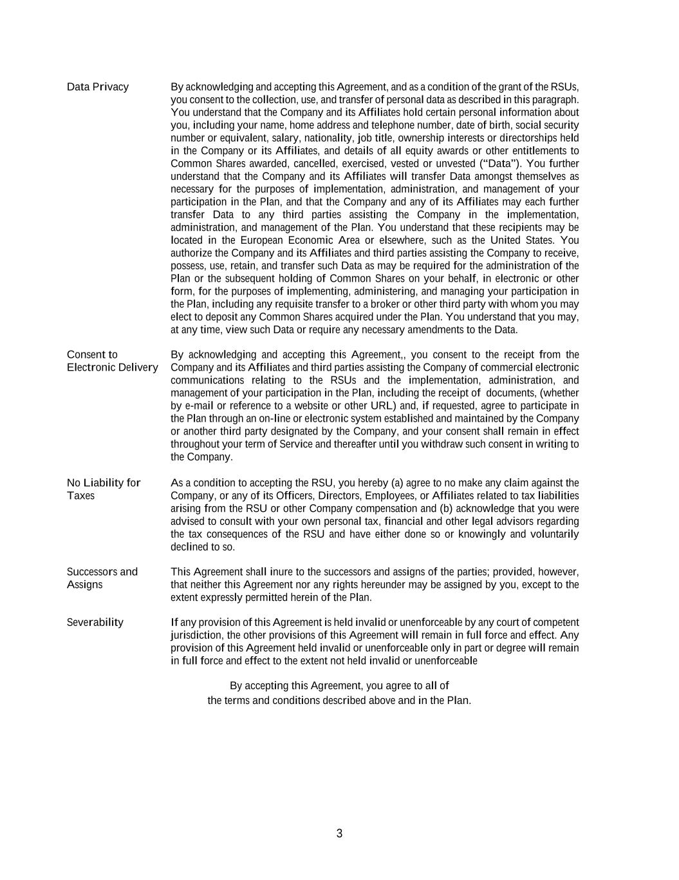
3 Data Privacy By acknowledging and accepting this Agreement, and as a condition of the grant of the RSUs, you consent to the collection, use, and transfer of personal data as described in this paragraph. You understand that the Company and its Affiliates hold certain personal information about you, including your name, home address and telephone number, date of birth, social security number or equivalent, salary, nationality, job title, ownership interests or directorships held in the Company or its Affiliates, and details of all equity awards or other entitlements to Common Shares awarded, cancelled, exercised, vested or unvested (“Data”). You further understand that the Company and its Affiliates will transfer Data amongst themselves as necessary for the purposes of implementation, administration, and management of your participation in the Plan, and that the Company and any of its Affiliates may each further transfer Data to any third parties assisting the Company in the implementation, administration, and management of the Plan. You understand that these recipients may be located in the European Economic Area or elsewhere, such as the United States. You authorize the Company and its Affiliates and third parties assisting the Company to receive, possess, use, retain, and transfer such Data as may be required for the administration of the Plan or the subsequent holding of Common Shares on your behalf, in electronic or other form, for the purposes of implementing, administering, and managing your participation in the Plan, including any requisite transfer to a broker or other third party with whom you may elect to deposit any Common Shares acquired under the Plan. You understand that you may, at any time, view such Data or require any necessary amendments to the Data. Consent to Electronic Delivery By acknowledging and accepting this Agreement,, you consent to the receipt from the Company and its Affiliates and third parties assisting the Company of commercial electronic communications relating to the RSUs and the implementation, administration, and management of your participation in the Plan, including the receipt of documents, (whether by e-mail or reference to a website or other URL) and, if requested, agree to participate in the Plan through an on-line or electronic system established and maintained by the Company or another third party designated by the Company, and your consent shall remain in effect throughout your term of Service and thereafter until you withdraw such consent in writing to the Company. No Liability for Taxes As a condition to accepting the RSU, you hereby (a) agree to no make any claim against the Company, or any of its Officers, Directors, Employees, or Affiliates related to tax liabilities arising from the RSU or other Company compensation and (b) acknowledge that you were advised to consult with your own personal tax, financial and other legal advisors regarding the tax consequences of the RSU and have either done so or knowingly and voluntarily declined to so. Successors and Assigns This Agreement shall inure to the successors and assigns of the parties; provided, however, that neither this Agreement nor any rights hereunder may be assigned by you, except to the extent expressly permitted herein of the Plan. Severability If any provision of this Agreement is held invalid or unenforceable by any court of competent jurisdiction, the other provisions of this Agreement will remain in full force and effect. Any provision of this Agreement held invalid or unenforceable only in part or degree will remain in full force and effect to the extent not held invalid or unenforceable By accepting this Agreement, you agree to all of the terms and conditions described above and in the Plan.

Exhibit 31.1

CERTIFICATION PURSUANT TO RULE 13a-14(a) OR 15d-14(a) OF THE SECURITIES
EXCHANGE ACT OF 1934, AS ADOPTED PURSUANT TO SECTION 302 OF THE
SARBANES-OXLEY ACT OF 2002
I, Lindsay Androski, certify that:
1.I have reviewed this Quarterly Report on Form 10-Q of Arbutus Biopharma Corporation;
2.Based on my knowledge, this report does not contain any untrue statement of a material fact or omit to state a material fact necessary to make the statements made, in light of the circumstances under which such statements were made, not misleading with respect to the period covered by this report;
3.Based on my knowledge, the financial statements, and other financial information included in this report, fairly present in all material respects the financial condition, results of operations and cash flows of the registrant as of, and for, the periods presented in this report;
4.The registrant’s other certifying officer and I are responsible for establishing and maintaining disclosure controls and procedures (as defined in Exchange Act Rules 13a-15(e) and 15d-15(e)) and internal control over financial reporting (as defined in Exchange Act Rules 13a-15(f) and 15d-15(f)) for the registrant and have:
(a)Designed such disclosure controls and procedures, or caused such disclosure controls and procedures to be designed under our supervision, to ensure that material information relating to the registrant, including its consolidated subsidiaries, is made known to us by others within those entities, particularly during the period in which this report is being prepared;
(b)Designed such internal control over financial reporting, or caused such internal control over financial reporting to be designed under our supervision, to provide reasonable assurance regarding the reliability of financial reporting and the preparation of financial statements for external purposes in accordance with generally accepted accounting principles;
(c)Evaluated the effectiveness of the registrant’s disclosure controls and procedures and presented in this report our conclusions about the effectiveness of the disclosure controls and procedures, as of the end of the period covered by this report based on such evaluation; and
(d)Disclosed in this report any change in the registrant’s internal control over financial reporting that occurred during the registrant’s most recent fiscal quarter (the registrant’s fourth fiscal quarter in the case of an annual report) that has materially affected, or is reasonably likely to materially affect, the registrant’s internal control over financial reporting; and
5.The registrant’s other certifying officer and I have disclosed, based on our most recent evaluation of internal control over financial reporting, to the registrant’s auditors and the audit committee of the registrant’s board of directors (or persons performing the equivalent functions):
(a)All significant deficiencies and material weaknesses in the design or operation of internal control over financial reporting which are reasonably likely to adversely affect the registrant’s ability to record, process, summarize and report financial information; and
(b)Any fraud, whether or not material, that involves management or other employees who have a significant role in the registrant’s internal control over financial reporting.

Date: August 12, 2026
/s/ Lindsay Androski
Name: Lindsay Androski
Title: President and Chief Executive Officer

Exhibit 31.2

CERTIFICATION PURSUANT TO RULE 13a-14(a) OR 15d-14(a) OF THE SECURITIES
EXCHANGE ACT OF 1934, AS ADOPTED PURSUANT TO SECTION 302 OF THE
SARBANES-OXLEY ACT OF 2002
I, Tuan Nguyen, certify that:
1.I have reviewed this Quarterly Report on Form 10-Q of Arbutus Biopharma Corporation;
2.Based on my knowledge, this report does not contain any untrue statement of a material fact or omit to state a material fact necessary to make the statements made, in light of the circumstances under which such statements were made, not misleading with respect to the period covered by this report;
3.Based on my knowledge, the financial statements, and other financial information included in this report, fairly present in all material respects the financial condition, results of operations and cash flows of the registrant as of, and for, the periods presented in this report;
4.The registrant’s other certifying officer and I are responsible for establishing and maintaining disclosure controls and procedures (as defined in Exchange Act Rules 13a-15(e) and 15d-15(e)) and internal control over financial reporting (as defined in Exchange Act Rules 13a-15(f) and 15d-15(f)) for the registrant and have:
(a)Designed such disclosure controls and procedures, or caused such disclosure controls and procedures to be designed under our supervision, to ensure that material information relating to the registrant, including its consolidated subsidiaries, is made known to us by others within those entities, particularly during the period in which this report is being prepared;
(b)Designed such internal control over financial reporting, or caused such internal control over financial reporting to be designed under our supervision, to provide reasonable assurance regarding the reliability of financial reporting and the preparation of financial statements for external purposes in accordance with generally accepted accounting principles;
(c)Evaluated the effectiveness of the registrant’s disclosure controls and procedures and presented in this report our conclusions about the effectiveness of the disclosure controls and procedures, as of the end of the period covered by this report based on such evaluation; and
(d)Disclosed in this report any change in the registrant’s internal control over financial reporting that occurred during the registrant’s most recent fiscal quarter (the registrant’s fourth fiscal quarter in the case of an annual report) that has materially affected, or is reasonably likely to materially affect, the registrant’s internal control over financial reporting; and
5.The registrant’s other certifying officer and I have disclosed, based on our most recent evaluation of internal control over financial reporting, to the registrant’s auditors and the audit committee of the registrant’s board of directors (or persons performing the equivalent functions):
(a)All significant deficiencies and material weaknesses in the design or operation of internal control over financial reporting which are reasonably likely to adversely affect the registrant’s ability to record, process, summarize and report financial information; and
(b)Any fraud, whether or not material, that involves management or other employees who have a significant role in the registrant’s internal control over financial reporting.

Date: August 12, 2026
/s/ Tuan Nguyen
Name: Tuan Nguyen
Title: Chief Financial Officer

Exhibit 32.1

CERTIFICATION PURSUANT TO 18 U.S.C. SECTION 1350,
AS ADOPTED PURSUANT TO SECTION 906
OF THE SARBANES-OXLEY ACT OF 2002

In connection with the Quarterly Report on Form 10-Q of Arbutus Biopharma Corporation (the “Company”) for the quarter ended June 30, 2026, as filed with the Securities and Exchange Commission on the date hereof (the “Report”), I, Lindsay Androski, President and Chief Executive Officer of the Company, certify, pursuant to 18 U.S.C. Section 1350, as adopted pursuant to Section 906 of the Sarbanes-Oxley Act of 2002, that to the best of my knowledge:
1.The Report fully complies with the requirements of Section 13(a) or 15(d) of the Securities Exchange Act of 1934; and
2.The information contained in the Report fairly presents, in all material respects, the financial condition and results of the operations of the Company.

Date: August 12, 2026
/s/ Lindsay Androski
Name: Lindsay Androski
Title: President and Chief Executive Officer

Exhibit 32.2

CERTIFICATION PURSUANT TO 18 U.S.C. SECTION 1350,
AS ADOPTED PURSUANT TO SECTION 906
OF THE SARBANES-OXLEY ACT OF 2002

In connection with the Quarterly Report on Form 10-Q of Arbutus Biopharma Corporation (the “Company”) for the quarter ended June 30, 2026, as filed with the Securities and Exchange Commission on the date hereof (the “Report”), I, Tuan Nguyen, Chief Financial Officer of the Company, certify, pursuant to 18 U.S.C. Section 1350, as adopted pursuant to Section 906 of the Sarbanes-Oxley Act of 2002, that to the best of my knowledge:
1.The Report fully complies with the requirements of Section 13(a) or 15(d) of the Securities Exchange Act of 1934; and
2.The information contained in the Report fairly presents, in all material respects, the financial condition and results of the operations of the Company.

Date: August 12, 2026
/s/ Tuan Nguyen
Name: Tuan Nguyen
Title: Chief Financial Officer

